МІНІСТЕРСТВО ОСВІТИ І НАУКИ УКРАЇНИ
ЗАПОРІЗЬКИЙ НАЦІОНАЛЬНИЙ УНІВЕРСИТЕТ

О.О. Приходченко

ІНОЗЕМНА МОВА ПРОФЕСІЙНО-КОМУНІКАТИВНОЇ СПРЯМОВАНОСТІ
(англійська)

Практикум
для здобувачів ступеня вищої освіти бакалавра
спеціальності “Хімія” освітньо-професійної програми
“Хімія”

Затверджено
вченою радою ЗНУ
Протокол № від

Запоріжжя
2024

УДК 811.111’0 (075.6)
П: 782

Приходченко О. О. Іноземна мова професійно-комунікативної спрямованості (англійська) : практикум для здобувачів ступеня вищої освіти бакалавра спеціальності “Хімія” освітньо-професійної програми “Хімія”. Запоріжжя : Запорізький національний університет, 2024. 139 с.

Практикум укладено відповідно до робочої програми навчальної дисципліни “Іноземна мова професійно-комунікативної спрямованості (англійська)” для студентів ІІ курсу ступеня вищої освіти бакалавра.
Зміст видання інтегрується з темами основного підручника (New English File (Upper-Intermediate), доповнює поданий у ньому матеріал цілим рядом вправ. Практикум сприятиме розвитку володіння студентами лексичним та граматичним матеріалом та формуванню навичок їх використання під час комунікації.
Для здобувачів ступеня вищої освіти бакалавра спеціальності “Хімія”, які навчаються за освітньо-професійною програмою “Хімія” як додаток до основного підручника.

Рецензент
І. І. Широкова, доктор філософії у філологічних науках, старший викладач кафедри іноземних мов професійного спрямування.

Відповідальний за випуск
С. В. Іваненко, кандидат філологічних наук, доцент, завідувач кафедри іноземних мов професійного прямування

Зміст
ВСТУП…………………………………………………………………………. | 5
Unit 1 A. Job interview………………………………………………………...  1. Lexical exercises………………………………………………….….…….  Word formation. Noun suffixes: -ness; -ity…………………………………..  2. Grammar. Questions in English…………………………………………… | 7  7  13  15
Unit 1 B. Do you believe in it?.…….…………………………………………..  1. Lexical exercises………………………………………………….………..  Word formation. Prefixes semi-; under-; over-; re-; co-; inter-……………….  Compound adjectives…………………………………………………………  2. Grammar. Comparison…………………………………………………….. | 18  18  22  23  24
Unit 2 A. Illnesses and injuries. Modern medicine..…………...…………….  1. Lexical exercises……………………………………………….…………..  Word formation: Prefixes in English…………………………………………  2. Grammar. Present Perfect / Present Perfect Continuous……………...…... | 27  27  33  34
Unit 2 B. Act your age. ………...………………………………………………  1. Lexical exercises…………………………………………..…………….…  Word formation: Prefixes (2) ………………………………………………..  2. Grammar. Order or adjectives………………………………………..……  Using adjectives as nouns……………………………………………………. | 36  36  41  42  42
Unit 3 A. Fasten your seatbelt. …………….………………………………….  1. Lexical exercises……………………………….……………….………….  So and such…………………………………………………………………...  2. Grammar. Narrative tenses: Past Simple, Past Continuous, Past Perfect, and Past Perfect Continuous ………………………...……...…...……………… | 44  44  52  53
Unit3 B. A really good ending?..........................................................................  1. Lexical exercises………………………………………………….………..  Word formation: adverb + adjective………………………………………….  2. Grammar. Confusing adjectives.……………………………..………..…..  The usage of adverbs.………………………………………...……………… | 56  56  60  61  63
Unit 4 A. Stormy weather ………………………………………...…………...  1. Lexical exercises…………………………………………...……….……...  Word formation. Suffixes…………………………………………………….  2. Grammar. Future tenses ..…………………………………………………. | 67  67  75  76
Unit 4 B. A risky business. ……………………………………...……………..  1. Lexical exercises…………………………………………………….……..  Phrasal verbs with take………………………………………………………………  2. Grammar. Zero, first conditionals; future time clauses…………………… | 78  78  82  84
Unit 5 A. I’m a survivor. ……………...……………………………………….  1. Lexical exercises……………………………………………………….…..  2. Grammar. Unreal Conditionals. Revision of Conditional Sentences. ……. | 86  86  91
Unit 5 B. Wish you were here……………..…………………………………..  1. Lexical exercises. ………………………………………………………….  Word formation: verb + preposition + noun collocations……………………  2. Grammar. Wish, would rather, if only…………………………………….. | 93  93  95  96
Unit 6 A. Night, Night……………………...…………………………………..  1. Lexical exercises. ………………………………………………………….  2. Grammar. Used to, be used to, get used to………………………………… | 98  98  101
Unit 6 B. Music to my ears………………………...……...…………………...  1. Lexical exercises…………………………………………………………...  Word formation forming adjectives from nouns……………………………..  2. Grammar. Gerund and infinitive…………………………………………... | 103  103  106  107
Unit 7 A. Let’s not argue…………………………...………………………….  1. Lexical exercises…………………………………………………………...  2. Grammar. Past Modals……………………………………………………..  Verbs often confused. ………………………………………………………... | 111  111  113  115
Unit 7 B. It’s all an act………………………………...……………………….  1. Lexical exercises…………………………………………………………...  Vocabulary. The body………………………………………………………...  2. Grammar. Word formation suffixes……………………………………….. | 120  120  126  127
Test your vocabulary …………………………………………………………… | 128
Test your grammar……………………………………………………………… | 133
СПИСОК ВИКОРИСТАНИХ ДЖЕРЕЛ………………………………….. | 138
СПИСОК РЕКОМЕНДОВАНОЇ ЛІТЕРАТУРИ……………………..…... | 138

ВСТУП

Курс “Іноземна мова професійно-комунікативної спрямованості (англійська)” належить до циклу дисциплін гуманітарної та соціально-економічної підготовки студентів напряму “Хімія”. Дисципліна ставить за мету формування та розвиток практичних умінь та навичок у студентів, їх іншомовної компетентності у сферах повсякденного та професійного спілкування в усній та письмовій формах.
Основним завданням дисципліни “Іноземна мова професійно-комунікативної спрямованості (англійська)” є практичне оволодіння іноземною мовою на рівні В2 (Upper-Intermediate) згідно з дескрипторами, запропонованими Загальноєвропейськими рекомендаціями з мовної освіти (2001 р.).
У результаті вивчення навчальної дисципліни студент повинен
Знати:
- лексичні одиниці відповідно до тем поданих у підручнику;
- граматичні конструкції, які використовуються в усному та писемному мовленні.
Уміти:
- розуміти основний зміст нормативного мовлення на теми запропоновані програмою (у тому числі спеціалізовані за фахом);;
- сприймати англійську мову на слух;
- читати й писати англійською мовою;
- перекладати письмово та усно з англійської мови на українську та з української на іноземну як художні, так і спеціальні фахові тексти;
Практикум містить лексичний матеріал та довідки з використання тих чи тих граматичних явищ, покликаних зробити вивчення іноземної мови більш цікавим та зрозумілим. Навички володіння граматичним та лексичним матеріалом є невід’ємною складовою успішної інтеграції студентів у розмовну практику іноземною мовою. Практикум є доповненням до основного підручника (New English File Upper-Intermediate) для закріплення лексичних та граматичних тем, які вивчаються відповідно до робочої програми.
Практикум містить 14 тем, які вивчаються студентами протягом другого року навчання та утворюють цілісну картину лексичного матеріалу (‘Job interview’, ‘Do you believe in it?’, ‘Illnesses and injuries. Modern medicine’, ‘Act your age’, ‘Fasten your seatbelt’, ‘A really good ending?’, ‘Stormy weather’, ‘A risky business’, ‘I’m a survivor’, ‘It’s all an act’, ‘Let’s not argue’, ‘Music to my ears’, ‘Night, Night’, ‘Wish you were here’) та повторення певних граматичних тем (‘Questions in English’, ‘Comparison’, ‘Present Perfect / Present Perfect Continuous’, ‘Order or adjectives’, ‘Narrative tenses’, ‘Confusing adjectives’, ‘Future tenses’, ‘Zero, first conditionals; future time clauses’, ‘Unreal Conditionals’, ‘Wish, would rather, if only’, ‘Used to, be used to, get used to’, ‘Gerund and infinitive’, ‘Past Modals’, доповнюючи та закріплюючи навички набуті протягом першого року навчання, та списку літератури.
Матеріал кожного розділу корелює з певним уроком підручника та розподілено на: письмові вправи, які спрямовані на відпрацювання навичок писемного мовлення; усні вправи, які ставлять за мету розвиток діалогічного та монологічного мовлення із запропонованих тем; вправи з граматики, які покликані вдосконалювати володіння граматичним матеріалом та його інтеграцію в усне та письмове мовлення.
Кожний розділ містить декілька текстів за темою заняття, дотекстові завдання різних типів (відповіді на запитання, пошук інформації у тексті, підстановка правильної відповіді), які спрямовані на розвиток навичок читання та активізацію тематичної лексики, завдання для самостійного виконання, що складають частину індивідуальної роботи та лексичний мінімум, для розширення лексичного запасу студентів із подальшим його використанням у діалогічному та монологічному мовленні. В кінці подано вправи на закріплення всього лексичного та граматичного матеріалу.
Практикум може використовуватися як для аудиторних занять (як додатковий матеріал до підручнику), так і для самостійної роботи студентів біологічного факультету.
У практикумі було використано наступні умовні позначення:
прочитайте | теоретичні відомості | виконайте вправу
зверніть увагу (увага) | повторіть | запам’ятайте

Unit 1A. Questions and answers
1. Lexical exercises
1. Look at the quiz. Fill in the missing letters to complete the list of jobs.
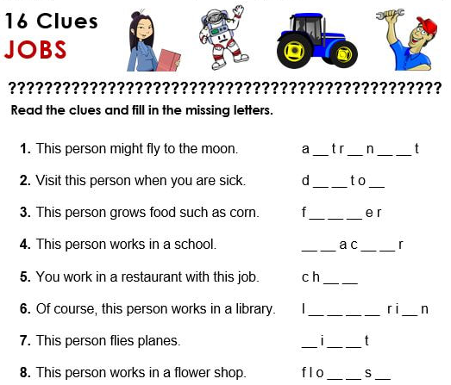
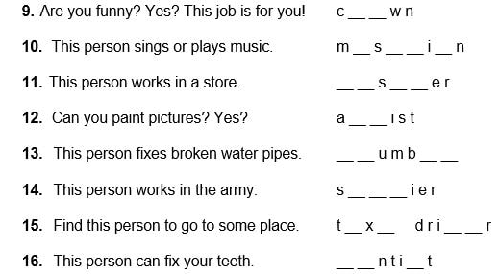

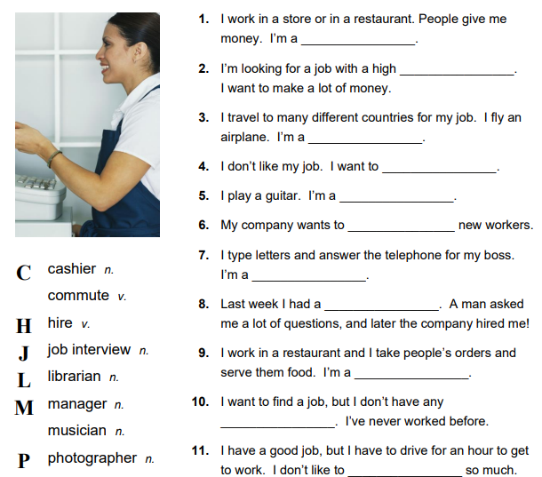
2. Complete the sentences with the suitable word.

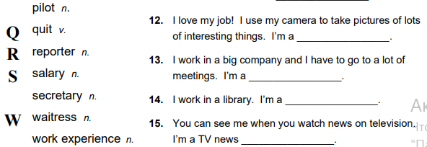

3. Consult the dictionary and write as many words to each letter as possible. Words should be connected with the topic “Jobs and working”.
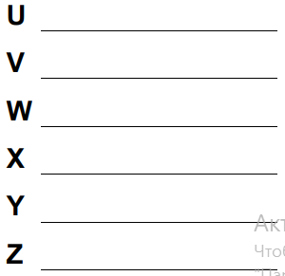
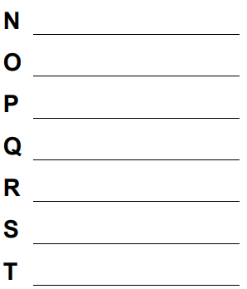
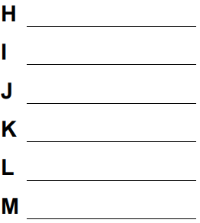
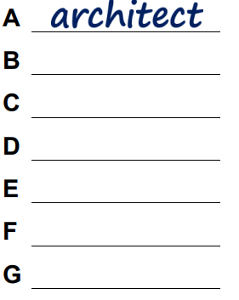

4. Answer the questions.
1. What is the job of your dream? What did you want to be when you were a child and when you grew up?
2. Would you like to have a simple job, which will just give you money for your living or some interesting, may be even dangerous, job?
3. If you could do one job, just for one day to learn what it is like, what would you do?
4. Which job do you find dangerous?
1. Are you a hard worker? What motivates you to work?
2. Where is the best place to look for work these days?
3. What qualities should a good boss have?
4. How many vacation days do workers in your country usually have per year? Is it enough?
5. Is it important to have good relations with co-workers? Why?
6. Are you an ambitious person? What career goals do you have?
7. There are companies which use a flexible time system and employees can work hours that suits them. What do you think about it?
5. Read the text and think would you like to have such job?
Would you dare do a job like this?
Mike Rutzen has one of the most thrilling occupations you could possibly imagine. He is an expert in the secrets and behavior of one of the most powerful and feared natural predators on the planet, the great white shark. Once a fisherman who was scared of this mysterious animal, Mike has learnt to admire and understand great whites, and now, he spends a large part of his time in their company. Mike’s passion for sharks goes beyond the limits of the most shark experts, though. Believe it or not, Mike doesn’t simply observe sharks in a tank or in the oceans; he actually pets them, plays with them and even hypnotizes them. He has developed such a special bond with sharks that he is now known as The Sharkman.
Rutzen is not a scientist. In actual fact, he taught himself everything he knows about sharks. He was brought up on a farm in the South Africa countryside and knew nothing about sharks until he started working as a fisherman off the coast of Gansbaai, a fishing village near Cape Town. As tourism developed in the area, there arose a need for experienced boat skippers to take tourists out to see the sharks. Despite his natural fear of sharks, Mike gradually came to love these giant fish and developed a very close relationship with them. He took lessons in free-diving so he could swim with sharks and he slowly learnt how to interpret their behavior and adapt his posture to avoid being attacked. He soon decided that he wanted to work with sharks and started up his own cage-diving business dedicated to sharing his passion for great white sharks.
Mike’s diving operation now specializes in locating and diving with great white sharks to provide people with the opportunity to experience a unique and unforgettable underwater encounter with these amazing creatures. Mike’s interest in sharks doesn’t end there, though. He has set himself the goal of changing the negative perception that so many people have of great white sharks. Through his interaction with sharks he aims to show people that they are far from the ferocious and mindless killing machines that are portrayed in the media, but that they are curious, intelligent and sensitive creatures. “They may be the top predator in the sea, but they are not the man-eating killers of our nightmares,” he says. He believes that great white sharks have personalities and enjoy interacting with people.
Sharks see Mike neither as prey nor as predator and they happily allow him to swim alongside them. A shark will occasionally let Mike ride with it by hanging into its dorsal fin. What’s truly surprising, though, is that these so-called ferocious killers even allow Mike to hypnotize them. By turning it on its head and massaging its snout close to its eyes, Mike can put a four-meter-long, 1.000 kg shark into a state of total immobility for about fifteen minutes. During this time, the shark will lie upside-down and rest on Mike’s hand; a sight that scientists can only marvel at.
The Sharkman has become a great champion of shark conversation, seeking to highlight the great white shark’s status as an endangered species and to raise awareness of the need to protect them. He regularly travels to give talks and lectures on the great white sharks and he also makes documentaries about them. In Sarkman, a Discovery Channel programme, he tours the world and drives with different species of sharks, demonstrating his ability to hypnotize them. He also starred in an episode of the BBC’s Natural World. He not only has an exciting and rewarding job but he also, as is stated by the title of another BBC programme, A Living Legend of Gansbaai.
6. Study the words from the text.
thrilling adj. | causing a feeling of great excitement or happiness | a behavior n. | the way in which someone conducts oneself
an occupation n. | an activity in which one engages | an interaction n. | mutual action or influence
an endangered species n. | anyone or anything whose continued existence is threatened | ferocious adj. | exhibiting or given to extreme fierceness and unrestrained violence and brutality
a predator n. | an animal that preys on other animals | alongside adv. | in parallel position
a passion n. | a strong liking or desire for sth | an immobility n. | not moving; motionless
to observe v. | to watch carefully | occasionally adj. | on occasion
a boat skipper n. | the master of boats | to marvel v. | to become filled with surprise, wonder
gradually adj. | moving, changing step by step | a perception n. | a capacity for comprehension
to avoid v. | to keep away from | an encounter n. | a chance meeting
an opportunity n. | a good chance for advancement or progress
7. Look through the text once more and fill in the words into the sentences.
1. Mike Rutzen works with sharks, one of the most feared _____ on Earth.
2. Mike was ____ in South Africa where he originally worked as a farmer.
3. He leant to respect sharks and _____ their behavior.
4. He also learnt how to ____ his posture to protect himself from possible shark attacks.
5. The ____ he runs specializes in watching after sharks.
6. Mike believes sharks aren’t ____ animals, but are actually intelligent and sensitive creatures.
7. Mike can hypnotize sharks to hold them in a state of total ____ for about fifteen minutes.
8. Mike believes a(n) ______ with a great white shark is an unforgettable experience.
8. Choose the correct answer and justify your answer.
1. What does the writer think Mike’s job is?
A. scary; | B. strange; | C. exciting; | D. creative.
2. Why is Mike different to most shark experts?
A. He owns pet shark;  B. He gets hypnotized by them; | C. He studies sharks in tank;  D. He builds strong bonds with sharks.
3. As a child, Mike lived …
A. in a fishing village;  B. in Cape Town; | C. on the coast;  D. in a rural area.
4. What led Mike to start his own business?
A. his lack of work as a fisherman;  B. his need for money; | C. his desire to be closer to sharks;  D. the demand created by tourists.
5. Mike hopes his work will
A. change people’s opinions of sharks;  B. make more people interact with sharks; | C. reduce the number of shark-related deaths;  D. create more interest in sharks in the media.
6. How does Mike sometimes swim with sharks?
A. by hypnotizing the shark into following him;  B. by hanging onto the sharks tail; | C. by grabbing a part on the back of the shark;  D. by stroking a part of the shark’s head.
7. Which of the following best describes the writer’s tone throughout the article?
A. impressed; | B. threatening; | C. envious; | D. uninspired.
9. Look at the words in bold: occupation, passion, work, job. What is the difference between them?
Job is a countable noun which is used to describe what you do for a living. It can also be used to describe a task at work or outside work (Today’s job is to wash dishes.) | Work is an uncountable noun used to describe a job you are paid to do or an activity that involves effort.  Work is a verb which means to do a job or to perform a task.  Work can also mean to operate, to succeed and to have an effect.
10. Complete the job interview between and interviewer (I) and an applicant (A) using these words.
background experience knowledge qualifications qualities talents
I: So can you tell me first a little bit about your 1) _____?
A: Sure. My mother’s French and father’s English. I was brought up in France and ….
I: And do you have any previous 2) _____ of journalism?
A: Yes. At university I was editor of the student magazine and after that I worked for a local radio station …
I: What 3) _____ do you have?
A: I have a degree in media studies and a diploma in …
I: What would you say are your best 4) ______?
A: I’m a very organized person, I’m hard-working and I think I …
I: Do you have any 5) _____ of European politics?
A: Well, I read the papers regularly and I take a great interest in current affairs…
I: And lastly. Do you have any particular 6) ______? Things that might make you different from other candidates?
A: I’m good at learning languages and I’m a good photographer.
11. Complete the sentences with the correct form of get and the words and phrases in the box.
promoted on-the-job training a pay rise made redundant
the hang of everything
1. My brother _____ six months ago and he hasn’t found another job yet.
2. I didn’t have a clue what I was doing in the first few days, but I ____ now.
3. We _____ every year in my firm. Instead, we have a system of bonuses if we meet targets.
4. We ____ at the moment. It’s great. I’m learning loads of new skills.
5. I’ve worked for them for nearly three years but I _____ yet. I’m not sure what to do to get the next level.
12. Read the job advert and find the following.

1) duties; 2) deadline for applications; 3) skills and qualifications required; 4) personal qualities required.
2) Which of these qualities would be useful for the job in the advert?
conscientious creative energetic hard-working methodical self-confident
3) Choose any two jobs you like and tell which characteristics are important for this job and justify your choice.

13. Underline the correct word.
1. Arthur worked in a bookshop for 35 years then quit / retired / discontinued / abandoned and lived off his pension.
2. The company made huge earnings / profits / benefits / money in 2021.
3. There is a consumer / applicant / buyer / customer at the counter waiting to be served.
4. I’ve got a new job at the university, so I’ve handed in my note / notice / warning / letter at the café.
5. John works well with his partners / comrades / colleagues / candidates at the leisure centre.
6. Kate enjoys her new workplace, but she had much better pensions / perks / permits / promotions in her old job.
7. Mrs Harman doesn’t make us work long hours. She is a fair trainee / worker / employer / employee.
8. My sister deals / directs / controls / runs her own business making clothes for children.
9. News spread quickly throughout the medical occupation / profession / trade / work about the new treatment.
10. Julie holds a vacancy / chair / post / situation as a nurse in a children’s hospital.
11. The team / crew / personnel / people department are responsible for all new employee contracts.
12. Due to the scandal, Tim had to dismiss / resign / fire / sack from his position as Managing Director.
14. Complete the gaps with the correct word derived from the words in bold.
Mark Miller is self-employed and carries out a range of building, repair and 1) _____ (maintain) jobs to the outside of tall structures. It takes from 2 – 6 years to train as a(n) 2) _______ (professional) steeplejack. “The one thing you must have for this job is a head for 3) ______ (high),” he says. Mark likes working outdoors, but it can be 4) _____ (danger) carrying equipment and trying to keep your balance when it gets 5) _____ (wind). He says that you have to be very 6) ______ (care). Mark often has to work 7) _____ (social) hours such as weekends and evenings. Also, he often works away from home for 8) _____ (extend) periods. It’s worth it in the end though. “It’s great 9) ______ (feel) when I finish and know that because of me 10) _____ (beauty) buildings will continue to grace the skyline for a few years,” Mark says.
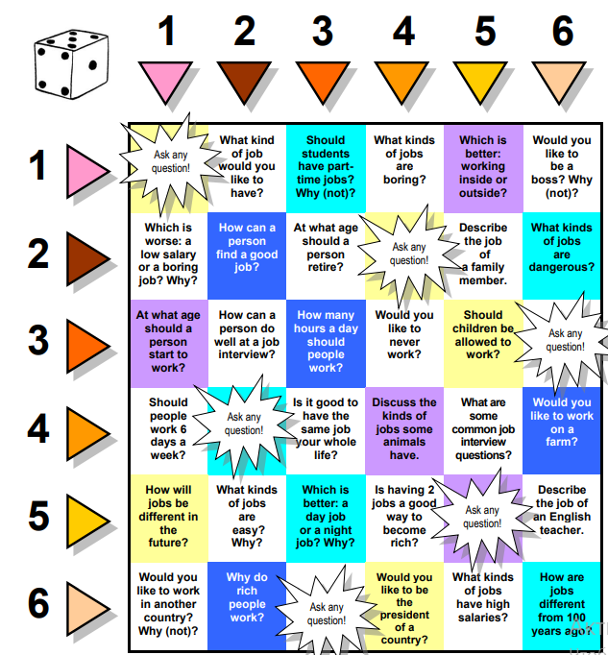
15. Look at the quiz with questions. Choose any 3 – 4 and answer them.

Word formation. Noun suffixes: -ness; -ity
Look at some of the most commonly used words with suffixes –ness and –ity. These suffixes are used
Words with –ness | Words with –ity
weakness illness darkness awareness happiness consciousness business effectiveness | university security quality majority activity possibility visibility curiosity
1. Put the nouns forms of the words below in the correct part of the table.
lazy kind necessary prosperous tired generous happy able generous prosper
-ness | -ity
2. Fill in the sentences with the correct forms of the words from the previous exercise.
1. There are motorways signs in the UK saying ‘____ kills’ to encourage drivers to stop and have a rest.
2. Money doesn’t make you _____, but it certainly helps.
3. The superhero, Mystique, has the ____ to change into anyone she wants to be.
4. Thank you for giving $100 towards our new sports centre. We really appreciate your _____.
5. My dad says he hates _____, but I think he just doesn’t know how to relax and do nothing.
6. Is it really _____ to do warm-up exercises before you go for a run?
7. It was really _____ of Jim to ask if I was OK.
8. Mayfair and Park Lane are the most _____ parts of London – that’s why they cost so much on the Monopoly board!
3. Use the following list of words to fill in the blanks.
clever – cleverness; secure – security; blind – blindness; curious – curiosity; happy – happiness; visible – visibility; messy – messiness; qualify – quality; ill – illness; stable – stability; impolite – impoliteness; able – ability.
1. a) He couldn’t become a pilot because he has a ____ in one eye.
b) The ____ man needed a guide dog to help him walk across the street.
2. a) In order to ____ the semi-finals you need to have a very good team.
b) The _____ of this works was not doubted by anybody.
3. a) Are you ____ to perform this task?
b) The ____ do drive safely is one of the most important things while you are at the wheel.
4. a) The mother made her ____ children to clean the room.
b) the housekeeper quit her job because of the family’s ____. It was too difficult to clean their house!
5. a) The tops of the high trees were _____ from the plane.
b) The ____ was very poor because of the bad weather.
6. a) He was promoted last year because of his ____ in being able to answer difficult problems that no one else understands.
b) The children were very _____ and found a solution to the teacher’s question.
7. a) The ____ of the office was at the top level.
b) The small girl felt herself _____ with her older brother.
8. a) The ____ of his firm was reached by the long years of hard work.
b) The patient was ____ enough to let him go home.
9. a) Your wedding day should be a day of _____.
b) The child was ____ when his father gave him some candy.
10. a) That little kitten is so _____.
b) ______ can be very good feature of character.
11. a) John was ____ and went to see a doctor immediately.
b) Mary had to leave work today because of her _____.
12. a) It is ____ to speak with your mouth full.
b) He was fired from his job at the grocery store because of his _____ to the customers. He was very rude to them.
2. Grammar. Questions in English
Yes / No Questions | Wh- questions
To form questions we put the auxiliary (can, be, will, have etc) before the subject. We use do/does to from questions in Present Simple and did to form the question in Past Simple.  He is eating. – Is he eating?  She reads a lot. – Does she read a lot?  Andy left an hour ago. – Did he leave and hour ago? | WH- questions begin with a question word (who, what where, why, when, whose, which, how etc.).  I am in the garden. – Where are you?  When there is a preposition, it usually goes at the end of the question.  My friend if from Italy. – Where is my friend from?  In questions with who the subject is substituted with the question word.  The cat is black and white. – Who is black and white?
We normally use the following question words to ask about:
people | things / animals / actions | place | time | quantity | manner | reason
Who  Whose  Which  What | What  Which | Where | When  How long  What time  How often | How many  How much | How | Why
1. Fill in: what, when, which, who, whose, why, how, how many, how much, how often, what time, where, how long.

1. “_____ has been wearing my coat?” “Sue has.”
2. “_____ pencil case is this?” “It’s John’s.”
3. “_____ are you doing tomorrow?” “I’m going to the beach.”
4. “__ one of you is the tallest?” “I am”
5. “__ size are your shoes?” “Size 5.”
6. “___ star sign are you?” “I’m Libra.”
7. “_____ did you do on holiday?” “I went to the Carrebean.”
8. “_____ have you lived in America?” “Three years.”
9. “_____ did you start learning French?” “Two years ago.”
10. “_____ do you go to the cinema?” “About once a week.”
11. “_____ shall we meet for dinner?” “About 8 o’clock.”
12. “_____ cheese would you like?” “400 grams, please”
13. “_____ cars do you have?” “We have two cars.”
14. “_____ do you get to work?” “By bus.”
15. “_____ did you call him?” “To confirm his travel arrangements.”
16. “_____ motorbike is parked outside?” “It’s Julie’s.”

2. Put the questions to the words in bold.
1. This book costs ten dollars.
2. Janet lives in the centre of London.
3. I go to the shop every day.
4. My cat has found a mouse in the house.
5. The weather is hot today.
6. He was travelling by train.
7. That film made my cry.
8. It took me almost 5 hours to get to my friend.
9. I didn’t buy that dress because it costs too much.
10. That test was too difficult for me.
11. I should finish this report by the end of the next week.
12. He has worked here for 3 years

.
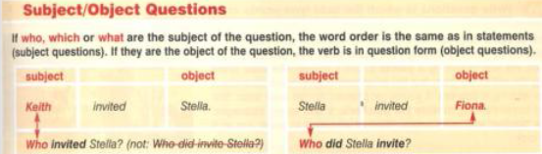

3. Write questions to the words in bold.
1. Josh left the window open.  2. Sally loves driving her car.  3. He chased the fox.  4. Maria opened the window.  5. Jack has read the book.  6. Tom went out with Tim. | 7. Trevor hit James.  8. The tiger lives in the jungle.  9. Jane saw the postman.  10. She hates strawberries.  11. Steven has no patience.  12. Walter stole a wallet.  13. Jane sent Paul a letter.  14. Terry drove a tractor. | 15. Shakespeare wrote Hamlet.  16. Claire likes eating.  17. Jenny likes Spain.  18. He shouted at Jim.  19. Ann typed the letter.  20. Chris saved a little girl.
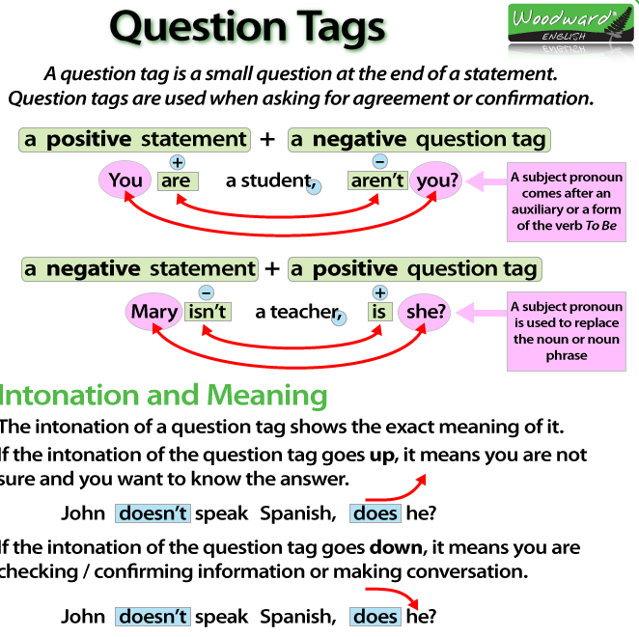

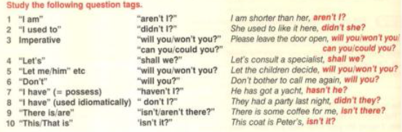

4. Fill in the blanks with the correct question tag.
1. Kate Winslet has brown eyes, _______?  2. Rob had a holiday in Venezuela, _____?  3. I shouldn’t drink so much coffee, ____?  4. Your niece will be 18 next year, _____?  5. You haven’t seen my memory stick, __?  6. You wouldn’t have walked to work, __?  7. Don’t forget to buy some bread, _____? | 8. Let’s have a break now, _______?  9. I’m making too much noise, ____?  10. It’s raining hard tonight, ______?  11. You were at home last night, ___?  12. There’s going to be a strike, ___?  13. You can’t speak French, ______?  14. You’ve been told about her, ___?
Revision of grammar
1. ____of the two pictures do you prefer?
A. What B. Which C. Who D. Whose
2. Everyone knows what he did to her, _?
A. doesn’t he B. don’t they
C. do you D. don’t you
3. He has a nap every day, ____?
A. hasn’t he B. isn’t he C. didn’t he
D. doesn’t he
4. _____ programmes do you like?
A. What B. Who C. Why D. How
5. I’m really unlucky, ____?
A. aren’t I B. am not I C. don’t I
6. ____ got the first prize?
A. Who B. What C. Whose D. Why
7. ___ you come yesterday?
A. Do B. Does C. Did D. Who
8. Oh, I’m sorry! ____ disturbing you?
A. Do I B. Have I C. Should I D. Am I
9. ___ pass me the salt, please?
A. You could B. Are you C. You are D. Could you
10. ___ hot when you were in Spain?
A. Was it B. It was C. Did it D. It made
11. ___ the couple you met last year in France last year staying at the same hotel?
A. Did B. Have C. Were D. Could

Unit 1B. Do you believe in it?
1. Lexical exercises.
1. Answer the questions.
1. What do you first think when you hear about mysteries?
2. Do you believe in coincidences? How can you explain them?
3. Do you like mysterious stories?
4. Do you agree that all mysteries can be explained by science?
5. What do you think about UFO sightings? Have aliens visited the Earth?
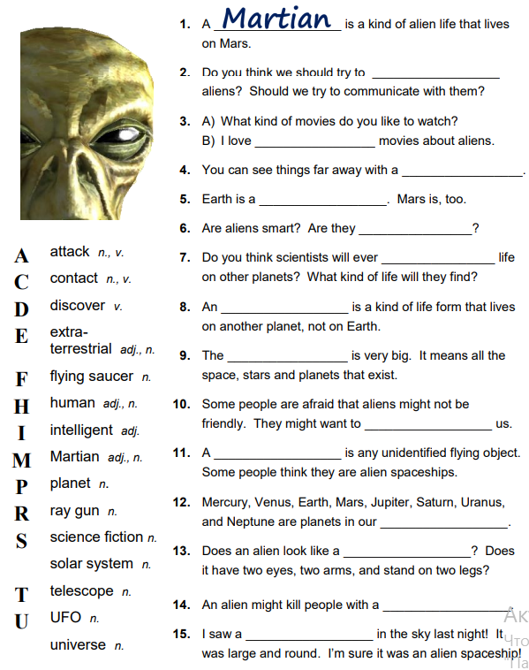
2. Look at the list of words and complete the sentences.

3. Read the text about mysterious places. For questions 1 – 15 choose from people A – D. The people may be chosen more than once.
Which person says:
- they had been intending to visit the place for quite some time before they did?  - you can’t fully appreciate the place until you visit it?  - they think certain speculations about the place are very unlikely?  - they often recall their visit to the place?  - whoever constructed the place was more technologically advanced than us?  - the place is best seen from a special vantage point?  - they don’t think the true meaning of the place will ever be discovered?  - unusual things happen at the place?  - it was due to luck they were able to visit the place?  - they have their own theory about the place’s purpose?  - the place wasn’t built all at once?  - the place is lined up with points on the compass?  - being at the place didn’t seem real?  - sick people may have been cured at the place?  - the place may have been built to magnify a force? | ___
Mysterious places
From ancient times there are a lot of places, which evoke misunderstanding and questions. What were they built for? Who built them? Here are some of the intriguing places, which were visited by people.
A) Anna has visited Easter Island. “Easter Island is a faraway place I’d heard about but never thought I’d get the chance to visit. Then, in 2010, I came into some money so I decided to go. What and experience! At 2,000 miles off Chile’s coast it is one of the most isolated places on Earth. I travelled there to see the mysterious giant stone monoliths, known as Moai, that dot the island’s coastline. There are over 800 of these statues, the largest weighing over 80 tones. There are many theories about what the statues represented and why they were constructed, but no one really knows who put them there and why. Some think the statues were put up to honour the ancestors of the island’s ancient inhabitants. Personally, I think they were put up to guard them. Standing in the presence of the statues is a surreal experience. Easter Island is one of the few places I’ve been to that I still dream about. It didn’t just live up to my expectations; it exceeded them”.
B) Steve had seen Nazca Linen in Peru. “Why in the world would an ancient civilization have spent years In the middle of the desert creating long lines and giant symbols, whose patterns are clearly visible only from the air? This is the mystery that has puzzled researchers for years. The ‘Nazca Lines’, which are located in the Nazca Desert in Peru, depict hundreds of different figures including sharks, monkeys and spiders. the pictures are believed to have been created between 400 and 600 AD, but why? Scholars have said the lines may have represented constellations or have had religious significance. More wild theories say the lines were created by aliens and were landing strips for their aircraft. Personally, I think that’s going too far! But seeing the drawings, I definitely couldn’t stop wondering how on Earth an ancient people could have created such massive works of art without the ability of flight to see what they were creating.”
C) John has visited Great Pyramids of Giza. “Nothing prepares you for the sense of wonder and complete awe you feel the moment you set eyes on the Giant Pyramids of Giza. The sheer size of the structure alone had me shaking my head in disbelief. Ti this day, no one knows how 5,000 years ago, people living along the Nile were able to move over 2 million stone blocks weighing up to 15 tones to a nearly 500-foot summit. But that’s not all that will make your jaw drop. Whoever built it encoded geographical, mathematical and astronomical information into its structure. How they had the knowledge to do this and why they did it is a complete mystery. For example, the pyramid’s four sides are perfectly aligned to true north, south, east and west. Why? Then, there’s the mysterious fact than on one level of the pyramid, food does not decompose and dull razor blades become sharp again. The accuracy of the pyramid’s workmanship is such that its base is almost completely level – it varies less than 15 mm in height over 13 acres! How did an ancient civilization achieve such accuracy when architects today can’t even do so? Some people believe the Great Pyramid was a structure for gathering, amplifying and focusing a mysterious energy field. Whatever its purpose, seeing it raises more questions than answers”.
D) Laura has visited Stonehenge in Britain. “Visiting Stonehenge had long been a goal of mine and on my last trip to England I finally managed it. When I was finally confronted by the sight of these famous huge stones I was speechless and walking around them provoked some very strange feelings in me. I could sense these stones are very important and Stonehenge has some mysterious meaning. If only we could discover what it is! All we know for certain is Stonehenge is over 5,000 years old, was constructed in stages and many of its stones came from mountains in Wales, more than 240 miles away. How did they accomplish such a feat? Stonehenge seems to taunt us with its mystery. The stones are set up to align perfectly with the midsummer sunrise. Was Stonehenge a temple, a burial ground, an astronomical calendar or a healing site? Somehow I doubt Stonehenge will ever give up its secrets.”
4. Study the words from the text.
to guard (v) | to protect from danger | to confront (v) | to face especially in challenge
to construct (v) | to make or form by combining or arranging parts or elements | to shake head in disbelief (phr.) | to turn one’s head showing the fact of not believing in something
in the presence of (phr.) | when (someone) is present | to provoke feelings (phr.) | to call forth feelings
to exceed (v) | to be greater than or superior to | a summit (n) | the topmost level attainable
a constellation (n) | the configuration of stars especially at one’s birth | to be of religious significance (phr.) | to be important form the religious point of view
an awe (n) | the rapt attention and deep emotion caused by the sight of sth extraordinary | to amplify (v) | to expand (something, such as a statement) by the use of detail or illustration or by closer analysis
a landing strip | the place where plains land | perfectly aligned | to be into precise adjustment
to encode (v) | to convert sth into code | to accomplish (v) | to bring about (a result) by effort
to set eyes on (phr.) | to make note of sth through the use of one’s eyes | a burial ground (n) | an area of land where dead people have been buried
to taunt (v) | to reproach or challenge in a mocking or insulting manner | to decompose (v) | to separate into constituent parts or elements or into simpler parts
a healing site (n) | the place where someone can be healed | sheer (adj) | very thin and easy to see through
5. Replace the words in bold with words from the list.
dot guard exceed admit taunt decompose
1. It is said that on one level food does not rot.
2. The Moai may have been put in place to protect the people of Easter Island.
3. I have to confess it was one of the most amazing sights I have ever seen.
4. The statues are placed along the coastline.
5. This mysterious place was able to outdo all my expectations.
6. Places like Easter Island and Stonegenge seem to tease us with their mystery.
6. Read the texts (A – C) and fill in the words:
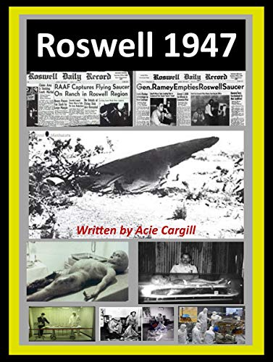
associated aliens extraterrestrial ancient floors supernatural release sank evidence occurrences disappearances hit
A) No one really knows what happened to this 1) ___ city, or whether it even existed in the first place. According to Plato, the city 2) ___ into the ocean in a single day. Since then, divers have explored ocean 3) ____ around the world in search of it, but still no 4) ____ has been found.

B) This region of the North Atlantic Ocean, off the west coast of Florida, is 5) ____ with the unexpected 6) ____ of airplanes and ships. Many scientists claim that these strange 7) ____ are due to violent weather, but others believe that some 8) ___ force exists in the area.
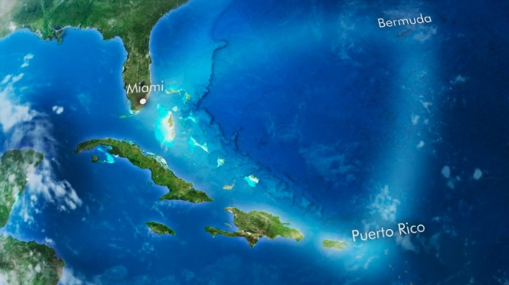
C) This incident 9) ___ international headlines. According to an official press 10) ____ issued by a local military office, an 11) ____ spacecraft crashed near the town of Roswell in New Mexico in 1947. A day later, however, another announcement stated that the object was in fact a ‘weather balloon’. Some people think that the military tried to cover up the truth and that 12) ____ actually landed on Earth. To this day, the case still remains unsolved.
Word formation. Prefixes semi-; under-; over-; re-; co-; inter-.
1. Match the prefixes with their meanings.
a) between | c) again or back | e) half, partly
b) together | d) not enough, below | f) too much
2. Complete the sentences with the words in brackets and prefixes from the previous exercise.
1. The island was _____. Too many people were living there. (crowded)
2. Once the Carters are under the sea, they will never ____. (appear)
3. If the islanders _____, there might be enough food for everyone. (-operate)
4. It’s difficult to ____ with people who speak a different language. (act)
5. The fish smelt bad and it was ____. It wasn’t safe to eat. (cooked)
6. Their new homes were _____. They could only live there for a few months. (-permanent)
3. Complete the words with the correct prefixes below.
re- inter- over- (x2) co- semi-
1. I like travelling by rail, but unfortunately the trains are often __ crowded.
2. I thought I’d lost my printer icon, and then it suddenly ___ appeared on my desktop!
3. Schools should show how important it is to __-operate with people instead of competing.
4. Home education has many advantages, but the children don’t learn how to __act with other children.
5. This pasta is really soft – you’ve __cooked it!
6. We live in a __-detached house, so I have to practice my drums when the neighbours are out!
4. Complete the sentences with the words in brackets and the correct prefix.
1. I think nurses are ___ (paid) – they deserve more money for the difficult and important work they do.
2. The last paragraph of your essay needs to be ___(written) so that it makes a better conclusion.
3. I think his films are __(rated). They’re not as good as most people think they are.
4. I love the __(action) between Sherlock Holmes and Watson in the new TV series.
5. The problem with many young people today is that they are __ (educated) but don’t have any work experience.
Compound adjectives
Form | A compound adjective has two parts. It is usually written with a hyphen (“-”).  The second part of the compound adjective is often:  - a present participle (tight-fitting; good-looking);  - a past-participle (old-fashioned; well-built);  - a preposition (well-off; broken-down);  - another adjective (brand-new). | Use | We can use compound adjectives to describe:  - physical appearance (dark-haired);  - personality (good-tempered; open-minded);  - places (run-down; wide-open);  - everyday objects (hand-made; worn-out).
1. Match items from the two lists to make 20 compound adjectives. Some words are used more than once. Provide your own examples.
broad; narrow; well; one; blond; red; good; bad; left; absent; light; open; thin; long; kind. | minded; built; dressed; eyed; haired; looking; handed; tempered; hearted; behaved; known; lipped; fingered; legged
2. Fill in each space with an appropriate compound adjective formed from the words in ex. 1.
1. Although my grandmother is eighty, she’s not at all ____. She even thinks our modern habits are better than those in her youth.
2. Change those awful clothes you’re wearing. You must be ____ for your interview.
3. You may think he’s ugly but I find him quite ____.
4. When he doesn’t like something he starts shouting; he is very _____.
5. Our children are very ____ at school. The teacher never has to tell them off.
6. He never remembers anything – he’s very _____.
7. She’s such a _____ television personality that almost everybody recognizes her in the street.
8. I was forced to write with my right hand even though I was _____.
9. He’s very ______ - perhaps it comes from doing all that weightlifting in the gym.
10. He’s not blond at all. In fact, I would say he’s almost _____.
3. Fill in each space with an appropriate compound adjective formed from a word in the list.
free distance up built made going up off conditioned class badly sighted headed
1. I made a long-____ call to England and it cost me a fortune.
2. I bought this phone duty-___ as I was coming back from London.
3. They seem to be very well-___ - at least they have a great big house and two expensive cars.
4. I’m fed ___ with this exercise – can’t we do something else?
5. On the train I travelled second-___ because it’s cheaper.
6. You can see this vase is hand-___ and wasn’t produced in a factory.
7. He’s a really relaxed guy – so easy-___.
8. I live in a built-___ area of the city which is very noisy and full of traffic.
9. The office is air-___ so it’s very cool, even in the summer.
10. He is so proud – I’ve rarely met anyone so big-___ . he has a really high opinion of himself.
11. A ___ maintained car won’t have a reliable engine.
12. There isn’t much grass in the ___-up areas of the city.
4. Complete the compound adjectives, each with a different meaning. Then use them to complete the sentences.
blue- pale- blonde- middle- short- sun- broad-
1. Jack spent most of his summer holiday lying in the beach – look how ____ he is!
2. Anna hasn’t got brown eyes and black hair – she’s ____ and ____.
3. If both parents are ____, there is 60% chance that their children will also need glasses.
4. It’s difficult to decide what ___ is now. People work later and live linger these days.
5. The ____ look is becoming more popular, because of the dangers of sunbathing.
6. Tom’s new jacket is a bit small, but he thinks it makes him look very ____!
2. Grammar. Comparison
as…as | We use this type of comparison to say that two things are similar or equal in some way. We use as + adjective + as; as + adverb + as.  Mary is as clever as her sister.  ! We use the construction as … as, but not the construction as … so in comparison:  The cat is as playful so a dog.  The cat is as playful as a dog.
as + many / much / little / few + as | We use the construction as + many / much / little / few + as in comparison without a. We cannot use more / less / several here:  My cat doesn’t eat as much food as yours.  If she has as few meals as her friend, she would be fitter.
the same (as) | We always use article the in comparison with same:  Their flat is the same (as ours).  We can use the word exactly in order to emphasize:  Their new computer is exactly the same (as mine).
so …as … | In negative statements we can use so … as … instead of as …as:  Computers are not so expensive as they were earlier.  ! In positive sentences and in questions we cannot use so … as:  She worked so hard as she could to finish that task.  She worked as hard as she could to finish that task.
like and as | We use like and as to say that things are similar. We use like to make comparison, and as to describe the position or function:  like + noun: He runs like a wind.  like + pronoun: Her sister is just like her.  like + noun: Like the Greeks, Italians like olives.  as + noun (phrase): She works as a doctor.
the … the | we can repeat the comparative to say that something is changing (increasing and decreasing) all the time:  comparative adj + and + comparative adj changing all the time Trees were getting more and more high.  the + comparative adj + verb + the + comparative adj + verb two things change at the same time The older I get, the wiser I became.  the + comparative adj + the + comparative adj used in common phrases the sooner the better
1. Match the halves of the sentences.
1. Last year, winter started so ….  2. Last winter, there were so …  3. Last year, we had such …  4. Last winter, there was so ….  5. Last winter, there was such a lot of …  6. Last winter was so … | A. many storms that we had floods.  B. cold that the water in the pipes froze.  C. a cold winter that I had to sleep with a gat on!  D. suddenly that many people were taken by surprise.  E. much snow that I skied nearly every day.  F. snow that many wild animals died.
2. Fill in like or as.
1. Charles Nichols is known ____ “Chuck” to his friends.
2. Her perfume smelt ____ roses.
3. People say she looks ____ Kim Basinger.
4. His father worked ____ an accountant in the city.
5. ____ usual, Terry was late for work.
6. Diving into the sea was ____ diving into an icy pool.
7. This is nice material – it feels ____ silk.
8. She doesn’t sing ____ well ___ her mother.
9. I don’t think you could describe Andy ____ an intelligent person.
10. Some politicians, such ___ John Major, are always in the news.
11. Ann looks ___ an angel.
3. Fill in correct comparative construction.
1. She gets _____ every day. (beautiful)
2. My toothache is getting ____. (painful)
3. Your ability to remember things gets ___ as the years go by. (bad)
4. The meteor was coming ___ the Earth. (near)
Revision of grammar
1. The noise got ___ until I couldn’t bear it any longer.
A. louder and louder
B. the louder and the louder
C. more louder and more louder
D. less louder and less louder
2. It rained ___ until the river bursts its banks.
A. harder and harder
B. the harder and the harder
C. more harder and more harder
D. less harder and less harder
3. ___ he works, ___ he becomes.
A. harder, successful
B. the harder, the successful
C. the harder, the more successful
D. the more harder, the more successful
4. ___ it got, ___ clothes they had to put on to keep warm.
A. colder, more
B. the colder, the more
C. the colder, the more bigger
D. the more colder, the more
5. Jake ran ___ and won the race.
A. faster B. the fastest C. more faster
6. __ he jumped, __ the crowd cheered.
A. higher, louder
B. the higher, the louder
C. the harder, the more louder
D. the more higher, the more louder
7. Cars are getting __ as the years go by.
A. cheaper and cheaper
B. more cheaper and cheaper
C. more and more cheaper
8. ___ you are, ___you find it to learn things.
A. younger, easier
B. the younger, the easier
C. more younger, more easier
D. the more younger, the more easier
9. ___ people are opening their own businesses these days.
A. more B. more and more C. the more D. the more and the more
10. ___ he gets, ___ he grows.
A. older, taller
B. the older, the taller
C. the older, the more taller
D. the more older, the more taller

Unit 2A. Illnesses and injuries. Modern medicine.
1. Lexical exercises.
1. Answer the questions.
1. Are you a healthy person? How often do you get sick?
2. Do you take vitamins?
3. How often do you get a medical check-up? How often should people do it?
4. What healthy habits do you have?
5. Do you trust modern doctors? Completely? Why or why not?
6. Lifespans are getting longer. How long do you expect your generation will live on average?
2. Answer the questions.
- What was the main idea of the series of films about Terminator?
- Do you agree with the idea that people need to be changed into something better with the help of electronic part of body?
3. Read the part of a TV preview show. Tick the three things the documentary is about:
bionic devices cosmetic surgery face transplants growing new organs
anti-ageing treatments
In the 1970s, two hugely popular American TV series were The Bionic Woman and The Six Million Dollar Man. In both films the main character had near-fatal accidents, and parts of their bodies were replaced with bionic parts which give them super-human abilities.
Presenter: In the TV series like The Bionic Woman, The Six Million Dollar Man or Terminator the characters are a futuristic mixture of technology and nature. Tonight on Channel 10, there’s a fascinating documentary which suggests that this bionic future is already here. Nadene, you’ve seen a preview of the programme.
Guest: Yes, Owen, and it really does seem as of science fiction has become science fact. The programme follows the treatment of a woman whose arm was amputated in a traffic accident, a man who has had a full face transplant and an amazing process which actually grows human organs.
Presenter: So, it’s not just looking at what medical science might be able to achieve, but how it really is changing people’s lives right now.
Guest: Absolutely. Take the woman I mentioned – the lady who injured her arm – Amanda Kitts. She’s been getting treatment in a hospital where they specialize in bionics. And they’ve developed a bionic arm which fits onto her shoulder.
Presenter: And what kind if things can she do now?
Guest: Well it’s early days, but the doctors are confidents that she’ll be able to do the normal things that we take for granted, like making sandwiches or holding a cup of coffee.
Presenter: So bionics is great news for patients who have lost use of a limb.
Guest: Absolutely. And the programme shows all sorts of other bionic devices, too. There will come time when the blind can see, the deaf can hear … Right now, it seems as of the possibilities are endless. The technology, or should I say biotechnology, already exists.
Presenter: And that’s on Channel 10 tonight at 9.30.
4. Study the words and word combinations.
futuristic (adj) | being or involve the latest methods of sth | treatment (n) | the action or way of treating a patient medically or surgically
fascinating (adj) | holding the attention or provoking interest | take for granted (phr) | to assume as true, real, unquestionable, or to be expected
to suggest (v) | to convey an idea indirectly
5. Match the two parts of the sentences.
1. The Bionic Woman was a TV series  2. The documentary is about a woman  3. Doctors have developed a process  4. Amanda Kitts is learning to do things  5. Bionics can help people  6. There’ll be a time | a) that we take for granted;  b) when blind people will use bionic devices to see;  c) where the character was part machine and part human;  d) which grows new organs;  e) who have lost limbs;  f) whose arm was amputated.
6. Match the pictures and the advice how to treat the injuries.
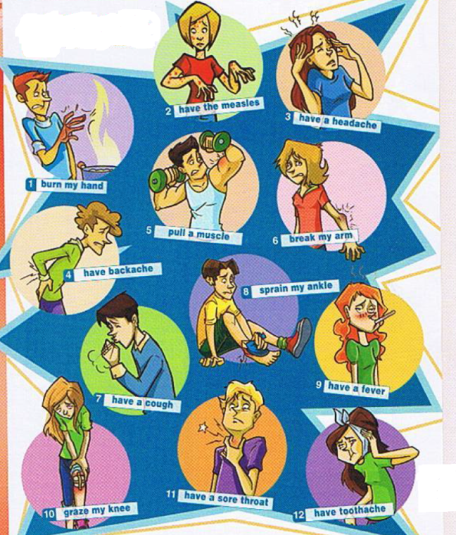
a) rest it for a few days;
b) put some cream on it;
c) clean the wound and put a plaster on;
d) put an ice pack on it;
e) lie down for half an hour;
f) go to the hospital for an X-ray;
g) drink some hot tea;
h) drink a lot of water and juice;
i) take an aspirin;
j) take some cough syrup;
k) see a dentist;
l) stay in bed and rest.

7. Fill the correct words into the texts.
throat nose flu cough temperature neck fever cold
A) A few days ago, I got a sore 1) ___ and my 2) ___ started to run. At first, I thought it was nothing, just a common 3) ___, but now I’ve got a stiff 4) ___ and a terrible 5) ____ that’s keeping everyone in my house awake at night. I checked my 6) ___ this morning and it was 38.5 ºC so it looks like I have a 7) ___, too. I think it might be the 8) ___ but I really hope not because I have a big tennis match tomorrow.
painkiller nausea vision headache reaction pain rash poisoning
B) Last night, I ate out with a few of my friends and this morning I woke up with a dreadful 1) ____ and terrible 2) ___ in my stomach. Then, when I got up, I had a blurred 3) ____ and terrible 4) ____ that forced me to lie down again. After I looked in the mirror, I noticed a strange red 5) ___ on my neck. I took a 6) ___, but that didn’t help at all. It’s probably food 7) ___ or an allergic 8) ____ to something I ate. I just hope it’s nothing serious.
8. Fill in the verbs in their correct form: relieve, recover, heal, apply, cure, prescribe, treat.
1. The doctor ___ a course of antibiotics for Brian’s flu.
2. An aspirin can help ___ the pain of a headache.
3. Lisa always ___ her minor illnesses with alternative medicine.
4. ___ the cream to the burnt area twice a day.
5. It will take a few weeks for the wound to ___ completely.
6. He fully ___ from the accident within a month.
7. Many types of cancer can be ____ if the disease is found early enough.
9. Read the clues and fill in the missing letters
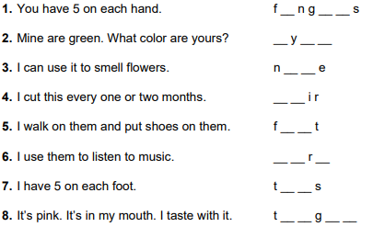

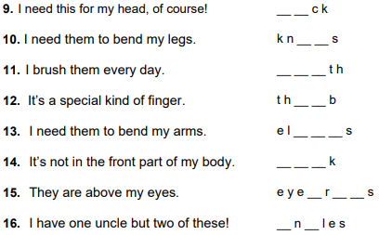

10. Find the correspondence between the word and the correct number.
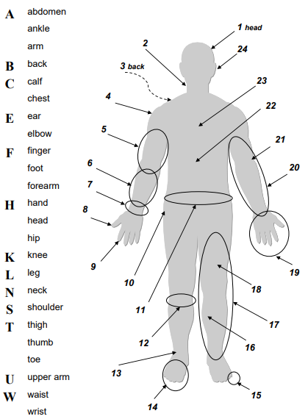

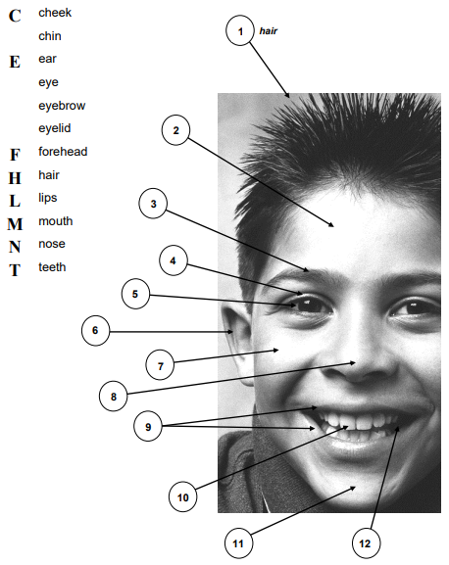

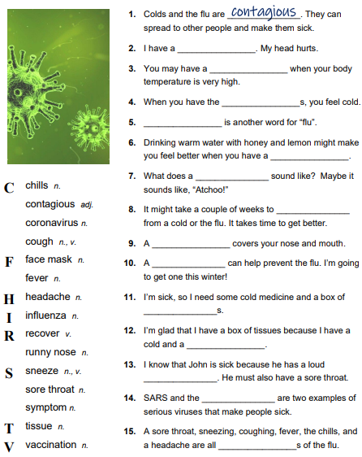
11. Fill the correct words into the sentences.

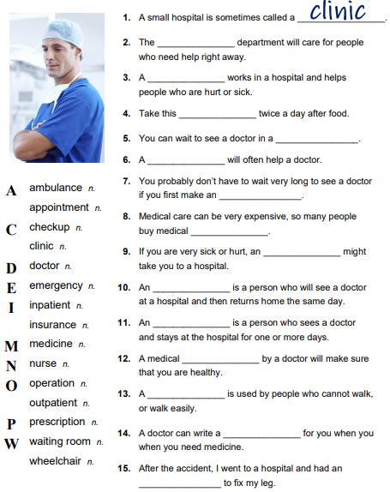

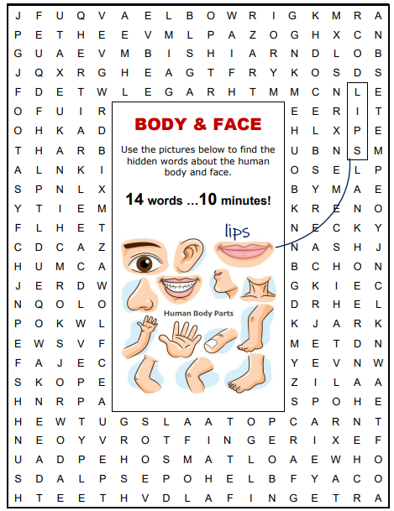
12. Look through the crosswords and find words, connected with medicine.

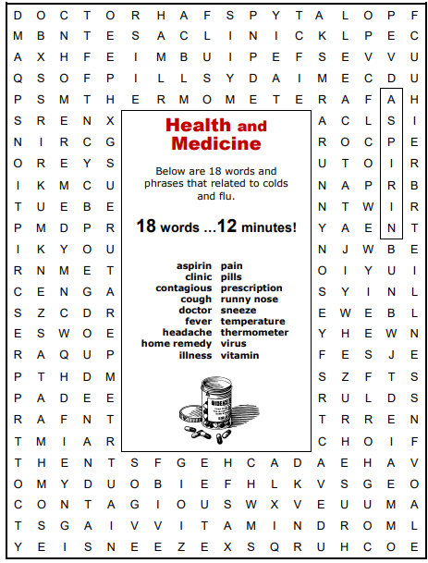

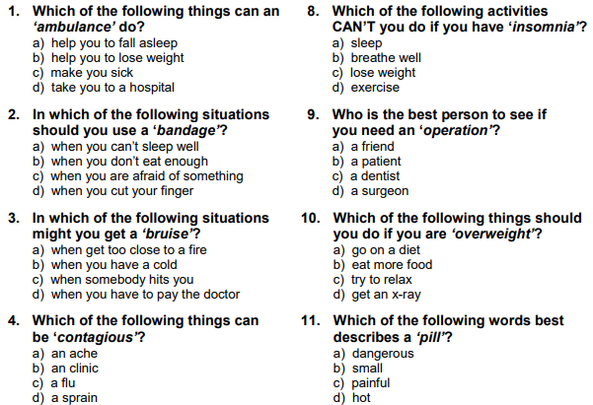
13. Answer the questions.

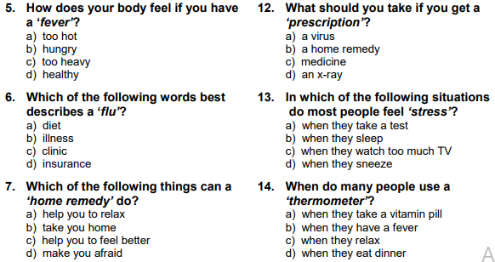

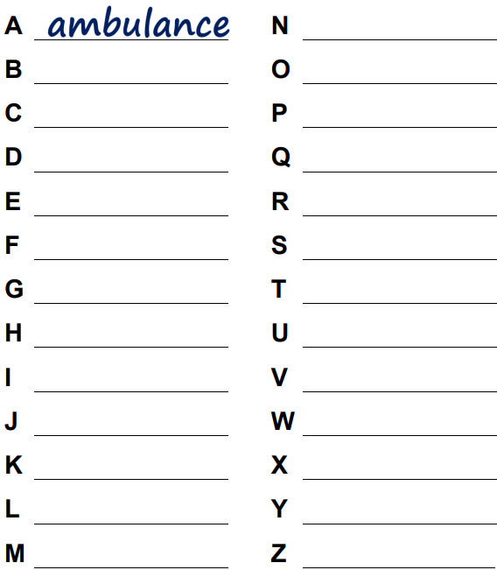
14. Write the word, connected with medicine, to each word of the alphabet.

15. Be ready to answer the questions from the quiz.
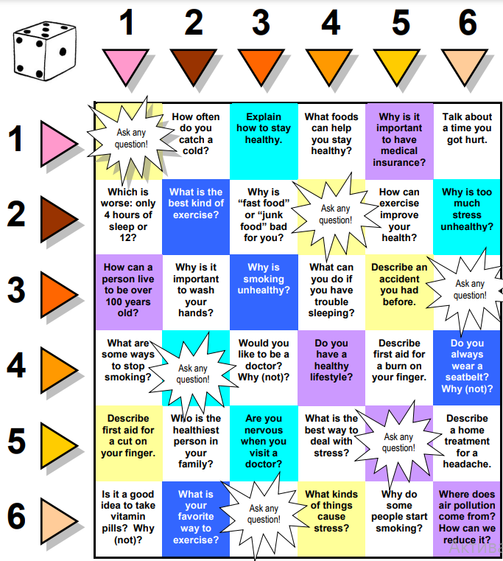

Prefixes in English
Prefix | Meaning / Use | example
anti + adjective / noun  anti + noun / adjective  co + noun / verb  dis + verb  il + adjective  im + adjective  in + adjective  inter + adjective  ir + adjective  mis + verb  over + verb  out + verb  post + noun / verb  pre + noun / verb  pro + noun / adjective  sub + adjective  super + noun / adjective  trans + noun / verb / adjective  un + verb / adjective  under + verb | opposite  against  together  negative / opposite  opposite  opposite  opposite  between  opposite  wrongly/ badly  too much  more  after  before  in favor of  below  greater than  across  negative / opposite  not enough | anti-clockwise;  anti-theft device;  co-worker;  dislike;  illegal;  impossible;  indirect;  intercontinental;  irregular;  mistook; mishandle;  overdo;  outnumber;  postgraduate;  pre-arrangements;  pro-European;  substandard;  superhuman;  transplant  unhappy;  undercook.
There are several rules:
- we use il instead of in with words that begin with l: il + legal = illegal;
- we use im instead of in with words that begin with m or p: im + polite = impolite;
- we use ir instead of in with words that begin with r: ir + responsible = irresponsible;
1. Look through the table and provide your own examples for the usage of each prefix.
2. Add a correct prefix to the following words.
1. __dependent | 6. __driver | 11. __do | 16. __inform | 21. __believe
2. __polite | 7. __approve | 12. __zip | 17. __historic | 22. __crowded
3. __logical | 8. __behave | 13. __ eat | 18. __Atlantic | 23.__understand
4. __behaving | 9. __moral | 14. __hear | 19. __interpret | 24. __regular
5. __national | 10. __sleep | 15.__ real | 20. __relevant | 25. __ natal
3. Add a prefix to form the correct word from the one in brackets.
Attempts to communicate in a foreign language can easily 1) ___ (fire). I’m always 2) ___ (appoint) by my attempts to get speak Greek. The waiter in Mykonos 3) ___ (understand) what I wanted and instead of beetroots brought me mushrooms. I 4) ___ (like) mushrooms intensely but when I asked him to 5) ___(place) them with beetroots he smiled, went into kitchen and 6) ___ (turn) with a plateful of aubergines. He also 7) ___ (take) my friendly attitude towards everyone I meet and when I complained that they had 8) ___ (cook) the meat, Manuel (that was his name if I am mot 9) ____ (take) grinned and twirled his moustache. To cap it all, 10) ___ (read) the bill and accused the poor man of 11) ___ (charge) me! It was my awful Greek again!
2. Grammar. Present Perfect – Present Perfect Continuous
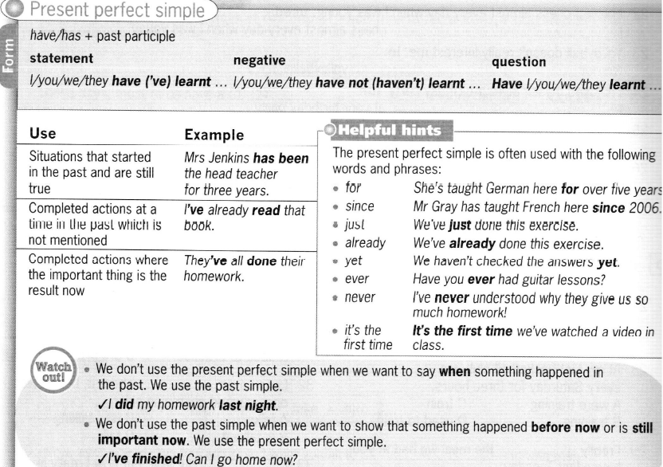

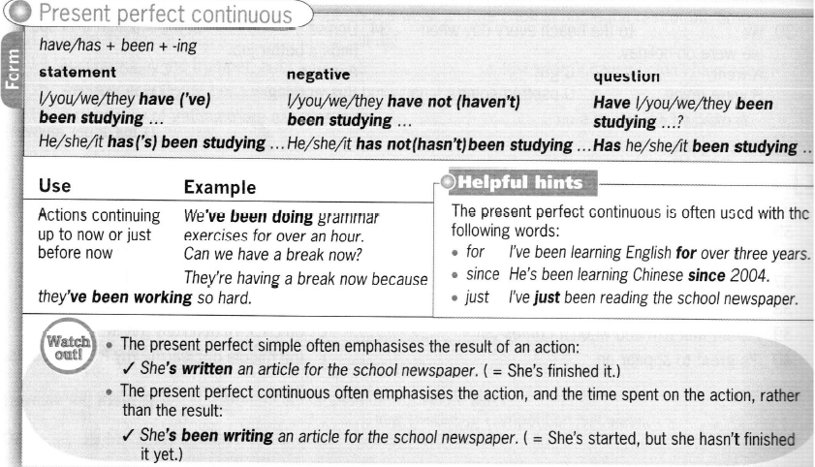

1. Complete the sentences using the correct Present Perfect or Present Perfect Continuous form of the verbs in brackets.
1. I ___ (see) this film already.
2. I ____ (look) for that book for three hours now.
3. John and Julie ____ (had) their car for about a year.
4. They ____ (use) that computer since the first day.
5. She ____ (not / take) her driving test yet.
6. My friend ____ (try) to pass the test for two weeks.
7. Sue ____ (be) a tour guide since she left university.
8. Sue ____ (think) about her career for a long time.
9. ____ (you / ride) into town on your new bike yet?
10. ____ (you / ride) a bike for a long time?
11. This new computer ___ (make) my life a lot easier.
12. All electronic devices ____ (reducing) the amount of job, since they appeared.
13. We ___ (not / decide) what to get Mark for his birthday yet.
14. They ____ (search) for that information for almost a day.
15. ___ (Paul / ever / meet) a famous person?
2. Choose the correct variant.
1. I think I have heard / have been hearing that song before.
2. They haven’t arrived / haven’t been arriving yet, but they should be here soon.
3. You have written / have been writing that e-mail for over an hour. How long is it going to take you?
4. Have you talked / have you been talking on the phone since eight o’clock?
5. Jo has already invited / has been inviting Shirley to dinner.
6. I have read / have been reading an interview with Brad Pit, but I haven’t finished it yet.
7. Have the boys played / have the boys been playing computer games since this morning?
3. Complete the sentences using the words in the box.
already ever for just never since yet
1. I haven’t listened to their new CD ____. Is it any good?
2. We’ve been waiting for you ____ over an hour. Where have you been?
3. Have you ___ been to the UK before?
4. I’m afraid we’ve ___ made plans for this weekend, so we won’t be free.
5. Pedro has been having English lessons ___ he was five years old.
6. It’s strange that you mention this film. I’ve ___ been reading about it in the paper.
7. I’ve ___ heard of a ‘sudoku’. What is it?
Revision of grammar
1. Have you ___ visited Tokyo?
A. ever B. never C. yet D. for
2. I have __ for my sister since morning.
A. been waiting B. waited C. waiting D. been waited
3. She has ___ this picture lately.
A. been painting B. painted C. painting D. been painted
4. My cat has ___ four mice.
A. already caught B. caught already
C. has already been catching
5. We have been friends ___ 10 years.
A. since B. for C. just D. already
6. He has ___ won the lottery.
A. just B. yet C. ever D. since
7. Have you __ it for the last few years?
A. been doing B. done C. doing D. did
8. Has he ___ that letter yet?
A. write B. wrote C. written D. been writing

Unit 2B. Act your age.
1. Lexical exercises.
1. Answer the questions.
1. Do you have a favorite item of clothing? What is it? Why do you like it? When do you wear it?
2. Do you have your favorite color? How many items of clothing do you have in this color?
3. Are certain colors more suitable for men and certain colors more suitable for women?
4. Do you but clothes online? Why or why not?
5. Is fashion a kind of art?
2. What do you know about these fashion styles: mod, hippie, punk, goth? Read the text and compare your ideas. Then complete the text with sentences A – F. There is one sentence that you don’t need.
A. I bought ordinary T-shirts, cut holes in them, fastened them with safety pins then wrote things on them using a marker pen.
B. And although it’s dark, it’s a very pretty look, with lots of lace for the girls.
C. We were the first generation that didn’t need to do that, so we had money to spend on stylish clothes.
D. It was important that the clothes were very comfortable to dance in.
E. That’s what happened before the 1960s brought the age of teenage rebellion and young people started their own innovative and original fashion styles.
F. And it wasn’t just the girls – the boys liked wearing pink and purple flowery designs, too!
Fashion never forgotten
Can you imagine dressing in exactly the same way as your parents? 1) ____. The different ‘looks’ were started by the new rock and pop bands, who often came from the UK. Four British people remember the excitement of being part of these fashion movements, which they still see alive in retro fashion today.
‘In difficult economic times before the 60s, parents expected teenagers with jobs to pay rent, 2) ____ . The mod look wasn’t cheap – the classic outfit was a slim-fitting suit with a shirt and thin tie, and pointy leather shoes. There was a more casual mod look, too. Although it borrowed a lot from Italian and French style, we liked to give it a very British character, with Union Jacks and RAF emblems. It’s a fashion that’ll always be popular with people who like to dress smartly.’ Alan, the mod.
Hippie fashion started in the USA, but in the London of the late 60’s, the designer boutiques of Carnaby Street and the King’s Road made it more chic. It was popular with fans of the Rolling Stones and The Beatles. ‘I sometimes spent a lot on hippie-style clothes – I had a fabulous purple dress that cost a fortune! But for the real hippie look, I bought things in second-hand shops. Long skirts and flared trousers seemed to be everywhere, in all kinds of bright colors. 3) ___ I can see a return to the hippie look in the ‘festival style’ young people wear to music festivals today.’ Carol, the hippie.
Punk fashion became popular with the British punk of the late 1970s, the Sex Pistols being the most famous. Punks were anti-pop music, anti-government, and … anti-everything, even fashion! ‘You might think all punks were angry and aggressive, but a lot of us were just having fun and enjoyed dressing in wars that would shock people. We wanted to have a kind of fashion that was cheap and ‘do-it-yourself’, so we avoided buying things from fashion shops. 4) ____. Piercing became fashionable with punk and the hair was an important part of the look. You still often see people with such haircut today.’ Jack, the punk.
The goth look started with the ‘gothic’ rock bands of the 80s and 90s, which came out of the British punk scene. Much of the style comes from the Victorian period in Britain. ‘It’s easy to say what the most important things about goth fashion is – black! It can be leather trousers, long dresses, boots or gloves but black is the first choice of color. 5) ____. You can find some great goth clothes in vintage chops. I loved goth culture as a teenager – it’s perfect for these times when life seems sad and serious. The goth style seems to be more and more popular these days, especially with all the interest in vampire books and movies.’ Gemma, the goth.
3. Match the words with definitions.
retro  stylish  innovative  original  designer  chic  second-hand  vintage | used by someone before  using a style from the recent past  completely new and different (2 items)  fashionable in a way that looks expensive (2 items)  with a famous name  a high quality example of sth made in the past
4. Complete the sentences with adjectives to describe fashion.
1. New technology could bring some very i____ ideas for future fashion, including clothes that change color!
2. This jacket looks new, but I brought it from a s____ shop in Camden Market.
3. I love v____ clothes, especially Victorian dresses. the quality of clothes in those days was incredibly high.
4. I sometimes buy expensive d___ clothes, but I hate it when the name is printed on them, like an advertisement.
5. Punk was such an o___ fashion movement. I think a lot of fashion since then has just copied it.
6. I like it when people manage to look very s____ without spending a lot of money on their clothes.
5. Read the clues and fill in the missing letters.
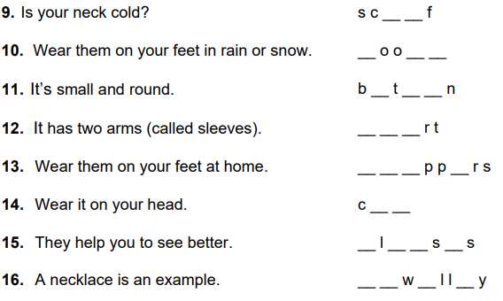
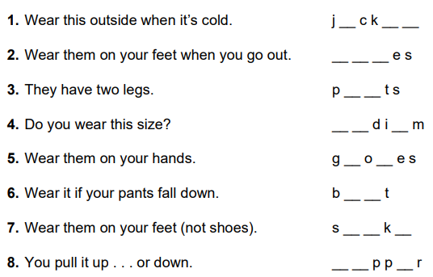

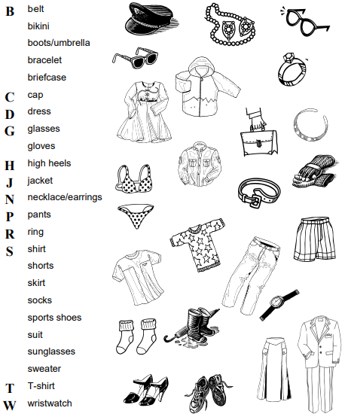
6. Combine the word with the picture.

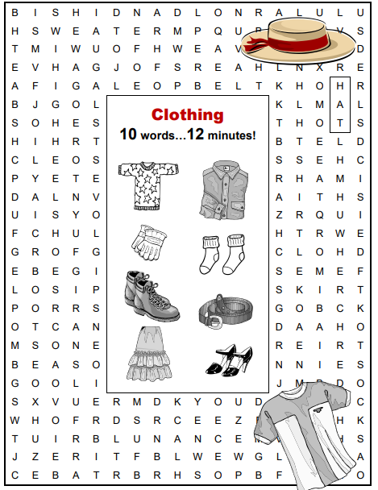

7. Find ten words in the crossword
and write them down.
1. __________
2. __________
3. __________
4. __________
5. __________
6. __________
7. __________
8. __________
9. __________
10. _________

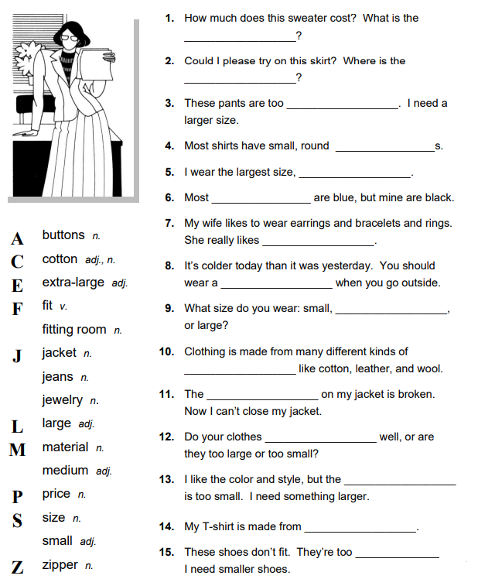
8. Fill the words into the correct sentences.

9. Decide which is the odd words in each group. Explain your choice.
1. necklace / bracelet / chain / belt / ring
2. top / shirt / jacket / skirt / jumper
3. jeans / trousers / earrings / tracksuit bottoms / leggings
4. slippers / trainers / sandals / boots / high heels
5. scarf / gloves / T-shirt / wool hat / thick socks
6. scruffy / trendy / smart / cool / nice
7. colorful / stripy / tight / bright / plain / checked
10. Give the correct answers to the questions.
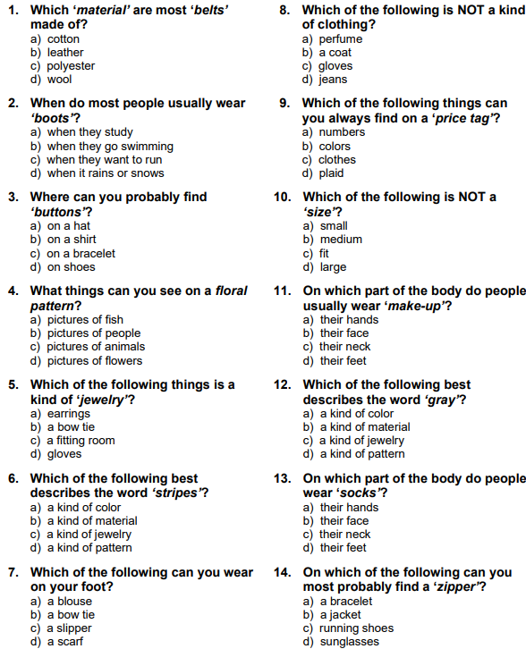

11. Match items of clothing a – f to descriptions of why people might wear them 1 – 6.
a) combat trousers  b) fleece  c) cardigan  d) Bermudas  e) tracksuit bottom  f) hoody | 1. This will keep you warm, but is easy to take off, with buttons down the front.  2. Great for boys to wear on the beach.  3. You can wear these in the gym or around the house when you’re relaxing.  4. On a cold day, this will even keep your ears warm!  5. Perfect for a camping or walking holidays, and all those pockets are useful, too.  6. This jacket can be really light and easy to wear, but incredibly warm.
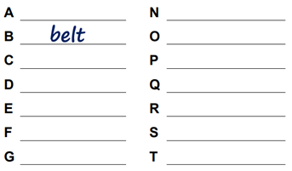
12. Write the word, connected with the topic “Clothing”.
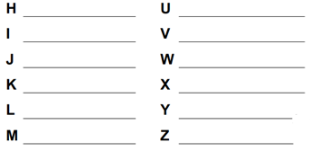

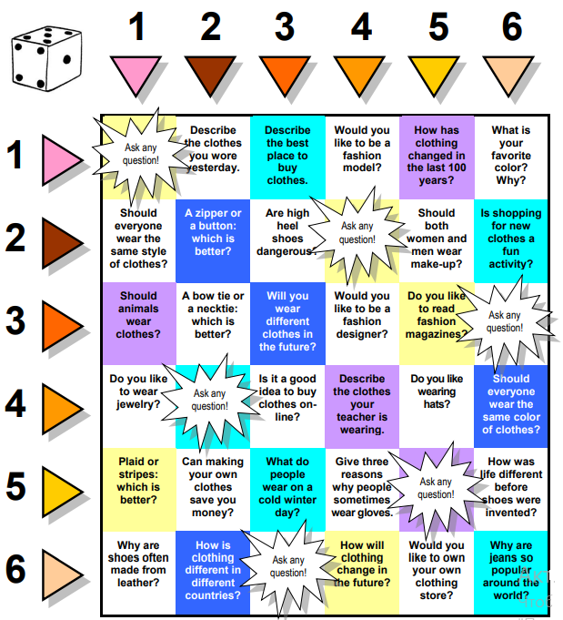
13. Get ready to answer the questions from the chart.

Prefixes (2).
de + verb / noun  de + verb  de + verb  ex + noun  macro- noun  micro + noun  mini + noun  mono + noun  multi + noun / adj.  semi + noun / adj.  semi + adjective  sub + noun  sub + noun | opposite  remove  reduce  previous  large  very small  small  one  many  half  partly  under  less / lower | decentralize;  debone;  devalue;  ex-husband;  macroeconomics;  microelectronics;  mini hi-fi;  monolingual;  multipurpose;  semicircle;  semiliterate;  subterranean;  subcommittee
1. Add a prefix from the list to the words and write the meaning of the new word.
1. final | 6. standard | 11. bus | 16. nationalize
2. partner | 7. national | 12. zero | 17. code
3. section | 8. regulate | 13.plot | 18. chip
4. ethnic | 9. biology | 14.wife | 19. soil
5. skirt | 10. darkness | 15.rail | 20. caffeinated
2. Underline the correct variant to fill the spaces in the sentences.
1. I’m not sure what the doctor wrote – it’s almost _____.
A. inlegible B. illegible C. legible D. illegal
2. If she left me, life would be _____.
A. unbearable B. debearable C. subbearable D. non-bearable
3. If only I hadn’t married so young – I was very ____ at the time.
A. inmature B. immature C. mature D. unmature
4. The examiners remove marks for _____ words, don’t they?
A. unspelt B. semi-spelt C. under-spelt D. misspelt
5. Wear what you like – we’re pretty ____in this office.
A. formal B. informal C. unformal D. deformal
6. Unless you _____ the fish first, your guests won’t enjoy it.
A. semi-bone B. unbone C. pre-bone D. debone
7. I think the Government should _____ the post office.
A. denationalize B. unnationalize C. disnationalize D. innationalize
8. I wish my ___ and I were still on speaking terms.
A. ex-partner B. pre-partner C. non-partner D. departner
9. Use this ____ tool and you’ll do an excellent job.
A. marcopurpose B. monopurpose C. micropurpose D. multipurpose
10. Let’s form a ____ and do something about the poor state of the common.
A. subcommittee B. anti-committee C. multi-committee D. undercommittee
3. Use the word in brackets in the correct form.
A breath of fresh air
The Government has decided to take the 1) _____ (popular) decision to ban smoking in a lot of public places. Though a lot of people find smoking 2) ____ (please), and though experts all agree it is 3) ______ (health) and that is costs the state a lot to treat victims of smoking, it is also 4) _____ (deny) that many people get pleasure from the habit and find smoking 5) _____ (resist) when they are in company. However, it is now 6) _____ (possible) to deny the antisocial nature of the habit. As advertising has proved 7) _____ (possible) with many smokers, the Government has now made smoking 8) _____ (legal) in most public places.
Smokers who are 9) _____ (ability) to stop smoking will be obliged to enjoy their pastime in private and may feel the new measures are 10) _____ (justice), but for passive smokers for whom a room full of smoke is 11) _____ (bear) they will come as a breath of fresh air.
2. Grammar. Order of adjectives
The order of adjectives in English is strict and should be remembered.
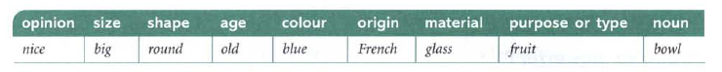

- Variation is possible when we focus on a particular feature, for example we can say: a round black shape (= normal order) or a black round shape (= focus on color).
1. Put the adjectives in the correct order. There are sentences with the correct order.
1. a young French man ___________
2. a dark tall man ________________
3. a wooden big spoon ____________
4. a birthday big delicious cake _____
5. a frying large old pan __________
6. a pair of black leather riding boots

7. a round large ball _____________
8. an old big brick factory ________
9. an old wooden ugly desk _______
10. a long wooden spoon __________
11. a big fat Italian opera singer ____
12. a pink silk beautiful blouse _____

Using adjectives as nouns
Here are some examples of plural adjectival nouns with their definitions.
The | blind  deaf  destitute  dead  dying  elderly  faithful  homeless  injured | people who | cannot see  cannot hear  have no money  are no long alive  are about to die  are old  religious  have no home  have been injured | The | insane  jobless  old  poor  rich  sick  wealthy  wicked  young | people who | are mentally ill  are unemployed  are no longer young  have little money  have a lot of money  are ill  are rich  are morally bad  are not old
1. Transform the following sentences using adjectives as nouns.
Example: Old people and young people need to come together on the issue of public transportation. – The old and the young need to come together on the issue of public transportation.
1. Educated people are running the country.
2. Rich people have a lot of advantages over poor people.
3. Old people are encouraged to get the flu shot.
4. Homeless men, women, and children are advised to find shelter in churches or public shelters for the next few nights.
5. Unemployed people should move to find work.
6. Living people must respect the wished of dead people.
Revision of grammar
Put the words in the sentence in the correct order to create a sentence.
1. cheaper / the / students / unemployed. / tickets / are / The / for / and.
2. the / linen / I’ve / bought / a / smart / suit / wedding. / for / new.
5. have / should / other / bought / the / ones. / You
6. more / the / for / provide / opportunities / The / should / young. council
7. long / Maya’s / dress. / a black / wearing
______________________________
3. Italians / stylish / famous / The / for / clothes. / are / wearing
4. white / sofa. large / a / It’s / leather
8. lovely / river. / boat / wooden / a /
old / has / on / the / He

Unit 3A. Fasten your seatbelt.
1. Lexical exercises.
1. Answer the questions.
1. Do you like travelling? Why? Why not?
2. What is the best place for vacation for you? Why?
3. How long should the vacation be? How long does it take you to really relax?
4. What forms of transportation do you prefer to use when you travel?
5. What is more important to you when you travel – comfort, relaxation or stimulating new experiences?
2. Look at the list of the benefits of travelling. Place them in order of importance beginning with the most important.
- enables you to get first-hand experience of new places;
- broadens your mind;
- gives you the opportunity to try out foreign cuisine;
- helps you get away from your daily routine
3. Read the texts A, B, C and answer the questions 1 – 6.
A. Racing Against Time. When it grew dark, there seemed to be some excitement amongst the passengers and they kept speaking to him, one after the other, as though urging him to further speed. He lashed the horses unmercifully with his long whip, and with wild cries of encouragement urged them on to further exertions. Then through the darkness I could see a sort of patch of grey light ahead of us, as though there were a cleft in the hills. Then excitement of the passengers grew greater; the crazy coach ricked on its great leather springs, and swayed like a boat tossed on a stormy sea. I had to hold on. The road grew more level, and we appeared to fly along. Then the mountains seemed to come nearer to us on each side and to frown down upon us; we were entering the Borgo Pass. One by one several of the passengers offered me gifts, which they pressed upon me with an earnestness which would take no denial; these were certainly of an odd varied kind, but each was given in simple good faith, with a kindly word and a blessing, and that strange mixture of fear-meaning movements which I had seen outside the hotel at Bistritz – the guard against the evil eye. Then, as we flew along, the driver leaned forward, and on each side the passengers, craning over the edge of the coach, peered eagerly into the darkness. It was evident that something very exciting was either happening or expected, but though I asked each passenger, no one would give me the slightest explanation.
1. Why does the narrator compare the coach to a boat being tossed on a stormy sea?
a) the coach was going at an incredible speed like a boat in the sea;
b) it was very windy;
c) the coach was rocking from side to side as if it was being tossed about by a rough sea;
d) the coach was going slowly like a boat drifting in the sea.
2. At the end of the passage the narrator
a) find out what all the excitement is about;
b) is still confused as to why there is so much excitement;
c) is told by one of the passengers what is going on;
d) leans over the edge of the coach to find out what is happening.
B. Visit Thailand. Just beyond the places and vibrant streets of Thailand’s capital, Bangkok, lie the lively floating markets at Damnoen Saduak and Lam Phaya, spectacular ruined cities at Ayutthaya and Kanchanaburi, an emotive setting for the infamous bridge on the River Kwai. Eith its colourful hill tirbes, ancient cities, Buddhist shrines and a rich cultural heritage, northern Thailand is a spectacular mix of sights and sounds, from the ancient capital of Sukhothai, to the rich diversity of Chiang Mai and the Golden Traingle. Bangkok’s bustling streets can boast some of the most luxurious hotels in Asia, with a rich variety of premier prosperities available in the heart of the Thai capital. For those looking for sumptuous elegance and exceptional service this city offers a wealth of options, from the opulence of world-class hotels, to the traditional and unique converted rice barges on the Chao Phraya River. Northern Thailand’s unique natural and cultural diversity is superbly highlighted amongst its exceptional range of idyllic properties and resorts. Contemporary Asian style, traditional temple designs, serene natural resorts and luxurious tented camps offer a quite dazzling variety of destinations that incorporate the finest elements of Lanna-style architecture, colonial grandeur and exclusive tranquility, all backed up by world-class service and outstanding modern amenities. Lapped by the clear turquoise waters of the Andaman Sea and the Gulf of Thailand, these spectacular beaches are amongst the finest in the world: idyllic havens of white sands, breathtaking coral and lush tropical views, that are served by some of the most elegant and enchanting resorts in Asia. from heavenly indulgence to tranquil charm, there is something here to appeal to everyone.
3. What is the purpose of the text?

a) to provide factual information;
b) to educate the reader;
c) to inform the reader and attract his/
her attention;
d) to give a personal account of a holiday destination.

4. Which word best describes the architectural style prevalent in Northern Thailand?

a) colonial;
b) conventional;
c) diverse;
d) traditional.

C. Leaving Earth. Humanity cannot remain in its Earthly cradle forever. Earth is full to the brim and it’s creaking. We’re facing climate change and we’re running out of essential resources such as oil, coal and fresh water, to name just two urgent issues. Perhaps we could learn to live within our means on the planet. But we would have to sacrifice not just population growth, but economic expansion too, which, let’s face it, is highly unlikely to happen. It is our inability to compromise on issues such as this that will lead to our ultimate migration to the stars.
Earth is just one world in a sky full of worlds. There is water on Mars, minerals waiting to be mined from the asteroids, and whole moons made of ice further out. And we’re even beginning to detect planets that may be similar to the Earth orbiting other starts.
Our first steps off Earth may be taken in search of resources off the planet to sustain our civilization back home. But once we get started, it’s unlikely we would stop there.
A Galactic empire has been a dream of science fiction from the days of Isaac Asimov’s Foundation series in the 1950s. But even travelling at lightspeed, it would take years or centuries to reach the nearer starts, and a hundred thousand years to reach the far side of our galaxy. And that’s almost as long as humanity has existed.
What effect will these immense scales in space and time have on our future history? If we leave Earth, will we conquer the Galaxy – or will the Galaxy conquer us?
5. What will be the initial purpose of our departure from Earth?

a) the search for resources in space;
b) the building of civilizations;
c) the transportation of resources to
space ports;
d) the detection of planets similar to Earth.

6. According to the text, a Galactic empire will

a) most probably be built sometime in the immediate future;
b) never be built;
c) take an inconceivable amount of
time to build;
d) be built as soon as we reach the nearest star.

4. Study the words.
an excitement n | the action of exciting; the state of being excited | an exertion n | the act or an instance of exerting
to conquer v | to gain or acquire by force if arms | to lash v | to thrash or beat violently
unmercifully adj | not merciful | an opulence n | wealth
sumptuous adj | extremely costly, rich, luxurious, or magnificent | a prosperity n | the condition of being successful or thriving
a cleft n | a hollow between ridges | to toss v | to fling or lift with a sudden motion
to sway v | to swing slowly and rhythmically back and forth | dazzling adj | brilliantly or showily bright, colorful
to whip v | to take, pull, snatch, jerk, or otherwise move very quickly and forcefully | a property n | a quality or trait belonging and especially peculiar to an individual or thing
earnestness adj | characterized by or proceeding from an intense and serious state of mind | serene adj | marked by or suggestive of utter calm and unruffled repose.
a denial n | refusal to satisfy a request or desire | odd adj | not regular, expected, or planned
to urge v | to present, advocate, or demand earnestly or pressingly | amenities n | sth that helps to provide comfort, convenience
a blessing n | the act or words of one that blesses | to crane v | to raise or lift by or as if by a crane
a tranquility n | the quality or state of being free from agitation of mind or spirit | immense adj | marked by greateness especially in size or degree
to cradle v | to place or keep in or as in a cradle | a turquoise n | a light greenish blue
spectacular adj | relating to, or being a spectacle | to sustain v | to give support or relief to
emotive adj | appealing to or expressing emotion | to orbit v | to revolve in an orbit around
infamous adj | having a reputation of the worst kind | tranquil adj | free from agitation of mind or spirit
a shrine n | a place in which devotion is paid to a saint or deity | to be full to the brim idiom | completely full
a heritage n | property that descends to an heir | a diversity n | the condition of having or being composed of differing elements
to be running out of phr | to come to an end | to peer v | to look narrowly or curiously
5. Match the words from the text with their meanings. There are two extra meanings which you do not need to use.
1. lashed  2. swayed  3. craning  4. sumptuous | a) luxurious  b) birthplace  c) rode  d) wealth  e) enormous | 5. opulence  6. cradle  7. orbiting  8. immense | f) moved from one side to the other  g) moving around  h) hit violently  i) learning  j) population
6. Read the clues and fill in the missing words.
1. You can sit down in an airplane here. | s_ _t | 8. You can find taxis here | t_ x_ st_nd
2. This person flies an airplane. | p_l_ _ | 9. This is the cheapest kind of airplane ticket. | e_ _ _ omy
3. A plane does this when it begins to fly. | t_k_ o_f | 10. When the plane is not on time | _ _lay_d
4. Another word for ‘baggage’ | _ _gg_ _e | 11. He or she can help you carry baggage. | p_rt_r
5. This person travels by air. | p_s _ _ng_r | 12. The place between rows of seats is the … | _ _sle
6. Another way to say ‘get on’ a plane | b_ _r_ | 13. When you leave an airport, you … | d_p_ _ _
7. This is the door to leave the plane | _x_t | 14. Put you food on this. | _r_y
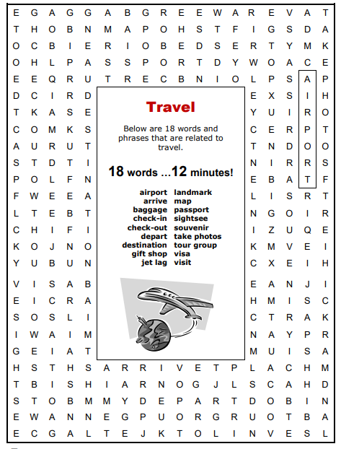
7. Find as many words as you can.
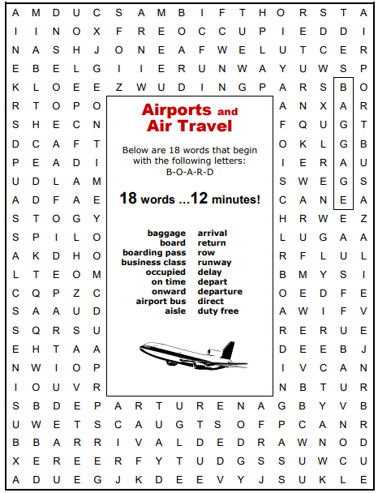

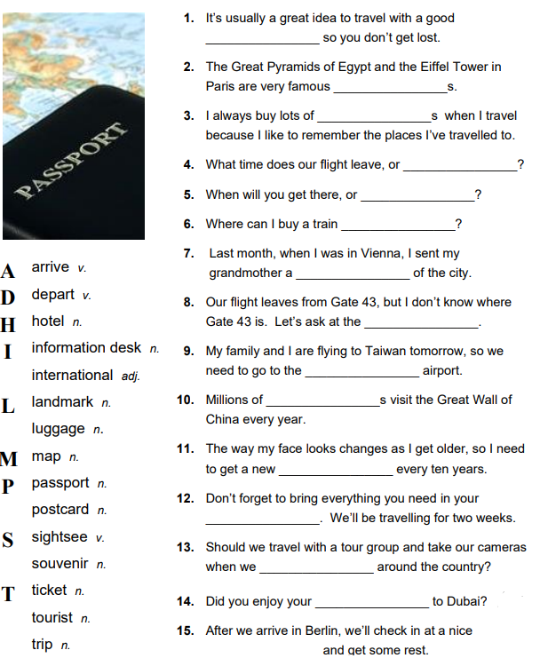
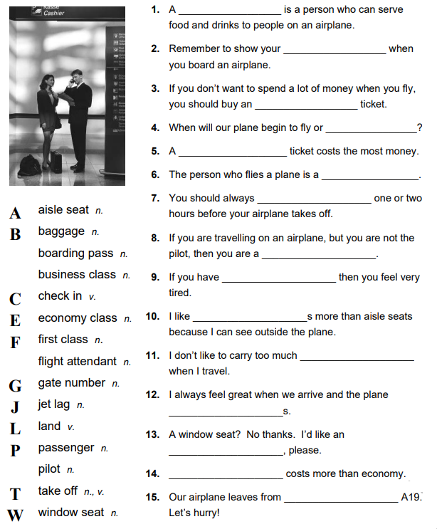
8. Fill the correct words into the sentences.

9. Complete the paragraph with the verbs in the correct Past Tense.
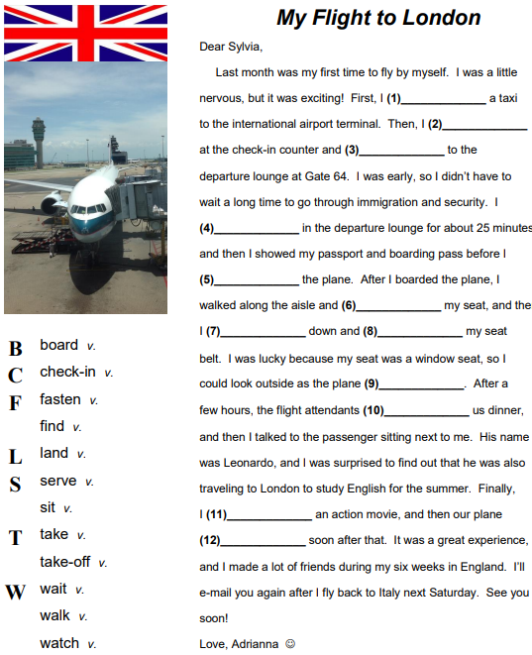

10. Look at the phrasal verbs connected with the topic ‘Travelling’. Choose the correct variant.
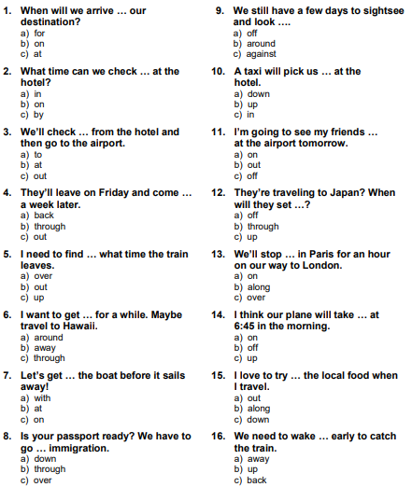

11. Give the correct answers to the questions.
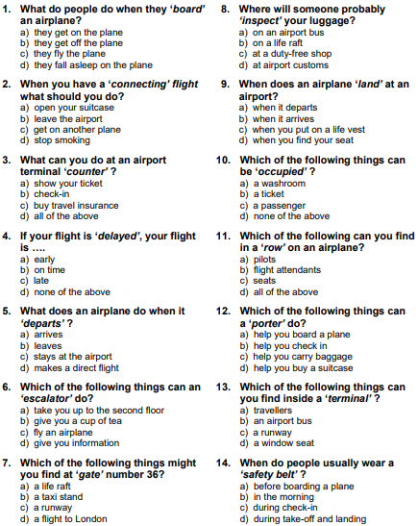
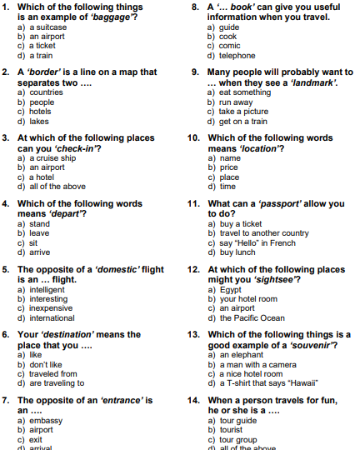

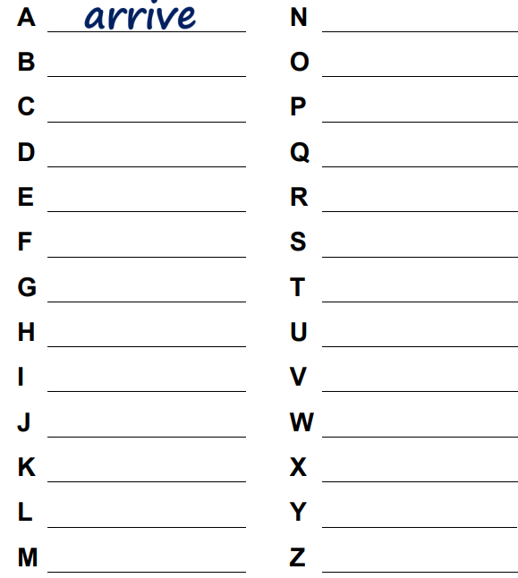
12. Write the word to each letter of the alphabet connected with travelling.

13. Be ready to answer the questions from the chart.
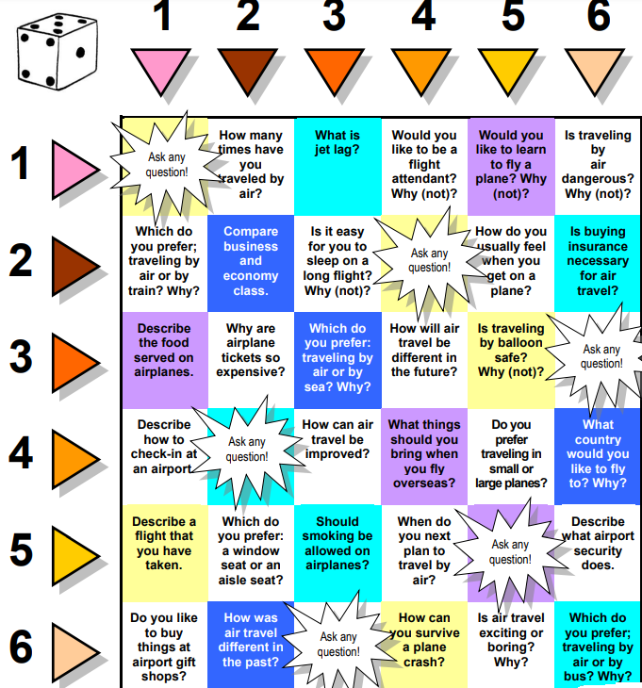

So and such
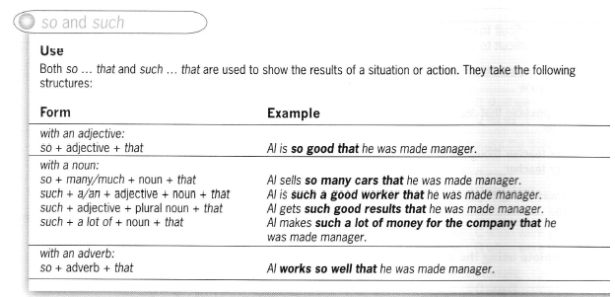

1. Complete using so or such.
1. The pan was ___ hot that I nearly dropped it!
2. Mr Jones was ___ a kind man that I was sad he moved to another town.
3. We have ___ many pets that sometimes it’s really noisy!
4. Alicia is ___ good at basketball that I think she could be a professional.
5. There was ___ a lot of smoke that I couldn’t see.
6. Tyron ran ___ fast that no one had a chance in the race.
7. Cherie is ___ popular that everyone wants to be friends with her.
8. Would you like to have ___ long hair that you can sit on it?
2. Tick the correct phrases and correct the ones with mistakes.
1. Paris Hilton is such famous that she gets recognized wherever she goes.
2. There we so many customers in the shop that I couldn’t move!
3. The man spoke such quickly that I couldn’t understand a word he said.
4. I had so good marks that my dad bought me a new computer!
5. Victoria is so old that she can remember seeing a car for the first time.
6. I’ve got so a lot of friends that I don’t have time to see them all.
7. There was so a long queue that we decided to go home.
8. Big Brother was such a successful that they’re making another series.
3. Rewrite each sentence using so … that.
1. John can see over the wall because he is tall. ____________________________
2. I’m sure my sister will go to university because she is clever. _______________
3. I can’t stop playing this computer game because it’s good. _________________
4. Tim can’t come out because he has a lot of work to do. ____________________
5. It’s hot, which means I can’t sleep. ____________________________________
6. Tina arrived late, which meant she missed the train. _______________________
7. We don’t have any money for luxuries because we have a lot of bills to pay. ___
8. It takes a day to get to Australia because it’s very far away. ________________
2. Grammar. Narrative tenses: Past Simple, Past Continuous, Past Perfect, and Past Perfect Continuous
1. Read the sentences and correct the mistakes. Some sentences are correct.
1. I had been learning English for six years before I decided to study in the UK.
2. My parents had first met at the age of sixteen, got engaged five years later and finally got married when they were 28 years old.
3. The boys were watching TV in their room when they heard a loud scream coming from downstairs.
4. When Sheila was younger, she was going for long walks in the countryside.
5. I hadn’t realized it was Michael until he had taken off his mask.
6. It was a sunny day and all the members of the family were being in the park. Eric was sitting under a tree reading a novel.
7. We checked in, went through passport control and rushed to our departure gate. Unfortunately, boarding finished two minutes before.
2. Complete the blanks with the Past Simple, Past Continuous, Past Perfect and Past Perfect Continuous of the verbs in brackets.
Last year, I 1) ____ (go) on an exciting safari holiday in Namibia with my husband. I remember it 2) _____ (rain) continuously for several days in Brussels before we 3) _____ (leave), so I couldn’t wait to board the plane which 4) ______ (head) for sunnier climates. Our safari holiday 5) _____ (be) unique in that, unlike many other holidays, the aim was not just to show a bunch of tourists some wild animals; while on holiday we would be volunteering a conservation centre. On our first night in the bush, while the biologists 6) _____ (entertain) everyone with tales, I 7) _____ (sit) back and 8) _____ (gaze) at the patterns made by starts. At one stage, I 9) _____ (get) up to stretch when all of a sudden I 10) _____ (see) a huge creature nestled on my husband’s shoulder I 11) _____ (let) out an embarrassing squeak of fear. Apparently, it was just a stick insect. Not like any stick insect I 12) _____ (ever / see); it was as big as my forearm! The next day we 13) ____ (set) off early; our task was to make a note of any wildlife we saw. While we 14) _____ (walk) through the thick forest, we 15) _____ (hear) birds and monkeys chattering in the trees. It was at once thrilling and calming to be so close to nature. However, after three hours, the novelty 16) _____ (wear) off, and I was exhausted. And then I 17) _____ (see) it. A deer 18) _____ (stand) under a tree just a few meters away from me; I proudly 19) _____ (make) a note on my pad. The next day, while we 20) _____ (travel) to a nearby village, we 21) _____ (spot) a herd of elephants crossing a road. All too quickly our two weeks in Namibia 22) _____ (draw) to a close and we 23)____ (find) ourselves back at home. Although we were a little sad, we both felt a tremendous sense of satisfaction as we 24) _____ (not only / visit) a beautiful part of the world, but we 25) ____ (also / make) our own small positive contribution.
3. Complete the blanks with the Past Simple, Past Continuous, Past Perfect and Past Perfect Continuous of the verbs in brackets.
Holiday Nightmare
Last year my husband, Jason, and I 1) _____ (decide) to go on a holiday somewhere different that time. We 2) ____ (spend) our holiday in France for the last 5 years, so we definitely 3) ____ (need) a change. I 4) _____ (think) how nice it would be to visit an exotic place and spend lots of time on the beach, next to the clear blue sea. In previous years, Jason 5) ____ (always / make) all the travel arrangements, but last year I 6) _____ (insist) on going to a travel agent. We 7) _____ (never / use) the services of a travel agency before, but I 8) _____ (think) that it would be much easier since we wouldn’t have to go to the trouble of making any arrangements ourselves. In fact, I was the one who 9) _____ choose) both the travel agency and the holiday destination. You see the offer 10) ______ (be) a really tempting - $600 for the two of us! I couldn’t believe my ears! 11) I _____ (know) that everything would be perfect.
However, events 12) _____ (prove) me wrong! The exotic holiday destination they 13) _____ (promise) us 14) _____ (be) a desert island somewhere in the ocean with almost no vegetation, high temperatures and lots of insects! The luxurious hotel accommodation 15) _____ (turn) out to be a small and hideous dirty room and the swimming pool 16) ____ (remind) me more of a swamp than a pool! I 17) ____ (never / see) anything so appalling before! Our holidays were ruined.
The strangest thing of all? We 18) _____ (meet) a couple there who were thrilled with the place! ‘We 19) _____ (never / have) the chance to visit such a beautiful island before! It’s amazing!’ the man said.
‘That’s it! I think I 20) _____ (have) enough!’ I told Jason. ‘Pack your bags and we are out of here! This place will definitely drive us crazy!’ The next thing I remember is having a hot shower back in our house in Norwich and sleeping like a log for the next two days!
Revision of grammar
Read the text and choose the correct answer.
It was the first time I 1) ___ to travel abroad and I 2) ____ so fascinated with that idea that I 3) ____ to pack my suitcase days in advance! I 4) ____ everything to be perfect! I also 5) _____ home five hours before the flight because I 6) ____ to be late in any case. As soon as I 7) ____ at the airport, I 8) ______ to the check-in desk to avoid any queues and have some time for duty-free shopping. The flight 9) ____ perfect and there 10) ____ no delays at all compared to other airline companies. After passport control, I 11) ____ the luggage carousel in front of me full of bags and suitcases. ‘It must be somewhere there’, I imagined. I 12) ____ to trace it for quite a long time when I finally 13) _____ !
I 14) _____ to the lost property office where I 15) _____ could get an answer to my problem. In fact, the only thing I 16) ____ was ‘I’m really sorry Sir but we have no information about the whereabouts of your luggage yet. You will have to wait for some time till we trace it.’ Fire hours later, they 17) ____ me that my luggage was traced at another airport but they would be unable to deliver it to me before the next day. Having spent so many hours trying to claim my suitcase, I could do nothing else but to leave without it. The bright side of the story is that by the end of the next day they 18) _____ my suitcase to me at last! I will definitely not travel with that company again!
1. | a) went | b) was going | c) had gone
2. | a) had been | b) was being | c) was
3. | a) had been beginning | b) had begun | c) was beginning
4. | a) had been wanting | b) wanted | c) had wanted
5. | a) left | b) had left | c) would leave
6. | a) hadn’t wanted | b) wouldn’t want | c) didn’t want
7. | a) was arriving | b) arrived | c) had arrived
8. | a) had rushed | b) was rushing | c) rushed
9. | a) used to be | b) had been | c) was
10. | a) had been | b) used to be | c) were going to be
11. | a) would see | b) had seen | c) saw
12. | a) had tried | b) had been trying | c) tried
13. | a) gave up | b) would give up | c) had given up
14. | a) was heading | b) had been heading | c) headed
15. | a) thought | b) was thinking | c) had thought
16. | a) had gotten | b) got | c) was getting
17. | a) had informed | b) used to inform | c) informed
18. | a) had been delivering | b) had delivered | c) used to deliver

Unit 3B. A really good ending?
1. Lexical exercises.
1. Answer the questions.
1. Do you like reading? What’s your favorite book and author?
2. Are you a fast reader or a slow reader?
3. What is the best place to read?
4. Historically, some books have been banned or burned. Can a book be dangerous to society?
5. What does “don’t judge a book by its cover” mean? Do you agree with this idea?
2. Look at the list of words and their definitions. Complete the sentences with them.
awful | extremely disagreeable or objectionable | disturbing | causing feelings of worry, concern, or anxiety
catchy | easily retained in the memory | weird | of strange or extraordinary character
commercial | viewed with regard to profit | gripping | taking a powerful hold upon one’s interest or feelings
hilarious | extremely funny | uplifting | elevating
over-the-top | extremely outrageous | dull | uninteresting
1. It does nothing for me. It’s quite boring, quite _____.
2. It’s one of those tunes that’s very easy to remember – very _____.
3. It’s ____ - just really, really funny.
4. I can’t explain it. It’s really strange – really _____.
5. It didn’t do much for me. It’s typical big-budget Hollywood – very _____.
6. It’s just too much for my liking – really _____.
7. You can’t stop reading. It’s so exciting, so _____ !
8. It’s good, but it’s quite upsetting – quite ____.
9. It’s really inspiring story, really _____.
10. Don’t go and see it! It’s dreadful, absolutely _____.
3. What were your favorite stories as a child? What do you know about the stories, which were adopted by brothers Grimm? Read the article to find out.
Once upon a time …
Once upon a time there lived in Germany two brothers who loved a good story – one with magic and danger, royalty and villains. At school they met a wise man who led them to a treasure – a library of old books with tales more enchanting than any they had ever heard. Inspired, the brothers began collecting their own stories, listening to the folktales people told them. Soon they produced their own treasure – a book of fairy tales that would charm millions in faraway lands for generations to come.
The brothers Grimm, Jacob and Wilhelm, named their collection Children’s and Household Tales and published it in Germany in 1812. The collection has been translated into more than 160 languages, from Inupiat in the Arctic to Swahili in Africa. As a world publishing phenomenon it competes with the Bible. The stories and their characters continue to feature in virtually every media: theatre, opera, comic books, movies, paintings, rock music, advertising, fashion. The Japanese have built two theme parks devoted to the tales. In the United States the Grimms’ collection helped launch Disney as a media giant.
Such fame would have shocked the humble Grimms. During their lifetimes the collection sold few copies in Germany. They early editions were not even aimed at children. They had no illustrations, and scholarly footnotes took up almost as much space as the tales themselves. Jacob and Wilhelm Grimm viewed themselves as patriotic students of folklore. They began their work at a time when Germany had been occupied by the French under Napoleon. The new rulers suppressed local culture. As young scholars, the brothers Grimm began work on the fairy tale collection in order to save the endangered oral storytelling tradition of Germany.
Long before the Grimms’ time, storytelling thrived in inns, barns and the homes of peasant women. During winter nights, as they sat spinning wool, women kept each other company and entertained themselves with tales of adventure, romance and magic. Altogether, 40 such storytellers delivered tales to the Grimms, many of them coming to their house in Kassel. One of them, ‘Marie’, was credited with narrating many of the most famous tales: Little Red Riding Hood, Snow white and Sleeping beauty. But these were not from the German oral tradition. Marie had had French nannies who retold stories to her that they themselves had read in a collection written by Charles Perrault in 1697, Tales of My mother Goose.
Although the brothers implied that they were just keeping records of tales, Wilhelm continued to polish and reshape the stories up to the final edition of 1857. In an effort to make them more acceptable to children and their parents, he stressed the moral of each tale, and emphasized gender roles. According to the Grimms, the collection served as ‘a manual of manners’. To this day, parents read them to their children because they approve of the lessons in the stories: keep your promises, don’t talk to strangers, work hard, and obey your parents.
Yet despite all Wilhelm’s additions, the core of these stories was left untouched, in all their medieval coarseness. The cruel treatment of children (the children Hansel and Gretel are put in a cage by a witch and then fattened ready for eating), the violent punishments handed out to the stories’ villains (in the original Snow White the evil stepmother is forced to dance in the red-hot iron shoes until she falls down dead), are too much for some parents.
So what accounts for their popularity? Some have suggested it is because the characters are always striving for happiness. But the truth probably lies in their origin. Grimms tales were born out of a storytelling tradition without boundaries of age or culture. The brothers’ skill was to translate these into a universal style of writing that seems to mirror whatever moods or interests we bring to our reading of them. And so it was that the Grimms’ fairy tales lived happily ever after.
4. Study the words from the text.
to launch v | to give a start | endangered | to be life-threatened
faraway adj | lying at a great distance | to imply v | to express indirectly
to be devoted to phr verb | to decide that sth will be use for a special purpose | acceptable adj | capable or worthy of being accepted
enchanting adj | powerfully pleasing, appealing, or delightful | to approve of v | to have or express a favorable opinion
humble adj | not arrogant or assertive | striving adj | struggling to something
5. Look back at the article and find significant (or surprising) facts about the following:
- the popularity of the Grimms’ fairy tales now;
- the popularity of the Grimms’ fairy tales at the time;
- Germany at the time of brothers were writing;
- the stories of Little Red Riding Hood and Snow White;
- the attitude of parents to the stories.
6. Find the words in the cross word.
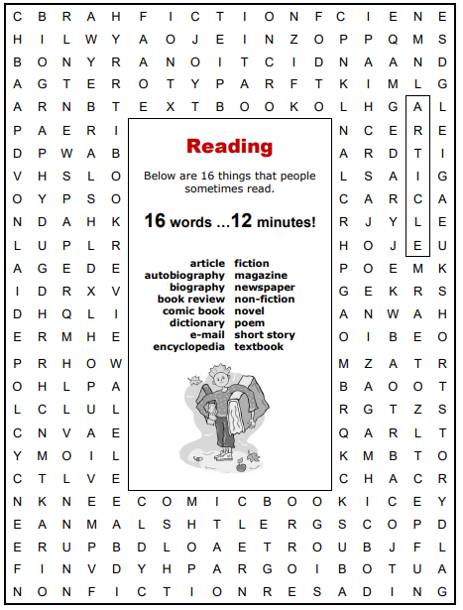

7. Answer the questions.
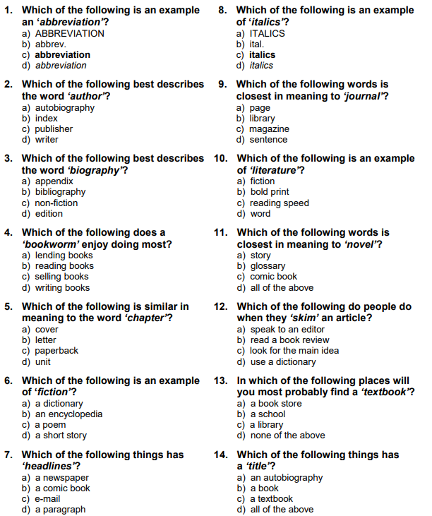

8. Be ready to answer the questions from the chart.
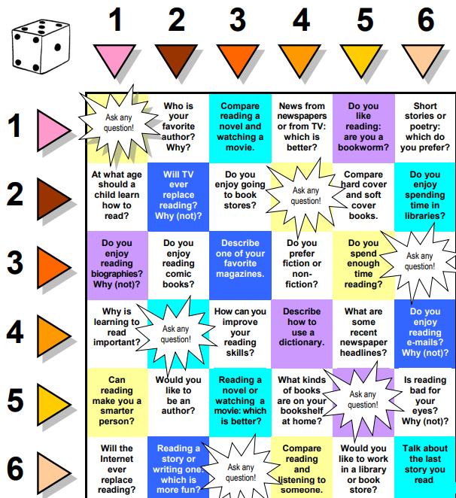

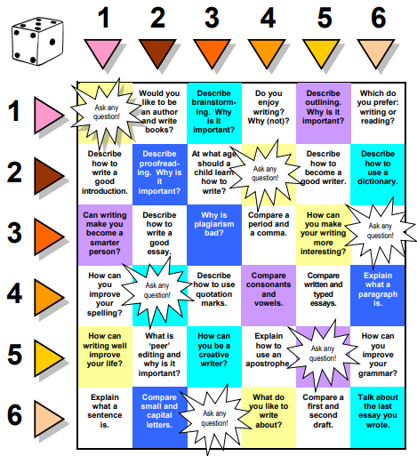

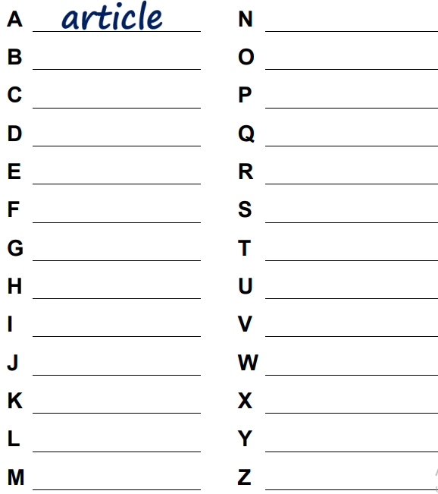
9. Write the word, connected with the topic “Reading” to each letter of the alphabet.

Word formation: adverb + adjective
1. Complete the sentences with these adverbs + adjective phrases.
cleverly designed economically disadvantaged ethnically mixed highly cultured ill prepared long-term unemployed politically correct upwardly mobile
1. It is very difficult for _____ people to get back into work, because they lose confidence.
2. These days you have to be ____ in your use of languages so that you don’t discriminate between people of different sex and race.
3. Nowadays, we say someone is _____ instead of ‘poor’.
4. They are an _____ family: her father was a miner; her daughter is now a top criminal lawyer.
5. I was _____ for the meeting. Everyone else had read all the background information.
6. London is a very ____ city. You can find people from most parts of the world living there.
7. It’s a ____ society in which it is common for ordinary people to visit museums and go to the theatre.
8. The houses, although small, are _____ with a lot of space inside.
2. Grammar. Confusing adjectives
In English there are adjectives, which meaning can be confusing:
Ashamed – shameful – shy – embarrassed
- ashamed means ‘guilty and disgusted with yourself because of something bad that you have done’: People who steal from the poor should be ashamed of themselves.
- shameful describes behavior which people thinks should make you feel ashamed: The cruel way some people treat their pets is shameful.
- shy means ‘anxious about talking to people, especially people you don’t know’: Jimmy is very shy with adults but he’s fine with other children.
- embarrassed means ‘feeling socially uncomfortable and nervous’: You can imagine how embarrassed I felt when I couldn’t pay the bill.
Anxious – nervous – worried – bad-tempered
- anxious means ‘very worried because you fear something bad may happen or may have happened’: Their daughter hadn’t come home from school and they were anxious about her safety.
- nervous means ‘worried because you are in, or about to enter, a stressful situation’: I was so nervous about the exam that I couldn’t sleep.
- worried means ‘unhappy because you have, or expect to have a problem’: She was worried that the hotel bill was going to be too high.
- bad-tempered means ‘easily annoyed and angry’: The farmer was a bad-tempered old man who wouldn’t let anyone cross his land.
Amusing – enjoyable
- amusing means ‘causing you to smile or laugh’: The speaker was embarrassed when the microphone stopped working but the audience found it amusing.
- enjoyable means ‘pleasant and causing you to feel happy’: It was one of the most enjoyable holidays we’ve ever had.
Tiring – tiresome
- tiring means ‘causing tiredness’: Staring at a computer screen all day can be very tiring, can’t it?
- tiresome means ‘annoying or irritating’: I find these so=called jokes extremely tiresome.
Typical – usual – ordinary
- typical ‘having the main characteristics of a group or thing; behaving in the usual way’: It was a typical English summer – rain every second day!; It was typical of him to get angry.
- usual means ‘the same as what happens most of the time’: Is it usual for lectures to start so early?; I’ll meet you at the usual time.
- ordinary means ‘without any special qualities or features’: It was just an ordinary house in an ordinary street.
Afraid – scared – frightened
afraid + to-infinitive | unwilling to do sth because you are anxious about what may happen. | She was afraid to eat in case it was poisonous.
afraid of + noun / -ing | anxious about sth which might happen | Most criminals are afraid of being caught.
scared of + noun | very nervous or afraid of sth or sb | I’ve always been scared of dogs.
scared of + -ing | very nervous or afraid of doing sth | He’s scared of going home alone.
scared + to-infinitive | very nervous or afraid to do sth | She lay on the floor trembling, too scared to move.
frightened (of) + noun | nervous or afraid (of sth) | He had a frightened look on his face.
frightened of + -ing | nervous or afraid of doing sth | I was frightened of being left by myself.
frightened + to-infinitive | very anxious or afraid to do sth | She was too frightened to look out of the plane.
1. Fill in each space with an appropriate form of the word in the list.
enjoy shy embarrass tire worry bad temper ordinary shame (x2) amuse like afraid
1. You may laugh, but I don’t find anything _____ about finding a snake in your tent in the middle of the night.
2. Gardening may be hard work but it can also be _____. I think it’s a wonderful way to spend one’s time.
3. I needed a lift home but I was too ____ to ask the other guests because they were almost strangers.
4. I was ____ of having lied to my mother. I shouldn’t have done it.
5. When I speak English I sometimes feel a bit _____, especially when I make mistakes.
6. The violent was he treated his children in public was _____.
7. ‘I am not ____ about money’, he said. ‘I’ve got plenty’.
8. She gets very ____ when the house is a mess, and starts shouting at the kids.
9. He says that he is ____ of losing his job if the company decides to get rid of staff.
10. If Philip weren’t so arrogant he’s de quite _____; as it is, few people like him.
11. We’ve all had a very ____ day – let’s go to bed.
12. Although he’s famous millionaire, he behaves like an ____ man.
2. Choose the correct phrase.
1. I have always been afraid of / afraid to spiders.
2. If you were threatened, would you be too afraid / too afraid to scream?
3. Ben hates hospitals – he’s so afraid / afraid of and always faints.
4. I can’t watch the match – I’m afraid of losing / afraid to lose.
5. It was pitching dark and we were too scared of / scared to the dark.
6. Leave the light on, the baby’s scared of / scared to the dark.
7. O won’t go near the fruit trees because I’m frightened to frightened of bees.
8. The teacher was always late but we were too frightened to / frightened of complain.
9. I’ll apply even though I’m frightened to be / frightened of being rejected.
10. I refuse to jump off the edge because I was so frightened / frightened to.
The usage of adverbs.
- The adverbs are used to modify verbs, adjectives, other adverbs and sometimes whole sentences. Their most common use is to describe how someone does something: She reads the book quickly.
- Adverbs can also describe where or when something happens, how often, or how much, or how strongly: Let’s go tomorrow; I’ll wait here; I come every week; It’s very cold in winter.
- We can use by far, frankly, easily to modify a superlative: This is quite frankly the worst essay I’ve read; It was easily the best party I’ve been to.
- There are other types of adverb, for example ‘linking adverbs’ such as also and ‘comment adverbs’ such as sadly: This car is silver but we have it in blue, bronze or black as well; To tell the truth, I don’t like any of those colors.
- When the phrase acts as an adverb, we call it an ‘adverbial phrase’: You’re driving far too fast; There’s a huge truck behind you; Let’s go tomorrow afternoon.
Formation of adverbs
We form most adverbs by adding –ly to the adjective |  | Adjectives ending in –le form adverbs by changing –le to –ly. |  | Adjectives ending in –ic form adverbs by adding –ally:
beautiful | beautifully | gentle | gently | automatic | automatically
brilliant | brilliantly | probable | probably | heroic | heroically
careful | carefully | simple | simply | tragic | tragically
effective | effectively | suitable | suitably | Adjectives ending in –y form adverbs by changing –y to –ily:
excited | excitedly | terrible | terribly
hurried | hurriedly | Some adverbs which end in –ly come from nouns:
occasional | occasionally |  |  | easy | easily
shy | shyly |  |  | noisy | noisily
truthful | truthfully | day | daily | Some adverbs have the same form as adjectives:
undoubted | undoubtedly | fortnight | fortnightly
unexpected | unexpectedly | hour | hourly | drive fast |  | a fast driver
wholehearted | wholeheartedly | month | monthly | sit still |  | still water
1. Fill in each space with an appropriate adverb using words from the list.
day soft well occasion early beauty month easy careful noise
1. The orchestra played the symphony ____, I thought.
2. John spoke so ____ I could hardly hear him.
3. Hold the baby ____, please.
4. The children played ____ in their bedroom and kept their father awake.
5. In Britain, some people have thir newspaper delivered _____.
6. The magazine is published ____ so we get twelve issues a year.
7. I go to the theatre ____ - I just don’t have the time to go more often.
8. You could ____ pass the test with a bit more work.
9. Come ____ if you want to find a good seat.
10. I hope you do ____ in your driving test.
2. Complete the sentences using the correct adverb from of the adjective or noun in brackets.
1. He treats his dog _____. (terrible)
2. If the phone doesn’t work, you get your money back ____. (automatic)
3. She touched him on the arm _____. (gentle)
4. She turned up at the party _____. (unexpected)
5. It is _____ too late to catch the plane now. (probable)
6. The exam was _____ easy and everyone passed. (surprising)
7. ‘I have a question,’ she said, raising her hand _____. (shy)
8. She has to take the medicine _____. (hour)
9. There was a _____ beautiful view from the bedroom. (true)
10. The fireman fought ____ to put the fire out. (heroic)
The word order of adverbs
- Most adverbs of manner (e.g. slowly) and some adverbs of time (e.g. once) and frequency (e.g. occasionally) can come at the beginning, in the middle (before the main verb) or at the end of a sentence. They modify verbs or clauses. The choice of position is a matter of emphasis:
the beginning of the sentence | the middle of the sentence | the end of the sentence
Slowly, she opened the door.  Once I had a motorbike. | She slowly opened the door.  I once had a motorbike. | She opened the door slowly.  I had a motorbike once.
- Many adverbs of time (e.g. yesterday) and place (e.g. outside) usually come at the end of a sentence but can also come at the beginning: I’ll be with you in a moment.
the beginning of the sentence | the end of the sentence
Yesterday I had a difficult day. | I had a difficult day yesterday.
- Some adverbs of frequency (e.g. always), time (e.g. already), degree (e.g. almost) and most adverbs of degrees of certainty and probability (e.g. definitely, probably) usually come on the middle position of the sentence, before the main verb: I always get up early; I never drink milk; I definitely saw him.
Here are some more examples of such adverbs:
frequency:  always  ever  frequently  hardly  never  normally  often  rarely  seldom  sometimes  usually | degree:  almost  hardly  nearly  degree of certainty:  certainly  definitely  probably  really | time:  already  soon  still  other meanings:  also  even  just  merely  only  suddenly
- Adverbs of manner (e.g. well, badly) and adverbs of place and time usually come at the end of the sentences. Adverbial phrases (e.g. in the playground, at home, on Sunday morning) are almost always placed at the end of the sentence: She speaks English very well.
- We often use more than one adverb in end position. They follow this order: manner + place + time – quietly + at home + in the evening.
They played badly at Wembley on Saturday.
1. Mark the correct sentences or write the correct variant if the adverb is used in the wrong position.
1. I went yesterday to the post office.
2. The magazine comes out monthly.
3. I’ve become recently interested in skiing.
4. We play football in the playground after school often.
5. Very carefully he drives on the motorway.
6. Outside he is waiting.
7. He got up and walked suddenly away.
8. I have never visited the United States.
9. Only I like ice-cream not chocolate.
10. I cooked and as well washed the dishes.
2. Rewrite the following sentences, adding the adverb or adverbs in brackets in the correct position.

1. You’ll finish your homework if you don’t hurry up. (never, in time)
2. I have lived in this neighbourhood for a year. (probably)
3. I love travelling by plane. (very much)
4. Doesn’t she play the piano! (well)
5. We arrived. (on Sunday morning, at nine o’clock, at the station).

Revision of grammar
6. She won’t be coming to work. (today, probably)
7. He performed the part. (on Saturday, superbly, at the National Theatre)
8. She visits her mother . (usually, in hospital, at the weekend)
9. Our party won’t raise taxes. (definitely)
10. Can you come? (at six o’clock, to my office, in town)

Fill in the following adverbs or adverbial phrases.
the night before probably usually occasionally after midnight always never often rarely quickly a few minutes later hardly outside yesterday immediately
Bill wasn’t feeling very well 1) __ - he has a headache and was feeling dizzy so he 2) __ decided to go and see the doctor. He didn’t 3) __ have to go to the doctor – on fact he very 4) __had a health problem. 5) __, say once every two years, he would go and have a check-up and the doctor had 6) __ found him to be in good shape. He had 7) __ had any serious health problems. There 8) __ wasn’t anything seriously wrong with him this time, either, but he 9) __ arranged an appointment, finished his coffee and 10) __ he was ready to go. 11) __, it was raining lightly but Bill 12) __ noticed, so surprised was he to find his car missing. 13) __, he had been to a party at a friend’s house and he had had a great time. He had got back 14) __ and parked his car where he 15) __ parked it, but now it was gone.

Unit 4A. Stormy weather.
1. Lexical exercises.
1. Answer the questions.
1. How important is nature to you? Do you try to get close to nature?
2. Describe the most natural environment for a human being.
3. What kind of pollution bothers you the most?
4. Which continents produce the most pollution?
5. Do you try to buy environmentally friendly products?
6. Describe your favorite type of weather?
2. How much do you know about Earth? Decide whether the following statements are True or False.
1. There wasn’t always oxygen on Earth.
2. The world’s oldest rock forms date back to just under 4 billion years ago,
3. The rise in oxygen level led to the first ice age.
3. Read the text and check your answers.
Magma rise sparked life as we know it.
Can Earth support oxygen-breathing life due to changes to the planet’s magma 2.5 billion years ago? Two geologists believe so.
Our planet has seen some amazing changes. Among these changes was the formation of the world’s oldest rock forms around 3.95 billion years ago as well as the rise of life itself. In order for Earth to support life as we know it today, however, a tremendous change had to take place in Earth’s atmosphere.
1) ____ . But what brought about this tremendous change in our atmosphere? Scientists once thought that breathable air was created by cyanobacteria, single-celled blue-green microbes that lived in the sea. These bacteria were able to harness the sun’s energy through the process of photosynthesis. This led to them producing oxygen as a by-product. 2) ____ .
This new research consists of studying 70,000 rock samples from around the world and may have solved the oxidation mystery. The rocks show a dramatic change in Earth’s magma composition at the end of the Archean, the earliest geological period which lasted from 4 to 2.5 billion years ago.
3) ___ . What is more, Keller and his co-author Blair Schoene speculate that it was the change in where magma forms that triggered the different chemical compositions seen in their rick samples. The scientists argue that such a change could have changed the balance of iron in magma from ferrous to ferric. These different versions of iron react very differently with oxygen.
4) ____ . Keller and Shoene’s theory is supported by fellow scientist William White of Cornell University. In his review of their study, he points out that this change in the composition of magma took place at approximately the same time as the rise in oxygen. ‘I suspect that this isn’t coincidental,’ he says in agreement with Keller and Shoene’s conclusions.
5) _____ . But before Earth could support oxygen-absorbing life, the planet was subjected to turmoil because of the rise in oxygen. Before the oxidation event, the greenhouse gas, methane, had already been warming Earth. The two gases – oxygen and methane – readily reacted with one another bringing about tremendous atmospheric changes.
Consequently, when oxygen levels rose, there was a drop in atmospheric methane. In a chain of events, Earth started to cool down due to the decrease in methane. The result? Earth and its inhabitants endured the planet’s first major ice age.
3. Study the words.
to support v | to promote the interests or cause of | coincidental adj | occurring or existing at the same time (by accident)
tremendous adj | notable by reason of extreme size, power, greatness, or excellence | turmoil n | a state or condition of extreme confusion, agitation, or commotion
to harness v | to tie together | to thrive v | to grow vigorously
a by-product n | substance produced during the process of making or destroying sth else | to endure v | to continue in the same state
to speculate v | to meditate on or ponder a subject | to emerge v | to come out into view
ferrous adj | being or containing divalent iron | to emit v | to throw or give off or our
ferric adj | being or containing iron usually with valence of three | a molten n | a metal or rock that is in a liquid state due to high temperature
approximately adv | nearly correct or exact | to imply v | to express indirectly
4. Five paragraphs have been removed from the text. Choose from the paragraphs A – F the one which fits each gap (1 – 5). There is one extra paragraph.
A. However, a recent study suggests that these bacteria alone were not responsible for the Great Oxidation Event. Instead, it suggests that the fact that our atmosphere is currently made up of 21% oxygen is due to changes in volcanic activity.
B. Some two billion years after this shift in the composition of magma, animals were able to emerge and thrive on the oxygen-rich air that Earth provided them. In addition, this rise in oxygen also led them to the creation of the ozone layer, out planet’s protective shield which prevents solar radiation harming life on Earth.
C. The world’s oldest rock forms have been dated as far as 3.95 billion years ago. Scientists have been able to identify ancient tock formations in Greenland, Australia and Canada. These ancient structures may have been formed when molten lava rose from cracks in the seafloor.
D. Keller goes on to explain that when volcanoes were producing magma containing ferrous iron, they emitted gases that absorbed atmospheric oxygen. On the other hand, when they started spewing magma with ferric iron, the gases consumed less oxygen. The scientists are of the opinion that this meant photosynthesis was able to enrich the air with the element.
E. ‘This was actually somewhat unexpected to us,’ said C. Brenhin Keller of Princeton University who was co-author of the study. The discovery implies that magma must have formed at greater depths during the Archean than it has at any time since.
F. We all know that we couldn’t live on Earth today if there was no oxygen. But for the first half on Earth’s existence, the air had almost no oxygen – if humans could travel back to that ancient atmosphere, they’d need spacesuits to survive. At some point in Earth’s past, what scientists call the Great Oxidation Event took place bringing this precious gas to Earth’s atmosphere.
5. Read the clues and fill in the missing letters.
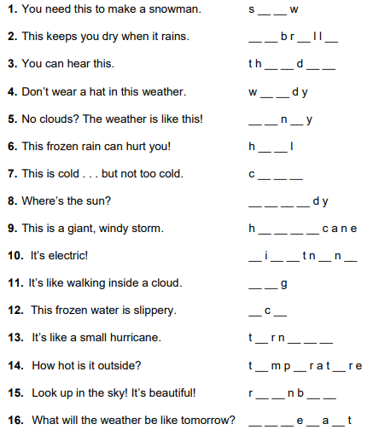

6. Fill the correct words into the correct sentences.
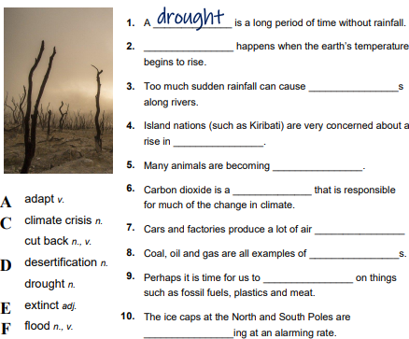
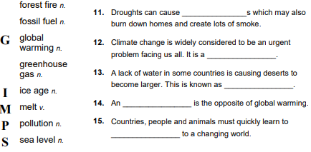

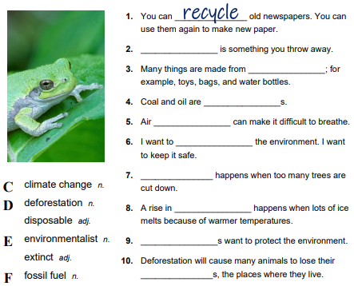
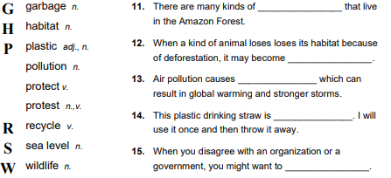

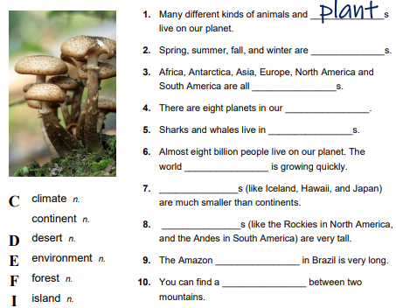
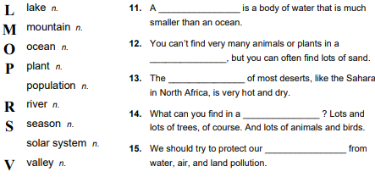

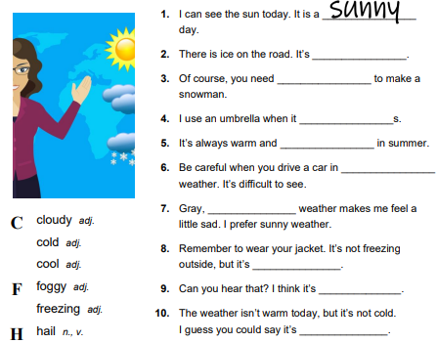
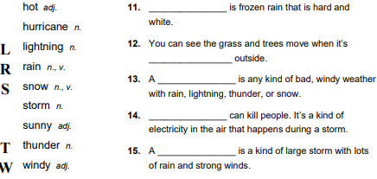

7. Find all words in the crossword.
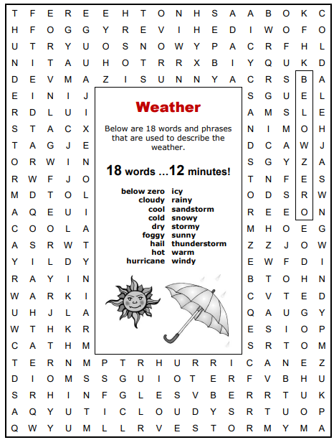

8. Match different kinds of weather with the descriptions.
cold fog rain snow storm sun / heat wind
1. I woke up in the middle of the night because the thunder was so loud and then there were these incredible flashes of lightning. It was quite scary.
2. We were driving along the motorway and suddenly we just hit it. It was really thick and you could hardly see the car in front. We had to come off the motorway and wait for it to lift.
3. It was boiling and really humid and there was no air conditioning on the bus. It was unbearable. I thought I was going to pass out!
4. I lost all feeling in my fingers and my lips turned blue. I thought I was going to freeze to death!
5. I got absolutely soaked on the way. When we left it was fine, but then the clouds came in and it suddenly started pouring down, and of course I hadn’t brought an umbrella or anything.
6. It blew down a tree and it hit our house. it did quite a lot of damage.
7. It was pouring down and then it turned to hail. It was incredible. In the end, we had to pull over until it all eased off.
8. The ferry couldn’t sail because it was so strong, but it eased off after a couple of hours.
9. Honestly, we had to slow right down because it started to settle and I was afraid of skidding. Apparently, there were lots of crashes and some people got stuck in their cars overnight.
10. It continued non-stop for about a week! The whole place was flooded. It was miserable.
9. Choose the correct word.
1. A: Wasn’t that storm / tornado incredible yesterday? The thunder was so strong / loud, I jumped right out of my chair. And the flashes / crashes of lightning lit up the whole sky. It was amazing! – B: Actually, I didn’t think it was much fun. I got absolutely wet / soaked on the way home.
2. A: I can’t stand this weather. It’s so cold nearly freezing / froze to death on the bus to work. – B: I know what you mean. I missed / lost the feeling in my fingers and my lips made / turned blue just getting to the car!
3. A: Did you enjoy the view from the top? – B: Actually, it wasn’t very clear when we got up there. – A: That’s pretty common. Some days we get really strong / thick fog. You have to wait ages for it to lift / rise.
4. A: I wasn’t that keen on Florida. The heat / hot was unbearable and it was so wet / humid I needed a shower every hour. – B: When we were there, the wind was really boiling / blowing. It was so strong / tough we hardly went out all week,
5. A: Is it still pouring / spilling down near the beach? It was awful earlier on. – B: No, it’s cleared / eased off quite a bit over here. It’s only really spitting / dripping now. We should be OK for a walk.
6. A: The temperature dropped and the rain turned to hail / snow. The stones were really hard and they bounced all over the road. – B: I cycle everywhere and it’s easy to skip / skid when it’s like that, but at least it doesn’t remain / settle and last for ages.
7. A: I’ve never known weather like it. Hundreds of trees have been cut down / blown down by the wind and we have days of non/stop / no/stop rain. – B: I know. Did you see those poor people whose houses got flooded / flood? One elderly couple got lost / stuck in their house and had to be rescued.
10. Complete the word groups with these weather words. Then, match each group to its meaning.
clear gusty overcast pouring roasting sticky
1. drizzly rainy showery  2. blistering oppressive sweltering  3. bright fair fine  4. dull gloomy grey  5. humid muggy sultry  6. blowy blustery breezy |  | a) uncomfortably warm and damp  b) windy  c) uncomfortably hot  d) pleasant and not raining  e) very wet  f) cloudy
11. Think of one word which can be used appropriately in all three sentences.
1. We ought to be making a bigger effort to recycle our ___ paper.
Surely it’s dangerous to dump nuclear ____ at sea.
That seminar was a complete ___ of time; I didn’t learn anything.
2. There’s no point in trying; you can’t change human ___.
Nicholas is, by ___, a very serious and scholarly sort of person.
It is impossible for zoos to replicate the same conditions found in _____ .
3. These batteries are expensive, but they have much longer _____.
Harry is still a teenager; he doesn’t know what he wants out of _____.
Redkneck had become a ghost town and there were no signs of _____.
4. Marina has an ____ of confidence about her.
No one knows what happened to Bob; he just vanished into thin _____.
It was stuffy in the office so I went outside to get some fresh _____.
12. Choose the correct word.
1. Due to chemical dumping and acid rain, the dirt / soil has been contaminated.
2. A Dutch company has won the rights to drill / mine for oil off the south coast of the country.
3. Sulphur dioxide is a polluter / pollutant release into the atmosphere when coal is burnt to generate electricity and heat.
4. Local residents are up in arms about plans to create a landfill / wasteland on the outskirts of town.
5. In 1989, the tanker Exxon Valdez was badly damaged at sea resulting in a massive oil slip / spill in the Gulf of Alaska.
6. The earthquake triggered a landfall / landslide in which dozens of people were injured.
13. Complete the text with these adjectives.
barren continental grueling hostile narrow scorched searing steep
Death Valley. Death Valley is located within Death Valley National Park, the largest national park in the 1) _____ United States. The long, 2) ____ valley sits between high, 3) ____ mountain ranges and is one of the most 4) ____ and forbidding environments in the world. Due to its unique geology, this sun 5) ____ land is the hottest, driest place in North America.
It is in this 6) ____ but startlingly beautiful landscape that the Badwater Ultramaraphon takes place, a 217-kilometre race through Death Valley in 7) ____ mid-July heat. The annual event is the most 8)____ foot race in the world.
Temperatures can soar above 50ºC. Runners must endure the oppressive heat of the day and continue running into the night, taking short naps whenever they can. They have a 48-hour time limit to complete the race, which starts at Badwater, the lowest elevation in the Western Hemisphere at around 86m below sea level, and ends on Mount Whitney at nearly 2530m.
14. Read the report and decide if each statement is true of false.
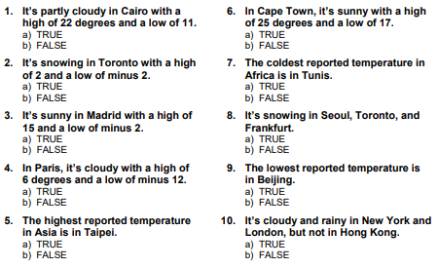
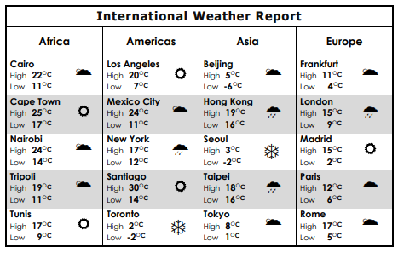

15. Choose the correct answer
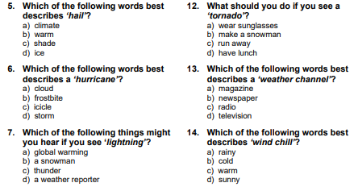
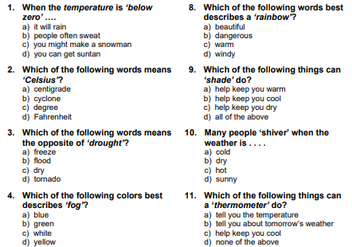

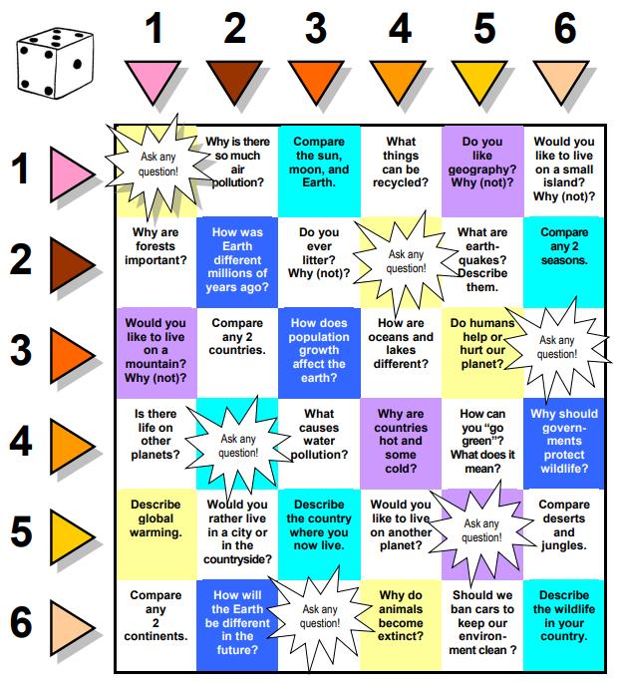
16. Be ready to answer the question from the charts.
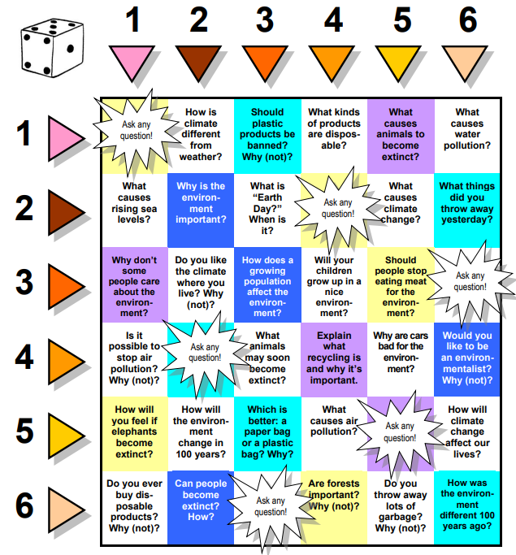

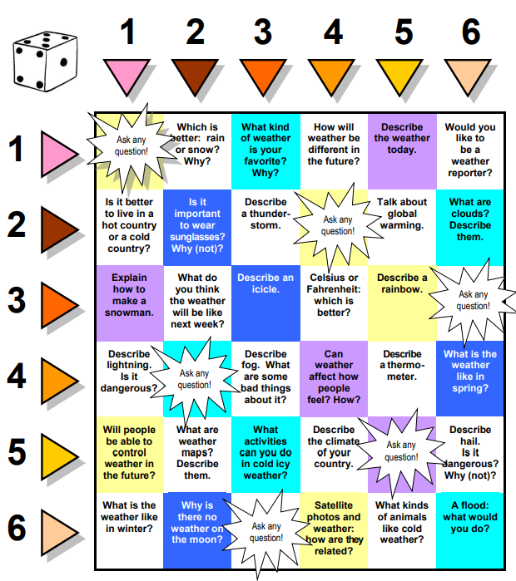

17. Write the word connected to the topic “Environment; weather” to each letter of the alphabet.
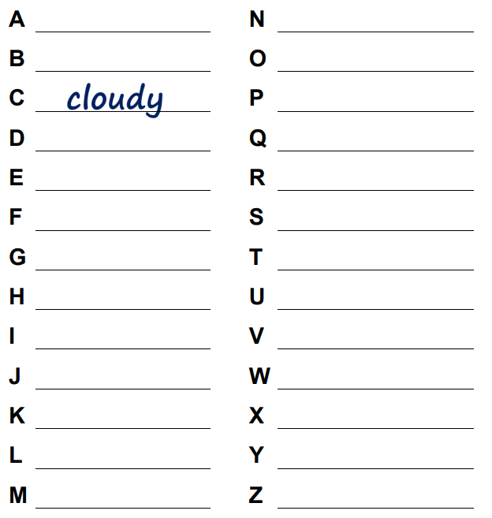

Word formation. Suffixes.
1. Choose the correct suffix for each word.
1. snow –scape / -ness / -ism  2. metalwork – ist / -ship / -er  3. craftsman – ism / -ship / -ness | 4. polite –ness / -ist / -ship  5. saxophone –ship / -er / -ist  6. romantic –ness / -ism / -scape
2. Write the correct noun using the correct suffixes.

1. The style of art that created surreal paintings.
2. Someone who plays the guitar.
3. Someone who present a show on TV.
4. A painting of a city view.
5. The state of being calm.
6. The arts movement that championed modern things.
7. A picture showing the moon’s
surface.
8. The ability to be a musician.
9. Someone who plays the trombone.
10. Someone who does carpentry.
11. The quality of being direct.
12. The state of being a companion.

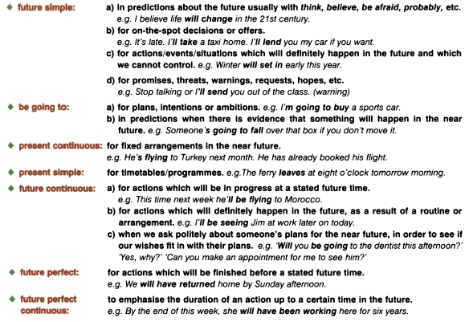
2. Grammar. Review of the future forms

1. Complete predictions (1 – 10) for mobile technology made by various industry experts by putting the verb in the Future Continuous or Future Perfect.
1. … very few people in the developed world _____ (use) credit cards because mobile phone payment ____ (replace) them.
2. … it is predicted that people _____ (sit) in front of traditional computers much less than they do now.
3. … data security ____ (become) a huge issue because mobile devices will store so much personal information.
4. … advertisers ____ (put) their adverts on mobile devices rather than on traditional media like TV, magazines etc.
5. … we _____ (get) accustomed to advertisements which target us directly with personalized messages.
6. … body sensors connected to our mobile devices ____ (provide) us with real-time information about our health.
7. … the problem of short battery life in phones ____ (disappear) because phones and mobile devices _____ (use) more sophisticated power sources, like kinetic energy.
8. … mobile phones will _____ (become) very sophisticated, so that as well as being your diary, address book and music player, you ____ (also / use) them as your secretary, accountant and lawyer.
9. … everyone _____ (use) universal translators in their mobile phones, which will make language learning less necessary.
10. … it is unlikely that we _____ (find) a way to use technology to know exactly where people are, because legally it is so difficult.
2. Read the sentences and choose the correct option.
1. In a few years, I’m sure we will be hearing / will have heard a lot more about this technology.
2. In the future, cookers will be making / will have made our meals for us.
3. We will all be using / will all have used intelligent fridges when food packaging is intelligent too.
4. In the next ten years, lack of water will be becoming / will have become a big issue, so we need to find alternatives.
5. In the future, people will be using / will have used energy fields that isolate a particular space from the rest of the house.
6. I don’t think people will be cleaning / will have cleaned kitchen surfaces either in the future.
7. Soon, we will be installing / will have installed surfaces that can act as computers or TV screens in almost every room.
8. I think in ten years or so, that kind of technology will be becoming / will have become quite common in new-building houses.
9. Next year, our company will be launching / will have launched a new lighting system for bedrooms that simulates the sunrise.
Revision of grammar
Choose the correct variant.
1. ‘I haven’t seen Mark for weeks.’ – ‘Well, I ____ him this afternoon. Why don’t you come along?’
A. have met B. am meeting C. meet
2. ‘We’d better take a taxi to the station.’ – ‘Yes. The train ____ in fifteen minutes.’
A. has left B. will have left C. leaves
3. ‘Cathy doesn’t study enough.’ – ‘I know. I’m afraid she ___ her exam.’
A. won’t pass B. won’t be passing C. won’t have passed
4. ‘ ___ to the library today?’ – ‘Yes. Would you like me to return your bike?’
A. Will you have gone B. Will you be going C. Will you have been going
5. ‘Shall we go shopping?’ – ‘I can’t go until the babysitter ___.’
A. arrives B. will arrive C. arrives
6. ‘I’ve invited Sam to my party.’ – ‘I doubt if he ___. He’s studying for an exam.’
A. comes B. will come C. is coming
7. ‘I’m having trouble with the car.’ – ‘I’m sure John ___ you fix it if you ask him.’
A. is going to help B. helps C. will help

Unit 4B. A risky business.
1. Lexical exercises.
1. Look through the quiz and answer the questions.
Are you a risk-taker, or are you risk-averse?
1. What sports activities sound best to you?

a) free climbing, paragliding and horse riding;
b) cycling and swimming;
c) watching sport on TV

2. You’ve just won a lot of money. What do you do with it?

a) You buy a bright red, high-performance car. It is sire to go up in value.
b) You use the money to expand your
family’s successful business.
c) You put it in the bank in case you need it for an emergence later.

3. Your train leaves at 12.00. What time do you arrive at the station?

a) 11.59. There’s nothing wrong with cutting it fine.
b) 10-15 minutes before it’s due to leave.
c) 45 minutes ahead of time in case things go wrong.

4. What would be your dream holiday?

a) sailing the seven seas in a yacht;
b) exploring a European city on a weekend break;
c) going to the same all0inclusinve resort you’ve been going to for the last ten years.

5. Do you read the instructions before you use a new piece of equipment?

a) You never read them – you prefer learning by trial and error.
b) You only look at them if you get
stuck.
c) You always read them from cover to cover before you unpack the item.

6. You’re eating out at a restaurant. What do you order?

a) You ask the waiter to surprise you.
b) You ask for advice and look at what other diners have ordered.
c) You play it safe and go with what you know.

7. Which of these jobs appeals to you most?

a) an astronaut;
b) a pilot;
c) an airline check-in clerk.

2. Answer the questions below. Use the information in the quiz to help you.
1. Can watching sport on TV ever be dangerous?
2. What are the advantages of investing your money in a family business?
3. What is the problem with always cutting it fine?
4. Why do more people not ‘sail seven seas;’ when they go on holiday?
5. Why might it be a bad idea to read the instruction from cover to cover?
6. What could happen if you asked a waiter to surprise you?
7. Why might the job of an airline check-in clerk appeal to some people?
3. Read the text and find the synonyms for each of these words:
1) countries; 2) injury; 3) people; 4) financial; 5) regulations; 6) liable.
A government has a duty to protect its citizens from personal, professional and financial risk.
Governments of some countries see it as their responsibility to control the amount and kind of risk that their citizens are exposed to. They can use legislation to protect personal health, prevent injury in the workplace and help people to handle financial natters. In other nations, citizens are expected to take care of themselves and carry the responsibility of their own safety and that of others. Here you will read about advantages and disadvantages of both approaches.
In the UK, the government protects its population from risks in a number of areas. It makes it compulsory to wear a seatbelt or helmet while on the roads, and manages risks of disease by taxing or prohibiting unhealthy foods or cigarettes. It prevents the spread of disease by investing in vaccination programmes and health education. Workers are protected from harm though government-implemented health and safety regulations and companies and managers are liable for employee death or injury. This has resulted in 800 fewer deaths per year in the British workplace. In terms of financial protection, the UK government gives those in poverty access to healthcare, food and shelter. It also tires to prevent fraud and other financial crime, while encouraging prudence through methods such as saving.
While some people believe the UK government acts in the best interests of their citizens, others feel it infringes on the freedom of the public. They object to paying hefty financial penalties (for example, for riding a motorbike without a helmet), even though they may personally accept the risk. People who smoke and eat unhealthy food argue that they are posing less risk to their health than horse riders or skiers and it is dangerous sports which should be banned, not food. Businesses complain that health and safety regulations mean that they spend too much time and money protecting against very low risks, and that this has a negative impact on their business and the national economy, Others reject government advice about saving money as hypocritical when they notice an increase in state borrowing.
In conclusion, we can see that there are both benefits and risks attached to a government that tries to control the safety of its citizens. This can reduce accidents, disease and crime, and cater for the basic needs of all members of society. Conversely, however, over-protective legislation can limit individual freedom and cause resentment. It can also suggest that people do not have to be responsible for their own actions. The country with tight controls provides a pleasant and safe environment. However, legislation needs to be carefully monitored to ensure it is appropriate, up-to-date and not excessively restrictive.
4. Study the words.
a responsibility n | the quality or state of being able to answer for sth or sb | prudence n | the ability to govern and discipline oneself by the use of reason
a legislation n | the exercise of the power and function of making rules (such as laws) that have the force of authority | a penalty n | the suffering in person, rights, or property that is annexed by law or judicial decision to the commission of a crime or public offense
an approach n | an act or instance of getting near to sth | hefty adj | quite heavy; impressively large
compulsory adj | required by law or rule | to infringe v | to defeat
to prohibit v | to forbid by authority | to implement v | carry out; accomplish
an impact n | the force of impression of one thing on another | excessively adj | exceeding what is usual, proper, necessary, or normal
to be liable phr | to be obliged according to law or equity | to cater for idiom | to provide what is wanted or needed by (someone or sth)
poverty n | the state of one who lacks a usual or social acceptable amount of money or material possession | a resentment n | a feeling of indignant displeasure or persistent ill will at sth regarded as a wrong, insult, or injury
a fraud n | intentional perversion of truth in order to induce another to part with sth of value or to surrender a legal right | to reject v | to refuse to accept, consider, submit to, take for some purpose, or use
5. Complete definitions (1 – 7) with words from the box.
compulsory prudence regulations infringe responsibility legislation prohibiting
1. If something is _____, it means that you have no choice whether to do it or not.
2. To _____ on someone’s freedom is to take it away or limit it.
3. _____ means not taking any unnecessary risks.
4. _____ is a formal word for the making laws.
5. By ____ something you are effectively making it illegal.
6. If you are liable for something, it means you have legal _____ for it.
7. _____ are sets of rules established by an organization.
6. Replace the nouns in bold in sentences (1 – 7) with the words from the box.
regulations legislation prevention objection reduction confusion dissatisfaction
1. The fall in numbers shows that many people think the risks are too high.
2. The government intends to introduce new laws to control migration.
3. Workplaces must introduce more strategies with regard to the stopping of risk.
4. There is a considerable amount of unhappiness about recent changes to financial policy.
5. The company has brought in extra safety rules to prevent further accidents.
6. There was chaos when the decision was announced.
7. Companies have outlined a key complaint to the recent change in government policy.
7. Answer the questions.
1. Do you agree that the government should regulate the risks in the mentioned spheres of life?
2. Which other spheres of life should be regulated by the government?
8. Look at the list of adjectives. Which of these characteristics are positive and which are negative? Which of them can be used to describe your behavior?
altruistic | thoughtless | clumsy | considerate | cunning
cowardly | courageous | cynical | deceitful | disloyal
eager | pretentious | forgetful | heroic | hospitable
hysterical | over-sensitive | pushy | foolish | reckless
romantic | short-sighted | ruthless | spiteful | careless
9. Read 6 monologues and decide which adjectives best describe speaker’s actions.
1. My parents gave me the name Edward – which is OK. Lots of people my age are called Edward. But I don’t like being the same as lots of people. So I decided to change my name. I changed it to Eduardo. It’s similar to Edward but it’s got more style. It’s more exotic, more interesting, more exciting. I think it’s a better reflection of my personality. Eduardo. Sounds good, doesn’t it? I’ve started wearing sunglasses a lot more too. | 2. I’ve been Chief Executive of the company for three years now. When I arrived, there was a lot of work to do. Some of the employees just weren’t trying. So I called everyone into a meeting and told them that half of them were going to lose their jobs. And I was going to make that decision after four weeks so they better impress me! They did work harder after that! And four weeks later, the 50 per cent who weren’t performing as well as the others lost their jobs.
3. I bought him as a puppy, when he was only a few weeks old. I really wanted a dog. I know I live in a small flat, but I love pets – dogs, especially. Well, what I didn’t think about was how big that puppy was going to grow! He’s huge! Look at him! Yes, we are talking about you, aren’t we? Anyway, he’s wrecked the flat, of course. It isn’t his fault – he’s just too big. I didn’t think about that when I got him. | 4. I got so angry with my dad last week – I can’t remember why. I think he told me not to spend so much time on the computer. Anyway, I was cross. So do you know what I did? When he went pt work, I went outside and dug up all the roses in his flower bed. He loves roses. He loves them more than he loves his child, that’s what I think sometimes. So I dug them up! He went crazy when he found out.
5. So I had this ticket to go and see Lady Gaga performing live and I mentioned it to my cousin, Claire. It turned out she just loves Lady Gaga – she’s her favorite singer. She tried to book a ticket for herself but they were sold out. So I gave her my ticket. Well, I do like Lady Gaga but I wouldn’t say I’m her biggest fan. And Claire was really grateful, so that was nice. | 6. I wanted to get something special for my boyfriend last Valentine’s Day but I didn’t have any money to buy a present. I thought about it for a while and then I decided to write a song for him. I’m quite musical. So anyway, I wrote it and then I recorded it on my computer – singing and playing the guitar. I gave it to him on a CD. He loved it! Well, he said he did…
10. Complete the adjectives.
1. He’s so c_____. he left his cash card at the till of the supermarket the other day.
2. She’s so s_____. She never plans ahead.
3. Little Joe had only cut his finger, but his mum was completely h______, crying and panicking.
4. Cath’s mum has told her teacher to move her up to a higher maths class. Don’t you think that’s p______?
5. It was very f_____ of you to buy that old car. You’re bound to lose lots of money on it.
6. Jason is really p_____. He always carries a philosophy book around him, but he never really reads it.
7. Jake is so r_____. On Valentine’s Day he bought his girlfriend twelve red roses.
8. Liam is always making t____ remarks. He should consider other people’s feelings a bit more.
9. Beth is very e______ to improve her French. She’s studying really hard.
10. He has a r_____ determination to be the best. He lets no one or nothing get in his way.
11. It was d______ of him to lie about how he spent the money.
Phrasal verbs with take
to take after sb | to resemble sb | My sister really takes after out grandmother.
to take sth back | to return sth | If the dress doesn’t fit, you can take it back to the shop.
to take back sth | to say you regret saying sth | I’m really sorry for her words. She should take them back.
to take sth down  to take down sth | to make a note of sth | Can you speak a little more slowly? I’m taking down the information.
to take sb in | to deceive sb | Don’t be taken in by those products.
to take in sb/sth in | give a home to sb/sth | She’s always taking in some stray kittens.
to take in sth | include sth | This book takes in all his poems.
to take sth in | reduce the width of (clothing) | This T-shirt is too long – I need to take it in.
to take off | to leave the ground | An airplane takes off in an hour.
to take sth off | to remove (clothing)  to remove (make-up) | Take your shoes off in the house!  I forgot to take my make-up off.
to take sb on | to employ sb | We need to take on some new people.
to take on sth/sb | to agree to do sth | She is taken on too much responsibility.
to take sb out | to invite sb to a place | He takes my sister out today.
to take over sth | to take control of sth | Who is going to take over that shop?
to take to sb/sth | to begin to like sb/sth | I took to that song as soon as I heard it.
to take sth up | to start an activity  to discuss sth | He takes up swimming.  My brother is taking that story up with his friends.
to take up sth | to start a job  to accept a job  to take a period of time | She took up her first job in 2010.  When sis you take up your job?  This article took up almost all my time.
1. Complete these sentences with out, on, off, up, after, in or back.
1. We ought to get rid of this table, it takes ____ far too much space.
2. If you’re hot, you can take ____ your jacket.
3. This meat can’t be fresh, it smells awful – I’m taking it ____ to the butcher.
4. John’s always been difficult – he must take ____ his dad.
5. You shouldn’t take ____ more responsibilities that you can handle.
6. It must be difficult to give ____ teaching in order to travel.
7. We’ll need to take _____ some temporary teachers for the summer.
8. She took ___ her glasses when she had her photograph taken.
9. He was such a charmer – he took me ____ completely.
10. Rachel took me ____ to lunch.

2. Grammar. Zero, first conditionals; future time clauses.
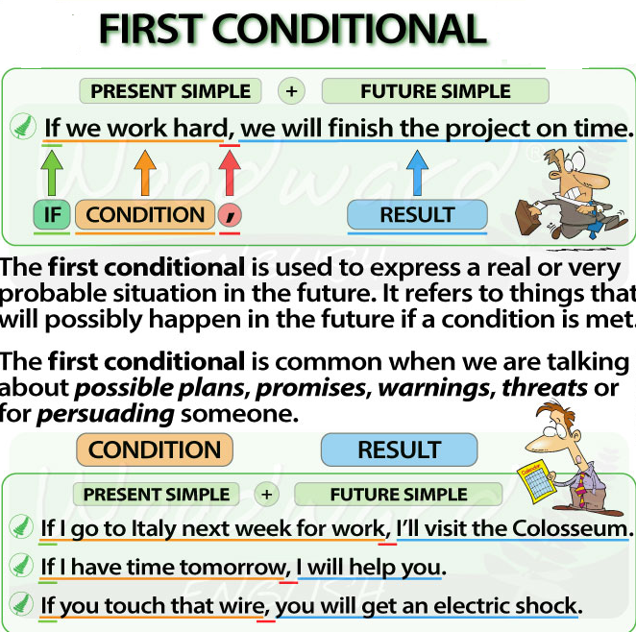
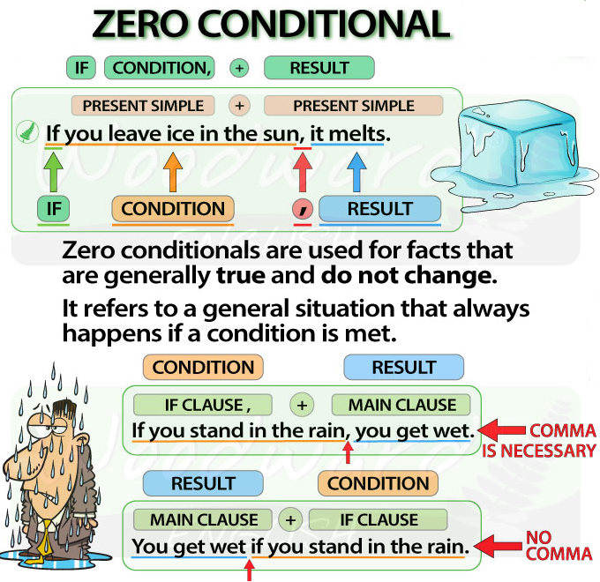

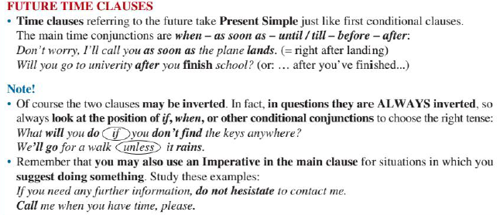

1. Match the two halves of the sentences.
1. Passengers can’t stand up  2. I won’t go unless  3. You mustn’t go windsurfing if  4. We’ll have to book a table  5. In case the temperature goes up  6. You can learn phrasal verbs as long  7. The PC will load the application  8. After you complete this course | a) call the doctor.  b) if we go to the restaurant on Saturday.  c) as you use them when you speak.  d) until the plane stops.  e) you’ll be moved to an advanced class.  f) it’s free.  g) you aren’t a good swimmer.  h) when you start the computer.
2. Choose the correct variant.
1. If it rains / will rain tomorrow, we’ll stay at home.
2. I’m / I’ll be amazed if they find a solution to the problem of energy.
3. If you connect / will connect to the internet, I’ll call you online.
4. If the helicopter arrives tonight, we leave / we’ll leave.
5. He usually texts / He’ll usually text when he’s on his way home.
6. If you don’t / won’t type the correct password, it won’t let you log in.
7. Your bank card won’t work if you don’t /won’t have enough money in your account.
8. If we see Jennifer, do / will you tell her our news or shall I?
3. Correct the mistakes in the given sentences.
1. If we will go shopping tomorrow, I’ll probably buy a new top.
2. If Mum is tired tonight, I cook dinner.
3. John will tell us if there will be any news.
4. If I won’t get a good mark in the geography test, I’ll be very annoyed!
5. You are tired in the morning if you don’t go to bed soon.
6. If you see Karen, do you ask her to call me.
7. Does Frank come with us if we go to the beach at the weekend?
8. If you need help, will tell me!
4. Complete the sentences using the correct form of the verbs in brackets.
1. If I _____ (do) well in the exam, my parents ____ (buy) me a new game.
2. If my sister _____ (borrow) my clothes again, I _____ (tell) my parents.
3. We _____ (leave) at six o’clock if the weather _____ (be) bad.
4. They _____ (not / mind) if we ____ (be) a bit late to their party.
5. Sarah ____ (be) very angry if you ____ (not / put) all the things on their places.
6. _____ you (still / go) to the concert if the tickets _____ (cost) a lot of money?
7. If you sister ____ (not / come) to the party, she ____ (be) very upset.
8. My cat ____ (be) surprised when he _____ (see) a new plate.
Revision of grammar
Write the correct form of the verbs in brackets.
1. If we ___ (invite) him, he ____ (come).
2. If you ____ (want), we _____ (go) to the party together.
3. If you ____ (look) in the cupboard, you ___ (find) some dishes.
4. If you ____ (lose) your luggage, you ____ (contact) the lost and found office.
5. The table ____ (break), if you ____ (stand) on it.
6. I ____ (be) very angry if you ____ (tell) them my secret.
7. ____ (you / buy) the flat if you ____ (like) it?
8. What ___ (you / do) if there ____ (not / be) anything on TV tonight?

Unit 5A. I’m a survivor.
1. Lexical exercises.
1. Answer the questions.
1. What is danger for you?
2. Have you ever been in a dangerous situation? What was it?
2. You are going to read three texts about potentially dangerous situations. Decide which text…
a) describes a location which feels threatening?
b) describes a situation where someone knows that they are in danger?
c) describes a situation which caused extreme discomfort?
1. A night fear. Cal turned over to go to sleep. But it was too quiet. Now and again he raised his head off the pillow and listened. Once a dog barked in the distance. Then another and another, from different farms. Just as suddenly they stopped and the silence returned. He listened so hard there was a kind of static in his ears – like listening to the sea in a shell. He expected to hear whispering voices, the squeak of a rubber-soled shoe on the concrete path. He lay on his back and listened to the echo waiting for his window to explode.
The first threat had been posted the same was and written in the same crude felt-tip printing. His father had been so worried and angry and had told some of him workmates about it, including Crilly. The very same night Crilly has arrived at the house with a friend of his. Cal had been off at the time but heard the story from his father. They had offered him a gun for his own protection and he had accepted it. He was happy to know that in the house he had the means to frighten off a mob that some night he knew would march up to his door. Or to get a doorstep killer before the killer got him. (From Cal Bernard Maclee).
2. An unpleasant night. Last night was desperately uncomfortable. A fierce wind blew, occasionally gusting with such ferocity that I feared it might tear the windows out. I lay awake, mouth dry despite regular swings of water, listening to the village dogs and detritus in the yard being flung about by the wind. As soon as I dropped off to sleep my breathing slowed and within moments I was wide awake, gasping for breath. I needed to sleep so much, but I found myself fighting it, forcing myself to stay awake and breath slow and deep.
On advantage of the wind is that when daylight comes it is clear and pristine. The summit of the mountain trails a plume of spindrift, blown off the mountain by winds which, at that height, must be in excess of a hundred miles an hour. The rest of the mountain, including the long flanking shoulders below the arrow-head peak, is crystal clear.
We had hoped to move up to Base Camp today, but with the wind still strengthening the decision is taken to stay down here and acclimatize. With atmospheric pressure about half that at sea level, everyone is suffering to some degree and Mr Yang, our minder, and John Pritchard, our sound recordist, are particularly uncomfortable. (From Himalaya by Michael Palin).
3. A night among the trees. Woods are not like other spaces. Their trees surround you, loom over you, press on from all sides. Woods choke off views, and leave you muddled and without bearings. They make you feel small and confused and vulnerable, like a small child list in a crowd of strange legs. Stand in a desert or prairie and you know you are in a big space. Stand in a wood and you only sense it. They are a vast, featureless nowhere. And they are alive. So woods are spooky. Quite apart from the thought that they may harbor wild beasts and armed, genetically challenged fellows named Zeke and Fetus, there is something innately sinister about them – some indescribable thing that makes you sense an atmosphere of pregnant doom with every step and leaves you profoundly aware that you are out of your element and ought to keep your ears pricked. Though you tell yourself it’s preposterous, you can’t quite shake the feeling that you are being watched. You order yourself to be serene – it’s just a wood for goodness’ sake – but really you are feeling jumpy. Every sudden noise – the crack of a falling limb, the crash of a bolstering deer – makes you spin in alarm and stifle a plea for mercy. Whatever mechanism within you is responsible for adrenalin, it has never been so sleek and polished – so keenly poised to pump out a warming squirt of adrenal fluid. Even asleep you are a coiled spring. (From A Walk in the Woods by Bill Bryson).
3. Study the words.
a crude felt-tip printing phr | written in a rough or inexpert handwriting | choke off v | to bring to a stop or to an end as if by choking
detritus n | a product of disintegration, destruction, or wearing away. | spindrift n | sea spray; especially blown from waves during a gale
fierce adj | violently hostile or aggressive | to muddle v | to make a mess
preposterous adj | contrary to nature, reason, or common sense | vulnerable adj | capable of being physically or emotionally wounded
ferocity n | extremely intense | gasping for breath phr | to catch the breath
spooky adj | strange or frightening | innately sinister phr | originally bad or unlucky
feeling jumpy phr | feeling nervous | to gust v | to blow suddenly
pristine adj | original | plea n | an allegation of fact
summit n | the highest peak
4. Choose the correct answer to the questions.
1. The writer uses the phrase the another and another (in the first text) to:
a) indicate that there are a lot of dogs in the area;
b) suggest that someone could be moving around outside;
c) emphasize the silence of the night once the dogs stop;
d) suggest that it will soon be morning.
2. How did Cal receive the first threatening message?
a) the postman delivered it through his letterbox;
b) a schoolchild delivered a note to the house by hand;
c) his father heard it from his work colleagues;
d) it came through the window, tied to something heavy.
3. What made the night particularly uncomfortable for the writer in the second text?
a) he found it difficult to breathe normally;
b) he was continually thirsty;
c) he found it impossible to fall asleep;
d) the noise of the dogs and objects in the wind.
4. Why did the group decide not to move to Base Camp?
a) they needed to get used to the weather conditions first;
b) the wind was getting stronger;
c) everyone was feeling stressed;
d) everyone in the group was feeling ill.
5. What is the writer describing in the third text?
a) the memory of a past experience which frightened him;
b) a past situation in which he was attacked by a wild animal;
c) feelings anyone might experience in a particular situation;
d) a childhood experience which made a great impression on him.
5. Look through the list of verbs and choose the correct preposition.
1. to believe in / at / for good stories
2. to protest after / over / against scary films
3. to belong about / to / for good company
4. to insist on / at / for reading a funny story
5. to rely in / on / at the friend’s opinion about the film
6. to set in / on / up a new company
7. to care about / with / after a general opinion about the film

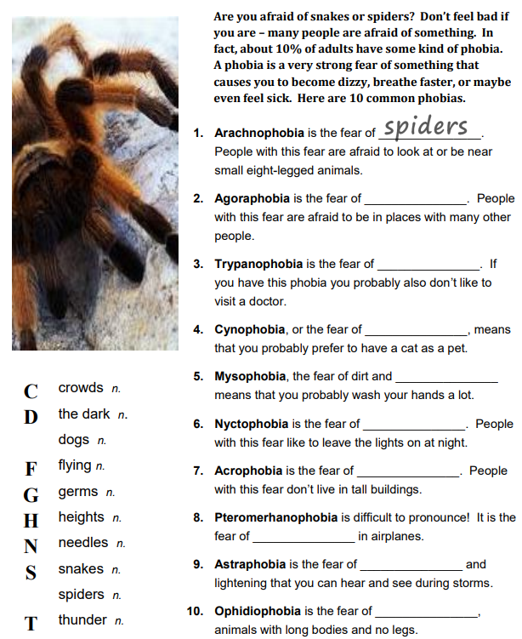
6. Complete the sentences with the correct words.

7. Complete the sentences with the correct words.
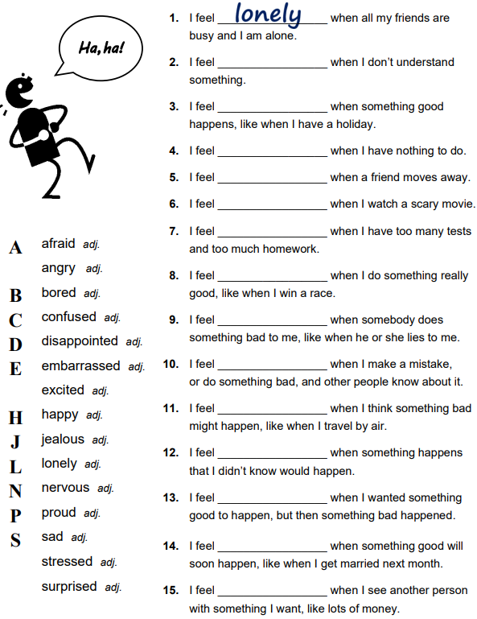

8. Choose 4 emotions and draw them in the circles.
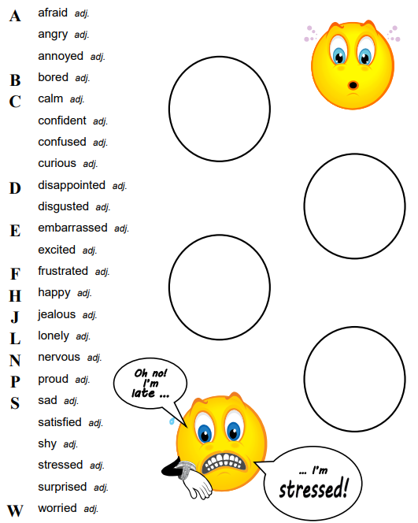

9. Be ready to answer the questions from the chart.
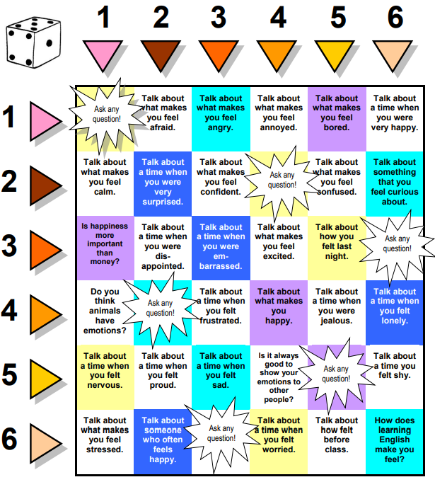

2. Grammar. Unreal Conditionals. Revision of Conditional Sentences.
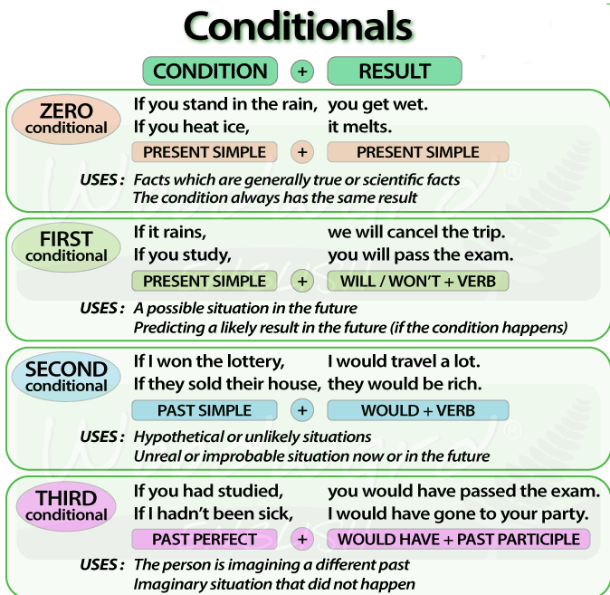

1. Choose the correct variant
1. ‘If you ____ that plate, you’ll burn your fingers.’ – ‘Why? Has it been in the oven?’
A. would touch B. will touch C. touch
2. ‘ ___ you’re busy, we’ll talk now.’ – ‘That’s fine. I’m not busy at the moment.’
A. If B. Provided C. Unless
3. ‘If you watch the news, you ____ a lot.’ – ‘I know. I watch it every day.’
A. learn B. were learning C. would learn
4. ‘Shall I invite John to the party?” – ‘Well, were I you, I ____ him.’
A. would invite B. will invite C. am inviting
5. ‘Don’t cry. Everything will be alright.’ – ‘Yes, but if I ____ the bus, I wouldn’t have been late for school.’
A. didn’t miss B. hadn’t missed C. don’t miss
6. ‘When water boils, it ____ steam.’ – ‘Yes, I know; and the steam is hot, too.’
A. would produce B. produce C. produces
7. ‘Can you help me, please?’ – ‘Well, if I wasn’t studying, I _____ you.’
A. would help B. help C. will help
8. ‘John crashed his car yesterday.’ – ‘I know, but if he hadn’t n been so careless, he ___.’
A. won’t crash B. wouldn’t crash C. wouldn’t have crashed
2. Put the verbs in brackets into the correct tense.
1. If I ___ (be) you, I wouldn’t drive in the snow.
2. Peter ____ (be able to) help you if he was here.
3. If I had closed the window, the cat ____ (not / jump) out.
4. I ___ (call) for help if I got stuck in a lift.
5. Had I known him, I ___ (talk) to him.
6. John ____ (may / lose) his job if he is rude to his boss.
7. If you ____ (save) some money, you would have been able to go on holiday last year.
8. You may win if you ____ (take) part in the contest.
9. If I had a toothache, I ____ (go) to the dentist.
10. They would have helped up move house if we _____ (ask) them.
11. If Jane ___ (be) older, she could live by herself.
12. We would have changed our plans if we ____ (hear) the weather forecast.
13. Emma ____ (send) a card if she had remembered it was their anniversary.
14. Robert ____ (feel) better if you talked to him.
15. If Sam was still living nearby, you ____ (can / invite) him for dinner.
16. If you ____ (like) chocolate, you will love this cake.
17. If you ____ (put) your money in your wallet, you will not lose it.
18. If Bill _____ (come) home early, he will eat dinner with us.
19. Sandra will join us later unless she ____ (have) a lot of work to do.
Revision of grammar
Choose the correct variant of the verb in brackets.
1. He’ll be furious if he ever ___ (find out) about this.
A. find out B. finds out C. will find out
2. The animals at the zoo ____ (not / play) unless they are fed.
A. don’t play B. doesn’t play C. won’t play
3. I ____ (run) home if I had known the football match was on TV.
A. run B. will run C. would run
4. The teacher ___ (not / shout) at her if she did her homework.
A. doesn’t shout B. won’t shout C. wouldn’t shout
5. He ___ (buy) a car provided he passes his driving test.
A. buys B. will buy C. would buy
6. We ____ (miss) the lecture unless we ____ (hurry).
A. will miss; hurry B. will miss; will hurry C. miss; hurry
7. If she ___ (pass) her exams, she ___ (go) to university.
A. pass; would go B. would pass; go C. had passed; would go D. had passed; go
8. If I ___ (understand) that language, I ____ (read) the poem.
A. understand; would read B. would understand; read C. understood; would read

Unit 5 B. Wish you were here.
1. Lexical exercises.
1. Answer the questions.
1. Do you find your life successful?
2. Do you regret something? Would you like to change something in your life?
2. Read the texts and complete the sentences with the correct name: Wilf or Harriet.
1. _____ generally had a relaxed approach to life.
2. _____ was very sensitive about how she / he looked.
3. _____ was left some money by a relative.
4. _____’ friend went travelling between school and university.
Things I wish I’d know when I was a teenager.
Wilf, 25. By and large, my teenage years were a reasonably happy and relaxed time for me. In fact, if anything, I was a bit too relaxed, and I didn’t take life seriously enough. I was full of energy and loved doing sports: football and rugby in the winter, cricket and tennis in the summer. It was all fine up to the age of about fourteen, but then things started to get serious at school. Exams were on the horizon, but to me they seems a long time off, though it was only two years. So, it was business as usual. I just carried on with my sport and having a good time. Looking back, I can see that my parents were worried. I remember them urging me to try harder at school, not to leave my homework to the last minute and to start revising early for exams. It wasn’t that I didn’t enjoy the lessons, but you need to be reasonably focused and organized to cope well with exams – and I certainly wasn’t! My parents didn’t put huge pressure on me because they wanted me to find my own way. I should have paid attention to what they were suggesting, though, because I didn’t do very well in my GCSEs (the exam you take when you’re sixteen). I scraped through, but the results should have been a wake-up call for me. However, I didn’t do much better in my A levels (the exams you take at eighteen) so I failed to get a place on the university course that I wanted to do. It wasn’t just at school that I had a happy-go-lucky approach to life. I had a very relaxed attitude to money too. My parents gave me a monthly allowance which I’d spend almost immediately. Money burned a hole in my pocket, as they say, and I never put any aside. I’m sure that in that respect I was a typical teenager. What I do regret, though, is spending the money I inherited when my grandmother died. I was seventeen and $ 1.000 was a huge amount of money. It’s difficult to believe now, but I managed to flitter it all away on music, clothes and going out with friends. I really should have saved it and put it towards something I really needed, to use it to help with university fees. Again, my parent tried to impress on me the importance of being careful with money, but I didn’t need their advice.
Harriet, 24. I wish I’d been more confident in my own abilities, especially when I was at school. I was a shy child and struggled a bit in talking to other people. I was fine at home and perfectly confident with my brother, sister and parents, so I don’t know why I found it so difficult to deal with other people. On the whole my parents were very supportive, always encouraged me and tried to help me relax in social situations, but I was always terribly self-conscious. I wish I hadn’t been so worried about what everybody thought of me. If I hadn’t felt so uncomfortable, other people might have found me easier company. I know now that if you are excessively shy, then it’s hard work to have a conversation with you. Now I try to think about the other person I’m talking to and put them at ease in my company, which means I have less time to think about feeling shy myself. However, at school, I found it especially difficult in my peer group. I wasn’t competitive, but I was acutely aware of my appearance and I constantly compared myself to other people, usually coming to the conclusion that I wasn’t as clever or as popular or as cool as they were. I wanted to be popular and in with the cool crowd, though now I really wonder why. I know now that the kids who are considered the coolest at school aren’t necessarily the most popular or successful when they grow up. I has a couple of good friends – I still have them – and I should have considered myself lucky to have then and just enjoyed myself and got on with other things.
I realize now that everything changes during your teen years – physically, mentally, socially and emotionally – and I just had a harder time than most. I wish I hadn’t let it stop me from doing things, though. I wish I’d taken a gap year at least travelled more when I left school. But to tell the truth, I didn’t have the courage to go off alone before going to college. I could have gone to Europe and America with a friend as I’d saved up sufficient money, but in the end I just didn’t want to do it enough. My parents really wanted me to try a gap year. They said it would be a great experience before college. I think they were right, and now I won’t have another opportunity to do that for a long time.
3. Study the words.
by and large | on the whole; in general | a wake-up call | sth that serves to alert a person to a problem
a long time off | not very soon | a happy-go-lucky | carefree
to carry on | to continue | Money burned a hole in smb’s pocket | not being able to deal with money
to urge | to present sth | to be acutely aware of | to know sth for sure
to put huge pressure on | to ask for sth very often | excessively | what is proper, usual, normal
4. Answer the questions.
1. Wilf’s parents
a. weren’t particularly interested in how he did at school;
b. told him off for performance at school;
c. were concerned enough to give him advice;
d. expected him to do really well at school
2. Wilf
a. did quite well at school;
b. generally enjoyed his school years;
c. was only ever interested in school sports;
d. failed all his school exams.
3. Wilf wishes that he had
a. had much tougher parents;
b. had more money to save;
c. spent more money on his car;
d. paid more attention to his parents.
4. Harriet thinks she
a. was a difficult, disobedient child;
b. didn’t work hard enough at school;
c. disappointed her parents;
d. made life harder for herself than it needed to be.
5. If Harriet had been less self-conscious, she
a. wouldn’t have thought herself so inferior to others;
b. would have been accepted by the popular crowd;
c. wouldn’t have had such good friends;
d. would have kept the friends she did have.
6. Harriet regrets
a. not saving up enough money to go abroad;
b. listening to her parents about a gap year;
c. not having the confidence to go travelling;
d. not having the opportunity to travel before college.
Word formation: verb + preposition + noun collocations
1. Choose the one verb in each group which does NOT collocate with the noun).
1. follow / do / have | a) a career | 6. gain / win / get | f) experience
2. make / do / attend | b) a course | 7. own / have / nurture | g) a talent
3. acquire / learn / get | c) a skill | 8. do / work / get | h) a job
4. take / make / pass | d) an exam | 9. gain / earn / get | i) a qualification
5. get / win / acquire | e) promotion | 10. join / set / take on | j) a company
2. Complete the description of someone’s career by putting a suitable verb in each space.
When I was 19 I 1) ___ an exam to get into a drama school in London, but I was unsuccessful. At that point, I had to decide whether to try to 2) ____ a career in acting or just abandon the idea and 3) ____ a completely different kind of job. All my friends told me that I 4) ____ a natural talent for acting and that I didn’t need to 5) ____ a qualification to prove it. So instead, I 6) _____ a small theatre company and 7) _____ experience of acting that way. Just by working with other actors I was able to 8) _____ new skills and two years ago I was asked by the National Theatre to perform in a production of Shakespeare’s The Tempest. I have never looked back!
2. Grammar. Wish, would rather, if only
wish about a present situation | wish + noun / pronoun + past simple
wish about a past situation | wish + noun / pronoun + past perfect
wish for someone to do sth about a present situation | wish + noun / pronoun + would  !Subject with wish and noun/pronoun should be different
strong wishes about a present or past situation | use if only in place of I wish
Stating what you would prefer to do | would rather + infinitive
Stating what you would prefer someone else to do | would rather + object + past simple
1. Choose the correct form to complete the sentences.
1. I wish people stopped / would stop complaining about the price of petrol these days.
2. I wish they didn’t cut down / hadn’t cut down those trees in the park to make a playground.
3. Would you rather walk / walked or would you prefer we go / went in the car?
4. Most oil companies wish they had / would have the freedom to extract oil from wherever they wanted.
5. If only we didn’t have / wouldn’t have to rely on our cars so much, but that’s the problem with living in the countryside.
6. If only I could speak / would speak better Spanish. Then I might try to get a job in Ecuador.
7. Sophie wishes that she had taken / would take a job with BP when she had the chance. She’d much rather work / worked for them than her present company.
8. I wish people woke up / would wake up to the problems of climate change.
2. Complete the conversation using the correct form of the given verbs.
1. A: Would you like to drive or shall I? – B: I’d rather you ___ (drive).
2. A: Are you going to buy that new electric car? – B: If only I ___ (have) enough money, then I’d get it tomorrow, but it’s over $20.000!
3. A: Some people think that cheap petrol is a basic human right. – B: I know. I wish people ___ (stop) complaining and use their cars less.
4. A: Your new car is amazing. Doesn’t it use a lot of petrol, though? – B: Yes. it does. I wish I ___ (buy) one with a smaller engine.
5. A: The oil spill was terrible. What do you think happened to all the oil in the sea? – B: I’d rather ____ (not / think) about it. It’s probably still out there.
6. A: We all depend too much on the countries who produce oil. – B: I know. I wish each country ___ (become) more independent in its energy needs.
7. A: Did you see the programme about alternative energies last night? – B: No, but I wish I ____ (see) it. It looked really interesting.
8. A: Shall I speak to the neighbours about parking their car in front of our garage? – B: I’d rather you ____ (not / speak) to them. I don’t want to have an argument.
Revision of tenses.
Put the verbs in brackets into the correct tense.
1. A: If only the children ____ (stop) yelling. – B: I’ll ask them to be quiet.
2. A: I wish John ____ (listen) to my advice. – B: You should try talking to him again.
3. A: I wish you ___ (pay) more attention to your teacher’s instructions yesterday. – B: But I did.
4. A: If only we (attend) the performance yesterday. – B: B: We could go on Saturday if you like.
5. A: I wish I ___ (know) how to cook. – B: Don’t worry. I’ll teach you.
6. A: If only you ____ (be) here, Mum! – B: Don’t worry, I’ll be there tomorrow.
7. A: Will Sue be going with you to New York? – B: She wishes she ___ (come), but unfortunately she’s very busy at the moment.
8. A: If only people ___ (not / throw) their rubbish in the streets. – B: Fortunately, the town council is setting up a campaign next month.
9. A: I wish he ____ (explain) exactly what he wants me to do every day. – B: Why don’t you ask him to be more clear?
10. A: I wish you ____ (help) me with the house work more often. – B; I’m sorry. I’ll try to do so from now on.

Unit 6A. Night, night.
1. Lexical exercises.
1. Answer the questions.
1. Do you get enough sleep? If not, what stops you from sleeping enough?
2. How many hours of sleep should a person get each day?
3. What it your favourite place to sleep?
4. Can you sleep in an unfamiliar place? How about a train or a bus?
5. Have you ever suffered from insomnia? What are the ways to deal with it?
2. Match the words with definitions.
a habit | not getting enough sleep
to fall asleep | a problem with your sleep
sleep deprived | sth you do regularly; a part of your daily routine
to yawn | to start sleeping
a sleep disorder | to have a short, light sleep without intending to
to snore | to open your mouth wide because you feel sleepy
to doze off | somebody who knows a lot about sth
an expert | to make a sound when breathing while you are sleeping
3. Read the text.
Sleepy teenagers. It’s official. Teenagers need more sleep than their parents. According to sleep experts, people aged between 10 and 17 need to sleep between 8.5 and 9.25 hours each night. Are you tired at the moment? What time did you go to bed last night? Have you ever fallen asleep in a class? Recent research shows that 25% of the UK population suffer from some sort of sleep disorder and two-thirds of British children may be sleep deprived.
Sleep lessons. Research in Scotland has shown that teenagers are suffering from sleep deprivation which is causing problems with behavior, concentration and learning. To get nine hours sleep, a teenager needs to go to bed at about 10 p.m. during the week. However, many young people watch TV till around midnight and then play computer games till late into the night. Teachers in Scotland now give lessons on the importance of sleep to their teenage pupils. The teachers want young people to understand that sleep is very important if you want to do well at school and enjoy your life.
Sleeping habits. People of different ages around the UK emailed us about their sleeping habits:
- I have a strange habit of falling asleep when I watch the television and it usually happens when I am watching sth I am really interested in! The television seems to hypnotize me and I doze off really easily. Then when I go upstairs to bed I find I can’t sleep and I usually listen to the radio for hours and hours during the night. Philip, aged 64.
- I have an eight-month-old baby and three-year-old so I don’t get much sleep at the moment. In fact, I can’t remember the last time I had a whole night’s sleep. last night I think I had about five hours, as the baby woke up three times. I work during the day and it can be difficult to stay awake when I haven’t slept much. Clare, aged 35.
- I share a room with my older brother. He snores! It’s really annoying. Clyde, aged 16.
- I read in the paper the other day that most children in Britain don’t sleep enough. They watch TV until late in the evening and then they are really tired at school. I’m a teacher and sometimes in the class after lunch the students look as if they are about to fall asleep. They yawn a lot and look quite exhausted! Some people say that maybe school should start later for teenagers. I think they might be right. Jag, aged 29.
Sleep advice. If you have a sleep problem here is some advice from the sleep experts:
- You shouldn’t drink tea or coffee in the evenings;
- You should go to bed at the same time every night, even at the weekend.
4. Choose the correct answer to the question.
1. Teenagers need between 10 and 17 hours of sleep a night. True False
2. A quarter of people in the UK have problems with their sleep. True False
3. Not getting enough sleep can cause problems at school. True False
4. Philip watches television in bed. True False
5. Clare had three small children. True False
6. Clyde likes sharing a room with his brother. True False
7. Jag’s students seem very tired in the afternoon. True False
8. It is recommended to have a regular bedtime. True False
5. Choose the best word to complete the sentences.
1. off / fall / go asleep | 3. stay up / to / at late | 5. up / off / stay awake | 7. at / off / in the day
2. doze off / up / at | 4. wake off / up / of | 6. go to / at / in bed | 8. at / in / on night

6. Fill in the words
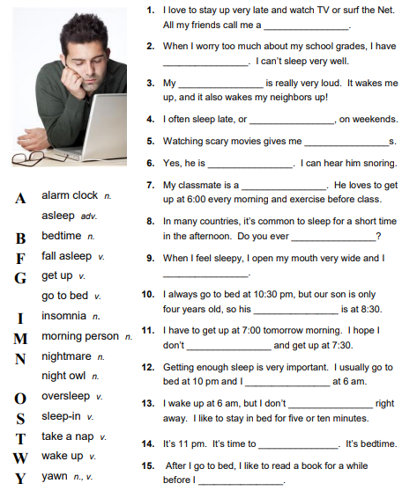

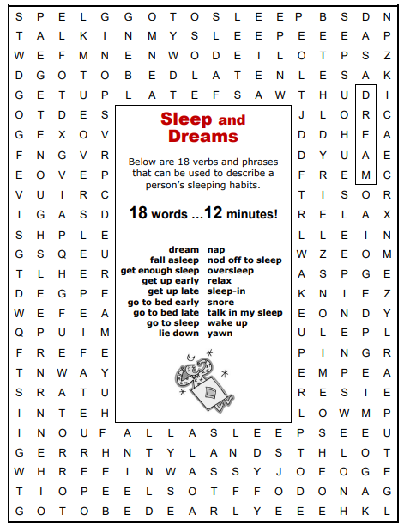
7. Find all the words in the chart

8. Be ready to answer the questions in the chart.
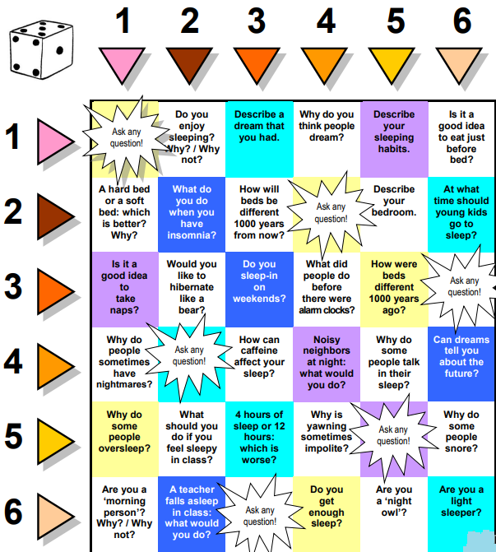

2. Grammar. Used to, be used to, get used to.
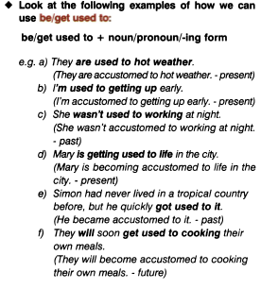
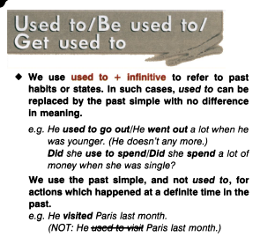

1. Rewrite each person’s comment using used to or didn’t use to.
1. Sally | ‘I don’t walk to work anymore’ | 5. Lisa | ‘I don’t eat junk food anymore’
2. Gordon | ‘I’ve got a dog now’ | 6. Edward | ‘I live in a big house now’
3. Paul | “I’m not shy anymore’ | 7. Helen | ‘I haven’t got long hair anymore’
4. Jane | ‘I go to the gym every night now’ | 8. Frank | ‘I eat lots of vegetables now’
2. Choose the correct answer.
1. ‘I find it hard to get up early.’ – ‘You ___ to getting up early once you start working.
A. are used B. will get used C. were used
2. ‘Do you often exercise now?’ – ‘No, but I ___ to exercise a lot when I was at school.’
A. used B. will get used C. am used
3. ‘Aren’t you bothered by all that noise?’ – ‘No, we ___ to noise. We live in the city centre.’
A. were used B. will get used C. are used
4. ‘Does your sister travel a lot?’ – “no, but she ___ to before she got married.’
A. didn’t use B. used C. wasn’t used
5. ‘I don’t like wearing a suit every day.’ – ‘Don’t worry, you ___ to it very soon.’
A. are used B. will get used C. were used
6. ‘Sandra ___ to using a computer, but now she enjoys it.’ – ‘It’s a lot easier for her now.’
A. isn’t used B. will get used C. wasn’t used
7. ‘Do you remember the things we ____ to do when we were kids?’ – ‘Of course I do. How could I forget what fun we had!’
A. used B. were used C. got used
8. ‘Do you like living in the city?’ – ‘Well, I ___ to it yet, but it’s okay.’
A. am not used B. wasn’t used C. am used
Revision of grammar
Choose the correct variant
1. ‘Sharon looks different now, doesn’t she?’ – ‘Yes. She ___ to have long dark hair.’
A. is used B. used C. will used
2. ‘Do you know that man?’ – ‘Yes. he ___ to work with me.’
A. was used B. used C. is used
3. ‘Why are you so tired?’ – ‘Because I ____ to getting up early in the morning.’
A. am used B. used C. am not used
4. ‘Have you ever lived in a flat before?’ – ‘No. But I will ___ to it.’
A. be used B. get used C. used
5. ‘Did you find your degree course difficult?’ – ‘Yes, but I soon ___ to it.’
A. used B. got used C. was used
6. ‘Aren’t you tired?’ – ‘No. I ___ to walking long distances.’
A. am used B. got used C. used

Unit 6B. Music to my ears.
1. Lexical exercises.
1. Answer the questions
1. How often do you listen to music?
2. What genres of music do you like? Which do you dislike and why?
3. Do you enjoy live music? Have you ever been to any concerts?
4. What is your favourite music band?
5. Have you ever tried to sing or to play any musical instrument? Would you like to?
2. Read the text.
A. Cuban music is born from the rich amalgamation of Spanish folk music formulas and African rhythms. The phenomenal richness of Spanish folklore, mixed with the vigour of African music, created an explosive and exuberant musical tapestry. Quinteto Cha is composed of musicians of different nationalities who play their own interpretations of traditional Cuban music. Mexican singer and songwriter Luis Angulo is backed by four Europeans: female bassist Irmgard Lerch, Alex Zanthis on percussion, flautist Hery Eberhard and huitarisr Günter Kleinmann.
B. The sheep-herding mountaineers of Poland used a style of singing called bialy glos or ‘white voice’; a type of powerful melodic screaming used to communicate across long distances. Warsaw Village Ban travelled Poland’s countryside in search of the old people who could recall the traditional folk music of their regions. The band combines traditional music and experiments with modern instrumentation and subject matter. The Warsaw Village Band’s youthful but mature take on Poland’s roots music has allowed them to introduce this tradition to audiences around the world.
C. The multi-talented Brazilian artist known simply as Joyce combines song-writing, guitar-playing, vocal skills and a flair for feminist themed in her lyrics in a way that makes her unique. On her debut album Astronauta – Song of Elis, Joyce lends her sunny, jazz-savvy voice and guitar work to a programme of beloved Brazilian classics recorded in the ‘60s and ‘70s by the late Elis Regina, the revered vocalist. Astonauta features a cast of Brazilian and North American jazz musicians of global renown. The talents of Grammy award-winning tenor saxophonist Joe Lovano and pianists Mulgrew Milller and Renee Rosnes meld effortlessly with Joyce’s voice and guitar.
D. Cherish and Ladies is an all-female Irish traditional group based in the United States, which first came together in 1985 to perform at an one-off concept concert. Led by native New Yorker Joanie Madden – a former All-Ireland tin whistle camp – Cherish the Ladies has evolved into one of the most influential and beloved traditional Irish music acts on either side of the Atlantic. The Ladies’ ever-changing roster has include some of the most impressive woman in Irish traditional music, from all over the Irish diaspora – including Cathie Ryan, Aoife Clancy, Liz Knowles, and Marie Reilly.
E. Born in the village of Mazoso, in the province of Benguela, Angola, Moises and Jose Kafala both rose to national fame individually before their debut performance together in 1987 in Luanda. The Kafala’s music is best described as Angolan folk music. Their songs reflect real-life experiences, while painting poetic portraits of Angola’s 30-year-long war and continued struggle for national reconciliation. Using a single guitar and flute, the Kafalas are able to tell stories of war, sadness, love and joy with conviction and heartbreaking vocal harmonies which have been known to provoke uncontrollable tears to well up in the eye of those listening.
F. Despite his thin, sometimes strained voice, Gregory Isaacs in one of reggae’s all-time greatest singers, a master of subtle phrasing and sly innuendo who has voices some of the music’s best-known hits. A prolific recording artist and performed, Isaacs has penned classic roots anthems, as well as truly sappy lover’s rock. But no matter which side of Isaacs manifests itself on stage, he’s a riveting performer, driving crowds into a frenzy with the smallest of gestures. For this he’s been dubbed ‘The Cool Ruler’ and is one of the best-loved performers of Jamaican audiences, who have stuck loyally by the singer even when his turbulent personal life got in the way of the music.
3. Study the words.
a roster (n) | a roll or list of personnel | flair (adj) | a uniquely attractive quality
an amalgamation (n) | the action or process of uniting or merging two or more things | revered (adv) | regarded as worthy of great honor and respect
exuberant (adj) | joyously unrestrained and enthusiastic | vigour (n) | active bodily or mental strength or force
a tapestry (n) | a heavy handwoven reversible textile used for hangings, curtains, and upholstery and characterized by complicated pictorial designs | sappy (adj) | resembling or consisting largely of sapwood
a percussion (n) | percussion instruments that form a section of a band or orchestra | frenzy (adj) | a violent mental or emotional agitation
4. In which section was the following information mentioned?
a performer who sings, writes songs and plays an instrument
a single-sex group of musicians that is not fixed
an international musical quintet
musicians based in one country playing music from another
a fusion of traditional and experimental music
a popular musician who had performed in many concerts
a fusion of two ethnic musical traditions
music with biographical themes set in troubled times
a group that has performed internationally
musicians who were famous individually before joining forces
a musician who embraces two distinct musical traditions
an artist who has just brought out their first album
5. Choose the correct answer.
1. There are sites where you can get free music ___ on the Internet, but you need to know where to look.
a) loadings b) downloads c) copies
2. I love that song and if you listen to the ___, you’ll realize it’s incredibly sad.
a) poetry b) sounds c) lyrics
3. The artist would ___ his subject from many different angles before deciding on a final pose.
a) sketch b) doodle c) copy
4. In three days, they’ve sold over 5.000 ___ of their single! It’s fantastic news.
a) albums b) numbers c) copies
5. If you want to be a classical musician, you are going to have to learn how to ____ music.
a) decipher b) read c) listen
6. The official music ___ in the UK include classical as well as popular music.
a) lists b) tables c) charts
6. Choose the correct word.
1. He used to play avant-garde music, but now he’s basically a(n) mainstream / alternative musician.
2. He’s a typical musician, never at home, always on road / tour.
3. We thought we’d see her sculptures in the gallery, but they weren’t on display / parade.
4. Adele’s debut / opening album, 19, was a massive success.
5. She’s been under agreement / contract to the record label XL Recordings since 2006.
6. Who is the lead solo / vocalist for the band Kasabian? Is it Tom Meighan?
7. I’m reciting a poem at school tomorrow and I have to learn it by chest / heart.
8. Whose authority / management were the proup under when they became famous?
7. Fill in the correct word.

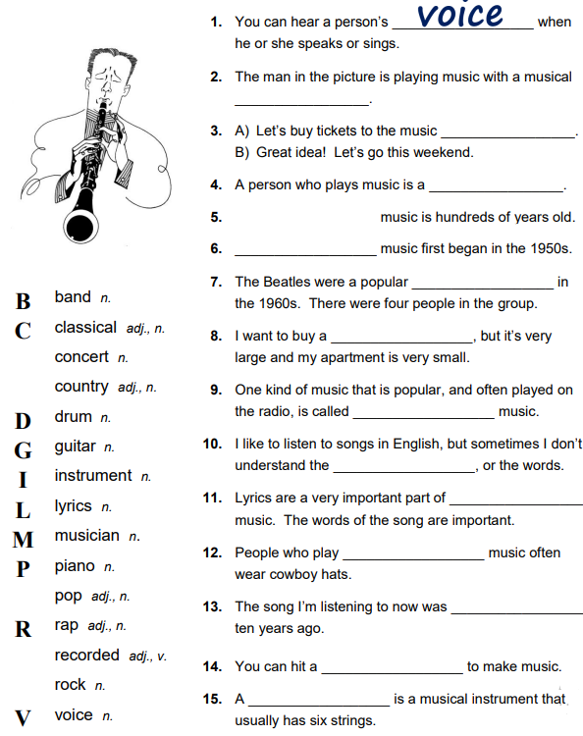

8. Write the word on each letter of the alphabet, connecting the topic ‘Music’.
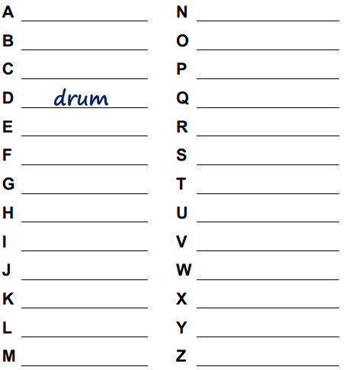

Word formation forming adjectives from nouns
1. Complete the table. Form adjectives from the nouns and verbs below.
care conversation control child depend decision difference dominate entrepreneur fool help humor industry intellect self love play practice respect sense study
-ful | -ish | -ive | -ious/-ous | -ent/-ant | -al | -ing
2. Complete the interview about a family using adjectives from the previous exercise.
Are you a close family? Yes, we are. We all have our own lives and careers so we are not 1)___ on each other, but we remain very close.
Why do you think that is? We were brought up in a very 2) ____ and loving environment and taught to look after each other.
Is there a clear head of the family? It’s quite a 3) ____ and traditional family in many ways. My father is certainly the 4) ____ figure – he gives the orders.
And do you all share a particular family trait? We’re all quite 5) ____ and down-to-earth people: good with our hands.
Is there someone in the family you admire especially? My uncle, who’s a historian. He’s more 6) ___ and quite a deep thinker, but he can also be very 7) ___. He tells some very funny stories.
Has your family influenced your own path in life? Yes. My father in an inventor and I think I have inherited his 8) ____ spirit. I set up my own business when I was 22. he’s also very hard-working and we are 9) ____ types too.
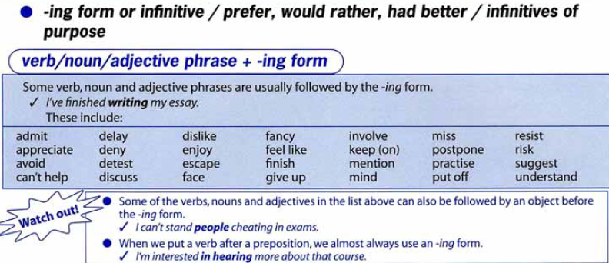
2. Grammar. Gerund and infinitive

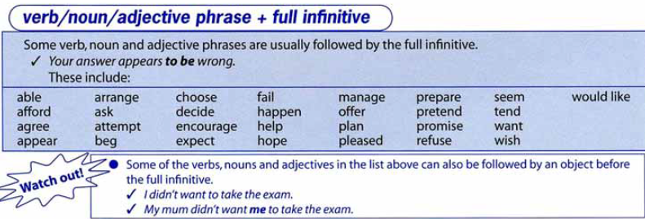

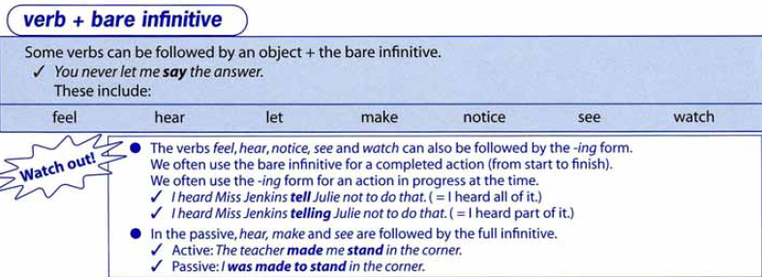

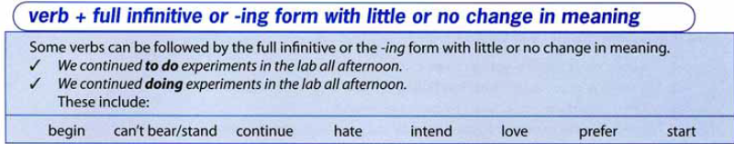

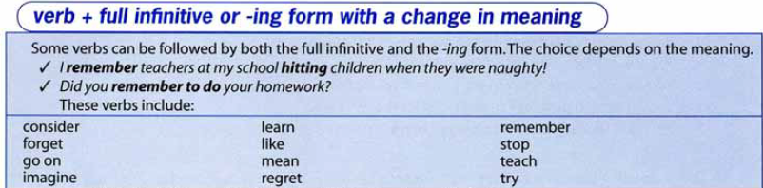

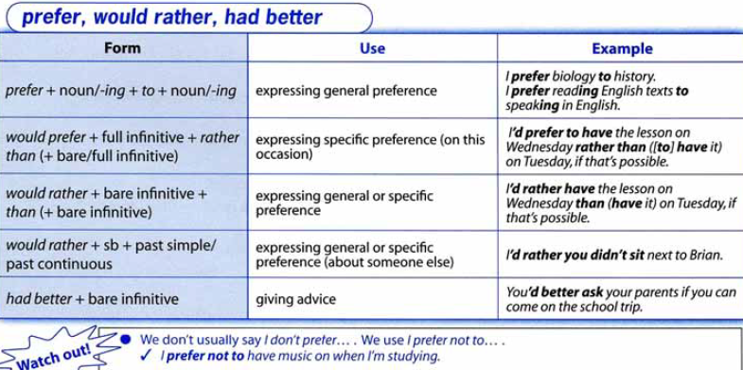

1. Choose the correct variant (Gerund or Infinitive).
1. I really don’t feel like going / to go out tonight. Do you?
2. Everyone expected his business failing / to fail within the first few months.
3. What would you like doing / to do this evening?
4. We discussed turning / to turn the attic unto a spare bedroom with the architect.
5. She wasn’t able speaking / to speak very clearly after her accident.
6. Do you mind moving / to move your car, please? You’re blocking the road.
7. They’re going to postpone making / to make a decision until next month.
8. Are you planning of getting / to get a new computer soon?
9. Are you thinking telling / to tell him about your secret?
10. I’m very pleased of getting / to get the new car.
11. Sarah’s offered putting / to put us up for the weekend.
12. I’m really looking forward to going / to go on the cruise.
2. Use the verbs from the box to fill in the text (use the bare infinitive, infinitive or gerund form).
achieve be behave come do hope improve learn listen make play
sit down tell try use work
Report: William Watson.
William Watson sometimes seems to be afraid of 1) ____ hard. He can’t help 2) ___ to avoid 3) ____ anything that involves 4) ____ his brain, particularly on Friday afternoons. he seems to detest 5) ____ life seriously, and pretends he isn’t capable of 6) ____ anything of worth. This is unfortunate as, with a little more effort, William could succeed in 7) ____ great progress.
However, at present he frequently just wants 8) ____ the fool. He enjoys 9) _____ jokes. Presumably, he imagines this 10) _____ the best way to make friends, but in fact he often ends up preventing the other students from 11) _____. He has promised on several occasions 12) _____ his behavior in class, but he just keeps on 13) _____ in exactly the same way. recently, I have had to beg him 14) ____ and be quiet in the classroom, but it’s difficult to know how to make him 15) ____ to his senses. He just doesn’t understand in 16) ____ to my opinion. I’m tempted to give up even 17) ____ that he might improve. Having said that though, Mr Watson is an extremely good maths teacher! Julie Cross – 5A.
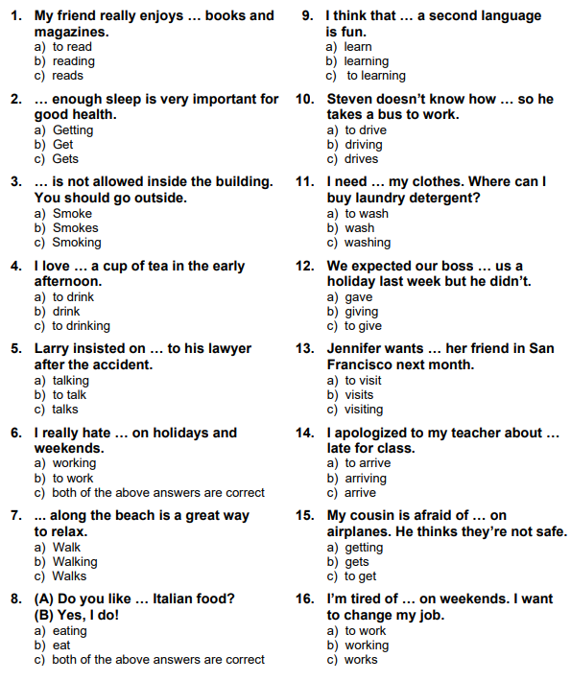
3. Choose the best answer.

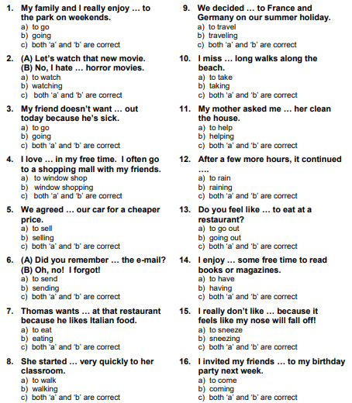

Revision
Fill in the verb in the correct form (Gerund or Infinitive).
1. The pilot decided ____ (delay) take off due to adverse weather conditions.
2. The main problem of a dieting is to advise patients on how best ___ (lose) weight in a safe and sensible way.
3. Would moving abroad mean ____ (sell) your house before you leave?
4. In your opinion, would it be beneficial ___ (conduct) more research into this phenomenon?
5. Matthew doesn’t want to travel this year. He would rather ____ (complete) his bachelor’s degree first.
6. After walking for a very long time, the hikers stopped ____ (take) a rest.
7. Max caught his little brother ____ (look) thorough his desk drawers and demanded to know what he was doing.

Unit 7A. Let’s not argue.
1. Lexical exercises.
1. Answer the questions.
1. Do you like arguing?
2. How often do you argue?
3. With whom do you usually argue?
2. Read the text and answer the question: Why do teenagers join gangs?
The choice. ‘They were my family, you know, they were good for me,’ says Joshua Blake, looking down at the floor, ‘but they weren’t good to other people. That was the problem…, but I was too scared to leave – once you were in, you were in. I didn’t think I had a choice.’
14-year-old Joshua was born in a council estate (an area of houses built and rented out of people by the local government) in South London. Like many of his peers, Joshua experienced hard times and misfortune in his early life. 1) ____. The family lived in a one-bedroomed flat and his mother struggled to pay the bills. She worked long hours as a nurse, so after school Joshua hung out with other boys on the estate. ‘There was nothing to do,’ he remembers. ‘They closed down the youth club years ago, so there was nowhere to go except the streets.’ Joshua became part of a gang with its own rules, its own codes and its own hierarchy. 2) _____. Belonging made him feel safe and gave him a sense of identity. But the crime worried him. ‘There was a lot of mugging and shoplifting, but it was the guns that really scare me. 3) ______.’ The older boys in Joshua’s gang got into armed robbery. Suddenly a lot of money was involved and the gang became very territorial. There was a lot of vandalism – graffiti appeared on buildings and signs were sprayed on shop doors, so people knew the names of the gangs who controlled each area. Knives and guns were used to keep pit other gangs. Things were getting out of control.
Then, one day, something changed. ‘I was walking home from school when a boy rode past on a bike,’ says Joshua. ‘I didn’t recognize him, but he called out my name and when I looked round, he pulled out a gun,’ Joshua was the victim of a revenge shooting. 4) _____. the boy on the bike was from a rival gang, whose leader had been attacked the day before. ‘My mum was devastated when she found out,’ says Joshua. ‘She knew about my misbehavior at school, but she had no idea about the gang. She just looked at me in disbelief, she couldn’t stop crying.’
Three weeks in hospital gave Joshua time to reflect on the choices he had made. he decided he wanted a different life, he wanted to change. 5) _____.
Ben Magoro is a mentor at Youth Inclusion Project, a programme which helps kids escape from gang culture and get back into education. Ben. like many mentors, was a gang member himself. He was involved in car theft and he’d been sent to prison for the offence. Ben understood ‘gang mentality’. ‘It’s like a family,’ says Ben, ‘it’s a family where the mistreatment of “outsiders” is OK, but show a gang member disrespect and you’ll be seriously hurt. It’s a family where crime and dishonesty are OK and any disagreement is solved with a gun. It’s a family that thinks committing crime is an acceptable way to make a living, but belonging to that family is a big mistake – all it does is destroying your life.’
The Youth Inclusion Project offered Joshua a way out and gave him the courage to turn his life around. Projects focus on teenagers’ interests, such as music, sport or fashion. Mentors help them to express themselves, reflect upon their past and make better life choices. ‘In the gang my choice was either die young or go to jail,’ says Joshua, ‘But now I can choose to get an education, I can choose a future … I can choose life.’
3. Complete the article with the sentences A – F. There is one sentence that you do not need.
A. He was shot in the arm, but luckily he survived.
B. There are 169 gangs there, with more than 5.000 members.
C. They were easy to get and easy to use.
D. His father left home when he was a baby, and Joshua and his sisters were brought up by their mother.
E. Its members had code names like P-Man or Stepz, and they looked after each other.
F. That’s when he met Ben.
4. Answer the questions.
1. Why did Joshua go to the gang?
2. What’s the main problem of gangs?
3. How would you help those children you have no other way-out, but go to the gang?
5. Read the text and decide which answer best fits each gap.
Arguing vs Quarreling
Oscar Wilde once remarked that he disliked arguments as they were always vulgar and often convincing. What, 1) _____ is the difference between an argument and a quarrel? Look the word “quarrel” up in a dictionary and you will find it defined 2) ____ an “angry argument”. It seems that “angry” is the 3) ____ word here. Both quarrelling and arguing involve disagreements 4) ____ it is only during the former that we become angry or upset. We may raise our voices or even display aggressive behavior when quarrelling, 5) _____ in an argument, we maintain a 6) _____ tome of voice and refrain from physically threatening out opponent. 7) _____, should we forget the differences in content. An argument is a discussion or debate in which two or more people put forward different or opposing views. They may not be personally concerned in the issues under discussion. 8) ____, the process is an objective, intellectual one. Evidence and logic may be used 9) ____ to support the speaker’s point of view and possibly to convince the other(s). A quarrel, 10) ____, is personal, bound up with the ego and the participants’ sense of self. 11) _____, things that the opponent may have said or done in the past are often dragged up at random as and when they occur to the speaker, in 12) _____ the logical marshalling of ideas which arguing involves. A quarrel may result from a clash of personalities, may hurt the participants and may be sincerely regretted afterwards. 13) ____ that there are hot-tempered people around, they may get carried away in an argument 14) ____ it degenerates into a quarrel, but it should, 15) _____ speaking, be dispassionate exchange of views 16) ____ a shouting match.
1. | a) particularly | b) then | c) although | d) say
2. | a) as | b) like | c) by | d) such
3. | a) key | b) basic | c) code | d) main
4. | a) notwithstanding | b) while | c) consequently | d) but
5. | a) nevertheless | b) when | c) whereas | d) however
6. | a)steady | b) level | c) plain | d) monotonous
7. | a)In addition | b) Also | c) Nor | d) In all
8. | a)Largely | b) Admittedly | c) Particularly | d) Consequently
9. | a)in order | b) in case | c) in the event | d) in effect
10. | a)notwithstanding | b) despite | c) however | d) no matter
11. | a)For that | b) For instance | c) In fact | d) That is
12. | a)comparison with | b) tandem with | c) opposition to | d) contradiction
13. | a)Allowing | b) Granted | c)Given | d) Knowing
14. | a)so there | b) so much | c) so as | d) so that
15. | a)generally | b) usually | c) normally | d) habitually
16. | a)better than | b) rather than | c) more than | d) other than
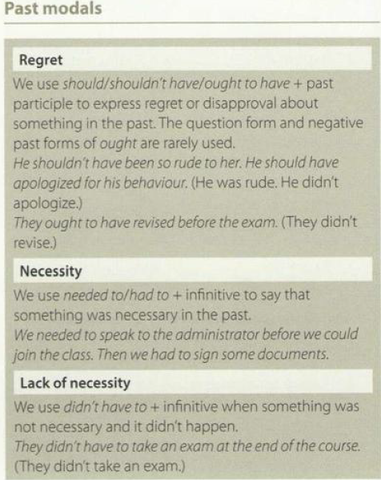
2. Grammar. Past Modals
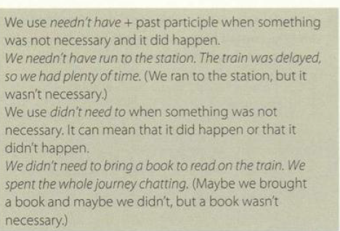

1. Choose the correct word.
1. Due to damage caused by flooding, the exhibits must / could temporarily be removed from display.
2. Close your exam paper! We aren’t supposed / able to oplen it until the examiner tells us to!
3. The parties agree that this contract would / shall form the basis of all future negotiations.
4. Make sure to wear warm clothing in case it should / might snow later on.
5. You shall / might ask before taking my laptop, Jenny!
6. Today I’m going to vote in a national election for the first time in my life = o mustn’t / couldn’t be more excited!
7. It’s no use trying to make John change his mind; he could / can be very stubborn when he wants to.
8. The queue is too long and we’ll never get tickets. We might / should as well go home!
2. Complete the sentences with these words and phrases.
can’t must have need needn’t ought to have should
1. Our garden is covered in snow! It ____ been snowing all night!
2. Rosie is extremely upset about the way you spoke to her; you ____ apologise immediately.
3. You ____ mentioned that a prerequisite for the job was a degree in anthropology – I wasn’t aware of that.
4. Please inform Gareth that he _____ wear a suit to the office tomorrow – it’s casual Friday and most people turn up in jeans.
5. You ____ expect me to believe your excuse, surely?
6. They look exhausted – they _____ to take a break.
3. Read the text and think of the word which best fits each space. Use only one word in each space.
Winter Light Festival.
If you 1) ____ go to any festival in the world, which one would you choose? One of the most beautiful is the ‘Winter Light Festival’ in the Japanese city Kuwana. Over sever million LED lights, powered by solar energy, are used to create dazzling scenes of natural beauty. Stroll in the extensive grounds, admire the incredible flower display and of course, you simply must 2) _____ miss the stunning ‘tunnel of light’. If you visit the park in the late afternoon, you will be 3) ____ to enjoy both the floral beauty by daylight and the illuminations by night. The park 4) _____ become fairly crowded so, in order to avoid the long queues, you 5) _____ to book your tickets in advance. Of course you 6) ____ to buy a ticket to enter the park. but there are discounts for children and families. You don’t need 7) _____ take any extra cash with you as the price of the ticket includes a voucher which can 8) _____ used to buy food and drink or souvenirs at the park. the festival runs annually from November until mid-March.
Verbs often confused
borrow / lend  borrow: receive, use and promise to return sth that belongs to someone else;  lend: give sth to someone for a short time, expecting them to return it | Dad I need to borrow some money.  Ok, I’ll lend you $20 and you can pay me back later.
teach / learn  teach: help someone learn sth by giving lessons or showing them what to do;  learn: acquire knowledge or a skill through having lessons or being shown. | Mr Grimsby teaches history and makes the lessons really interesting.  We’re learning all about the Tudor kings and queens in history this term.
reach / arrive  reach: arrive in or at a place;  arrive: reach a place. | We reached London in the morning.  We arrived in the morning.
sit / set  set: put sth or someone in a particular place;  sit: be in a position where your lower body is resting on the ground or a seat while the top part of your body is upright, or lower your body so you are in a sitting position | Set the vase of flowers on that table.  I set out your clothes on your bed.  Please come and sit here next to me.  I sat next to Linda on the bus.
speak / talk  speak and talk: often used interchangeably  speak: used for formal situations  speak: used for languages  speak: used in certain expressions  talk: used for lengthy discussions  talk: used in certain expressions | I’ll talk/speak to Rosie. She’ll know.  The Prime Minister spoke to the nation.  Jake speaks Spanish fluently.  Can you speak up, please?  Speak for yourself! 1 disagree  We spent the whole afternoon talking.  I talked to my boss for over an hour.  Let’s meet and talk about our summer holidays.  I didn’t offend you; you’re talking nonsense.
bring / take  bring: move from one place to the location where the speaker is; move from ‘there’ to ‘here’;  take: move to a different location; move from ‘here’ to ‘there’. | Can you bring my glasses when you come downstairs, please?  I brought you a cup of tea.  I’ll take the letters to the post office.  Martin took my keys when he left in a rush this morning.
bring, take / fetch  bring and take: movement is in one direction only; something is brought to the place where the speaker is, or is taken to a different place;  fetch: describes going somewhere, getting something and bringing it back; collect something from one place and bring to the place we are now. | I brought you some new flowers.  I’ll take these dead ones to the kitchen.  I can’t read the newspaper without my glasses. Could you fetch them,  please? They’re upstairs next to my bed.  I’m going to fetch the children from school; we’ll be back in half an hour.
hear / listen  hear: notice sounds with your ear; ecogni that someone or something is making a sound;  listen: pay attention to a sound; try to hear the sound that someone or something is making. | I heard the birds singing when I woke up this morning.  Can you hear that strange noise?  I often listen to the radio while driving.  OK. Tell me your news. Vm listening.  Ssh. Listen. What’s that noise?
make / do  make: create or manufacture something, cause someone to do or feel something, force someone to do something;  do: often describes an action or an activity or implies that a task has been completed | Mum made a delicious pie last night  These clothes are made in Thailand.  This film always makes me cry!  My teacher made me do the test again.  What are we going to do this weekend?  Are you doing the ironing? Thank you.  Have you done the shopping?
notice / realize / understand  notice: become aware of something through hearing, seeing or feeling it;  ecogni: know and understand the importance of something; start to know something you hadn’t noticed before;  understand: comprehend information or a situation. | I noticed you were upset this morning; is there anything 1 can do to help?  Jenna notices small details because she’s very observant.  Mia ecogniz her mistake and ecognize.  Jack looked at his watch and suddenly ecogniz how late he was.  Peter understands maths because he pays attention in class.  Dad understood why 1 was angry and didn’t try and make me change  my mind.
recall / remind  recall: remember (and tell someone)  remind: to make someone remember something | I recall our trip to Egypt and how much we enjoyed it.  You must remind Grandad to take his pills; otherwise he’ll forget them  again.
agree / accept  agree: say you will do as somebody asks/wants; say you think the same as somebody else  accept: give an affirmative response to a  request, offer, etc; willingly ecognize a fact, idea, etc | They agreed to postpone the meeting.  Mr Smith agreed to a postponement.  I agree with your plan.  She doesn’t agree.  I accepted the job in London.  He accepts that he was partly to blame.  He accepts his share of the blame.
let / allow / permit  let: give somebody permission to do something  allow: give somebody permission to do  something (more formal than let)  permit: give somebody permission to do  something (more formal then both let and allow) | Mother let me wear her gold earrings.  Please let me in!  The council don’t allow people to cycle in the park.  The council don’t allow cycling in the park.  You mustn’t allow strangers in.  The council doesn’t permit people to build on Greenfield sites.  The council doesn’t permit building on Greenfield sites.
fit / suit / match  fit: be the correct size, shape, etc  suit: be right in terms of colour, shape, etc; also,  be right in terms of character, emotion, etc  match: go well with another item, person, etc | My new dress fits perfectly.  That colour really suits you – you should wear it more often.  Motherhood suits her – she’s much happier now than she used to be.  Those brown shoes don’t match your blue suit.
1. Complete the sentences with the correct form of the verbs.
1. borrow lend
a) I’d appreciate it if you could _____ me your laptop for the meeting.
b) It’s been a week since you _____ my laptop and you still haven’t returned it.
2. bring fetch take
a) Please can you _____ these application forms to Human Resources? I can’t leave my desk right now.
b) My dog’s favourite game is to _____ his ball after it’s been thrown for him.
c) Will you _____ me a cup of tea from the canteen if you’re going?
3. speak talk
a) I’m afraid that in order to apply for this position, you must be able to ____ at least one additional European language.
b) I don’t understand – what are you _____ about?
4. lay lie
a) Please _____ the contents of your bag on the table; we need to verify that ir doesn’t contain any sharp object.
b) We ____ on our backs in the shade of the tree and looked up at the swaying leaves.
5. arrive reach
a) Catherine always _____ at work before anybody of her colleagues.
b) I usually ____ the office after everybody else because I have longer drive.
6. set sit
a) The cat was _____ at the top of a tall tree, looking down at the garden below.
b) Please _____ the tall glasses carefully on the drinks tray and don’t forget to bring some ice, too.
7. beat win
a) We _____ the other team 3 – 0 and our fans went crazy!
b) Our team has been training hard, sp I think we’ve got a good chance of ____ the match.
8. accept agree
a) You’ll just have to ______ that Jenny doesn’t want to be friends with you anymore and move on.
b) Did martin _____ to consider the idea of moving house?
9. hear listen
a) What do you mean ‘a funny noise’? I can’t ____ anything.
b) It’s no use talking to John because he never _____ .
10. deny refuse
a) Danny _____ to take a pay cut and chose to quit his job instead.
b) Do you ____ forging the director’s signature on this letter?
11. rob steal
a) Bill had his car _____ when he left it unlocked outside the supermarket.
b) A gang of masked men ______ the bank and made off with a haul of $2 million.
12. recall remind
a) Will you ______ me to stop at the chemist’s for my prescription on the way home?
b) I hope I’ll be able to ______ all these names and dates for the history exam.
13. notice realize understand
a) We _____ that it was too late to catch the last bus home, so we got a taxi instead.
b) I have never ______ why so many people anjoy watching football. I’ve always found it boring.
c) I didn’t _____ anything wrong with Harry – he seemed fine to me.
14. fit match suit
a) I bought this great pair of dark blue jeans, but now I need some trainers to ____.
b) I don’t think that student life _____ Clifford very well – he seems stressed and tired.
c) That T-shirt doesn’t _____ you any more – can’t you see that it’s far too small?
2. Choose the word or phrase that best completes the conversation or sentence.
1. Will you ____ all these books and papers to my office, please?
a) fetch b) bring c) take d) set
2. ‘Is Leah OK?’ – ‘Yes, we spent hours ____ about her problem and she seems to feel better now’.
a) talking b) speaking c) discussing d) listening
3. ‘Are your cousins getting a taxi from the airport?’ – ‘No, I’m going to ____ them’.
a) take b) fetch c) bring d) go
4. All those in favour of the motion, please ____ your hands.
a) raise b) rise c) rose d) arouse
5. Can you please ____ down and raise your right arm, so I can complete the examination.
a) lay b) lie c) lying d) laid
6. ‘I can’t believe the thieves ____ so much jewellery – they took everything we had in the shop.
a) robbed b) stole c) had d) picked

Unit 7B. It’s all an act.
1. Lexical exercises.
1. Answer the questions.
1. How often do you go to the cinema or to the theatre? Which genres of movies do you prefer?
2. What’s your favorite film? Why do you like it?
3. What’s the worst movie you have ever seen?
4. Do you like animated movies? Or are they just for kids?
5. Are there any actresses or actors who you consider to be very talented?
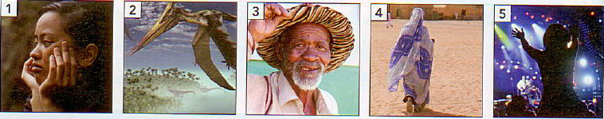
2. Look at the pictures below. How do you think, from which film could they be taken?

Which three criteria from the list below are most important for you in deciding how good a film is? Why?
*plot *well-known actors *soundtrack *special effects *happy ending *scenery *events based on a true story
3. Read the article and match the photographs which you think reflect the content of the films mentioned. Which film appeals to you most? Why?
Film Buff’s Guide to the Movies
Whatever you taste in films, National Geographic Entertainment has something for everyone.
Bored with predictable Hollywood blockbusters with surgery-sweet endings and little more substance than ‘they met, they fell in love, they lived happily ever after’? Then look out for Nat Geo movies. From moving personal accounts of life in remote countries to exhilarating documentaries on extraordinary pre-historic creatures, you’re bound to find what you’re looking for. Here are just some of films available to general audiences and film buffs. Life in a Day is an Oscar-winning film by director Kevin Macdonald in partnership with Ridley Scott’s film company, Scott Free UK and YouTube. When YouTube contributors were asked to submit film footage of their lives on July 24, 2010, the project’s organizers were inundated with over 80,000 videos, making up over 4,500 hours of deeply personal, powerful moments shot by contributors worldwide. Macdonald and his team sifted through these videos and pasted them together to create a remarkable feature-length film. The film shows – with beauty, humour and joyful honesty – what’s like to be alive on Earth today.
The First Grader is a heart-warming and inspiring true story of one man’s battle to gain the education he had been so long denied. Set in a small, remote mountaintop primary school in the Kenyan Bush, the film unravels the story of Maruge (Oliver Litondo), and old Mau Mau veteran in his 80s, desperate to learn to read and write. Maruge’s application, while receiving the support of head teacher Jane Obinchu (Naomie Harris), faces fierce opposition from parents who don’t wants to see a place in the school wasted on such an old man. The First Grader is for viewers aged 13 and over.
Flying Monsters 3D, with Sir David Attenborough, is a groundbreaking film that uses cutting-edge 3D filming technology to bring the story of giant flying monsters and their pre-historic world to life. Around 220 million years ago, dinosaurs were dominant on Earth. Control of the skies, however, fell to another group of reptiles – the pterosaurs,. The story of how and why these incredible creatures managed to defy gravity and tale to the air seems to be more fantastical than fiction. If you’re a fan of state-of-the-art films, then Flying Monsters is for you. Thanks to 3D CGS (computer – generated imagery), these spectacular creatures are recreated and we are invited into their world!
hailed by reviewers as ‘the future of concrete films’ and ‘an explosive, all access U2 concert pass’, U23D sets out to capture the relationship between the band members of pop’s supergroup U2. The film, which was shot in South America during U2’s Vertigo tour there, was made using the largest collection of 3D camera technology ever used on one project. The result is electrifying! Viewers find themselves immersed in the ecstatic world of a live U2 stadium concert.
Desert Flower if the heart-rending tale of Waris Darie (Liya Kebede), who at the tender age of 13, fled her family’s nomadic camp in the Somalian desert. The daring teenager wanted to avoid being married off as fourth wife to a man old enough to be her grandfather. Having made her way through the desert, she manages to track down relatives in Mogadishu, the Somali capital. They arrange work for her as a servant in the Somali capital. They arrange work for her as a servant in the Somali embassy in London. She attracts the attention of Terry Donaldson, the famous fashion photographer. He opens the doors to a completely different world and Darie soon becomes a well-known fashion model. Admittedly, it all sounds like a too-good-to-be-true Cinderella story, but Darie’s life is based on the true story of a supermodel who made her way from the deserts of Somalia to the famous catwalks in the world.
4. Study the words.
exhilarating adj | causing strong feelings of happy excitement and elation | to immerse v | to plunge into something that surrounds or covers
extraordinary adj | going beyond what is usual, regular, or customary | to defy v | to confront with assured power of resistance
a footage n | recorded video material | to capture v | to gain control of especially by force
to inundate v | to overwhelm | a catwalk n | a narrow walkway
remote adj | separated by an interval or space greater than usual | to track down phr v | to follow and finally find smb
to unravel v | to cause to come apart by or as if by separating the threads of | nomadic adj | roaming about from place to place aimlessly, frequently, or without a fixed pattern of movement
5. Choose the correct answer.
1. The writer claims Nat Geo films will appear
a) mainly to fans of Hollywood films.
b) especially to audience who enjoy love stories.
c) only to film buffs.
d) to people of all tastes in films.
2. Life in a Day was
a) produced in only one day.
b) directed by Ridley Scott.
c) filmed by ordinary people all over the world.
d) posted on YouTube.
3. In The First Grader, Maruge comes in for criticism because
a) some people feel he doesn’t deserve a place at the school.
b) he enlists the support of the school’s head teacher.
c) he’s still illiterate at the age of 80.
d) he refuses to go to school when he was younger.
4. What do The First Grader and Desert Flower have in common?
a) They both portray people who built a new life for themselves abroad.
b) The relate the struggles of real people.
c) They use amazing special effects.
d) They are unsuitable for under 13-year-olds.
5. Which film is a documentary that has been produced like a science fiction film?
a) U23D
b) Life in a Day
c) Flying Monsters 3D
d) The First Grader
6. What does the writer confess about Desert Flower?
a) It promotes arranged marriages.
b) It has fairy-tale like qualities.
c) It isn’t for the faint-hearted.
d) It glamorizes the fashion industry.
6. Complete the sentences with these words.
aisles backstage foyer intermission row set usher wings
1. The action took place on a minimalist ____ made up of an armchair and a floor lamp.
2. I’ll meet you in the _____ half an hour before the play starts.
3. We didn’t have good seats; they were in a(n) _____ at the back of the theatre.
4. After the show, Tom went _____ to see if he could get a few autographs.
5. The actor anxiously waited in the ____ before walking onto the stage.
6. It was a wonderful musical and the audience was dancing in the _____ !
7. Do we have enough time to get a drink during the _____?
8. We were shown to our seats by a(n) _______.
7. Choose the correct word.
1. This is a traditional play – you would never call it groundbreaking / heart – warming.
2. I saw the most heart-rending / cutting-edge film last night – even my father had a tear in his eye!
3. My producer / agent is always putting my name forward for films and TV shows. I’m never out of work.
4. Diana is an extraordinary film editor / boom operator. When she puts a film together, she makes magic.
5. We have to listen to the director / producer. After all, without him, there would be no financing for this film.
6. That actress could never learn her acts / lines and always had some holding them up for her in the studio.
7. I’m a(n) usher / gaffer at the National Theatre, so I can stand at the back and watch all the plays for free.
8. James’s ambition is to put on set / stage plays. He just loves the theatre.

8. Fill in the correct word.
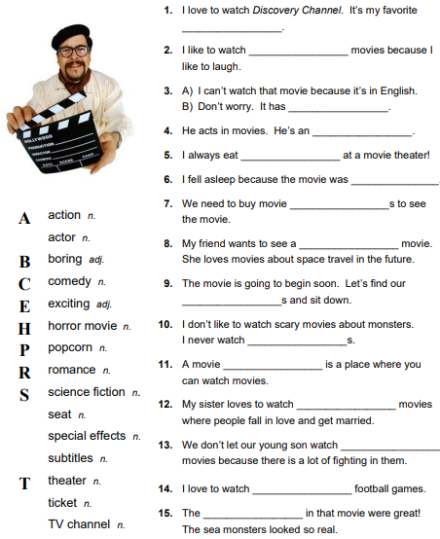

9. Find all the words in the quiz.
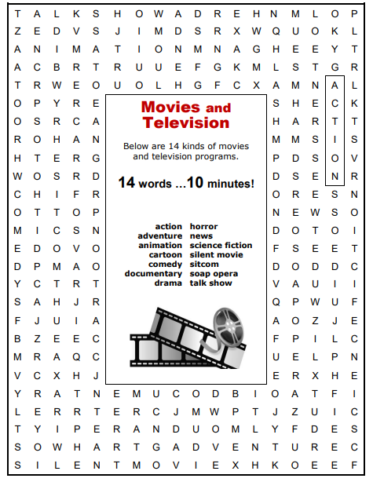

10. Write the words connected with the topic ‘Movies and TV’.
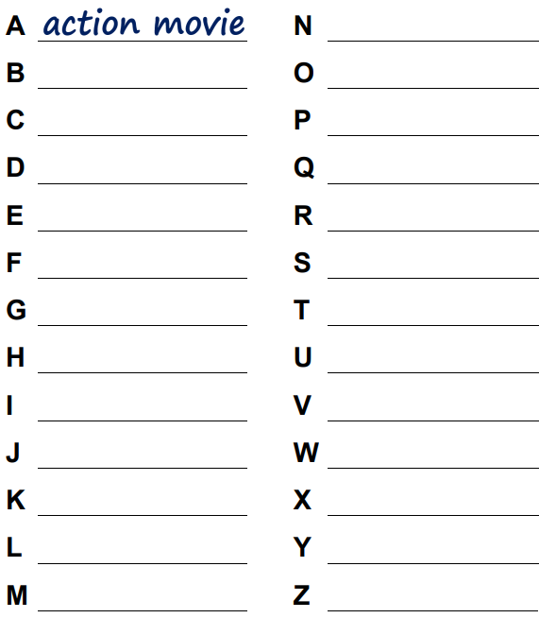

11. Choose the correct answer.
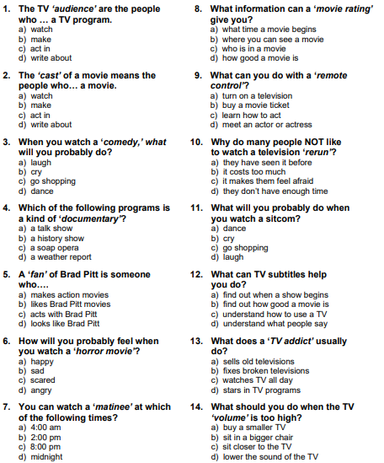

12. Be ready to answer the questions in the quiz.
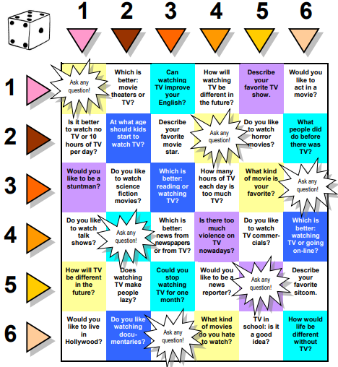

Vocabulary. The Body.
13. Match the verbs in the box with their definitions.
nudge duck kneel crouch tremble fidget curl up shudder frown nod shiver flinch
1. You do it when you make a small sudden movement because sth has hurt you (an injection, for example) or sth has made you jump.
2. Some people do it when they pray.
3. You do it to avoid sth that has been thrown at your head.
4 You do it with your elbow to get someone’s attention.
5 You do it on the floor or on a big sofa, often whilst reading a book or watching television.
6. You do it when you lower your body to the ground by bending your knees. When a football team is having its photograph taken, the players in the front row do it.
7 When you shake because you are cold, you do it.
8 When you shake momentarily because you have seen, heard or eaten something unpleasant, you do it.
9 When you shake because you are frightened, you do it.
10 You do it with your eyebrows when you are angry or you don’t understand.
11 You do it with your head when you are agreeing with someone or when you are saying yes.
12 Kids do it when they can’t keep still.
14. Complete the sentences using an appropriate body word.
1. I was born and bred in London so I know the city like the back of my _____.
2. He’s got football on the ____. It’s all he ever talks about.
3. It was a joke! I was just pulling your _____.
4. They’re so lucky! I’d give my right _____ for a house like theirs.
5. He fell ____ over ____ in love the minute she walked into the room.
6. Business has been awful. We’ve been losing money ____ over _____.
7. Do you see how much better you feel now that you have got it off your ____?
8. “There’s no way we can afford it,” she says. “It’ll cost an _____ and a _____.”
9. She had set her ____ on studying at Oxford but they turned her down.
10. Something was different about the place, but I just couldn’t put my ____ on what it was.
11. She stayed with us for six weeks and she was a real pain in the _____. All she did was criticizing me and complain about everything. When she left, I was glad to see the _____ of her.
12. I think it’s time we got a new television. This one is on its last _____.
2. Grammar. Word formation suffixes
1. Choose the correct suffix for each word. Then write the words. Find three other words with the same suffix.
1. snow -scape / -ness / -ism ____________________
2. metalwork -ist / -ship / -er ________________________
3. craftsman -ism / -ship / -ness _____________________
4. polite - ness / -ist / -ship ______________________
5. saxophone -ship / -er / -ist ________________________
6. romantic -ness / -ism / -scape ____________________
2. Write the correct nouns using the correct suffixes.
1. the style of art that created surreal paintings ______________
2. someone who plays the guitar _________________________
3. someone who presents a show on TV ___________________
4. a painting of a city view ______________________________
5. the state of being calm _______________________________
6. the arts movement that championed modern things _________
7. a picture showing the moon’s surface ____________________
8. the ability to be a musician ____________________________

Test your vocabulary

1. Choose the correct variant and explain your choice.
1. Bad weather has slowed down the ____ for survivors.
A. chase B. research C. search D. quest
2. My history textbook is ____ into six sections.
A. divided B. shared C. broken D. parted
3. Fire quickly ____ through the building and all residents were evacuated.
A. covered B. extended C. spread D. flew
4. A secretary’s ____ include answering the phone and typing letters.
A. duties B. chores C. works D. services
5. Sal stood back to ____ the view from the top of the mountain.
A. adore B. admire C. praise D. value
6. Sarah kept the children _____ by doing jigsaw puzzles with them.
A. employed B. concentrated C. occupied D. engaged
7. We were completely taken by ____ when they showed up at our house uninvited.
A. astonishment B. shock C. surprise D. amazement
8. I didn’t know how to ____ the bad news to her so I said nothing at all.
A. spread B. broadcast C. break D. declare
9. There’s no extra ____ for having your books delivered by post.
A. price B. money C. sum D. charge
10. It was a difficult time, but in the end things ____ all right.
A. set back B. put off C. picked up D. turned out
11. We decide to go for a walk along the ____ of the River Eden.
A. edges B. borders C. banks D. limits
12. Most people support the new law banning traffic from the city centre, but a few _____ it.
A. deny B. disagree C. oppose D. argue
13. It was amazing to see pandas in their natural _____ .
A. residence B. habitat C. territory D. location
Choose the correct item.
14. Please let us know if you are unable to ____ the meeting.
A. intend B. present C. attend D. visit
15. The mayor has made ____ for people with disabilities.
A. provision B. expansion C. adjustment D. arrangement
16. The police said that the driver of the mini bus was at ____.
A. error B. guilt C. mistake D. fault
17. It’s difficult to predict the weather ____.
A. exactly B. evenly C. accurately D. perfectly
18. The windows of our house are all ____ with security locks.
A. furnished B. fitted C. attached D. decorated
19. Physics, Chemistry and Maths are ____ related subjects.
A. widely B. carefully C. heavily D. closely
20. I bought this leather coat at a ____ of the original price.
A. fraction B. sample C. part D. portion
21. Nobody can ____ that Mozart was one of the best composers of his time.
A. defend B. assume C. dispute D. examine
22. Members of our club share a ____ interest in art.
A. joined B. combined C. cooperative D. common
23. The kind of iPhone you buy is _____ dependent on the money you have to spend.
A. quite B. very C. entirely D. alone
24. Don’t ____ the problem; it’s not that serious and it should be easy to solve.
A. extend B. overestimate C. enlarge D. exaggerate
25 Joshua was _____ from the quiz show after he got five answers wrong.
A. eliminated B. expelled C. deported D. evicted
26. My parents don’t ____ of me staying out after midnight.
A. approve B. prove C. agree D. consent
27. Sam has always loved paragliding and other outdoor _____.
A. actions B. activities C. practices D. strategies.
28. What was Tanya’s ____ when you announced her promotion?
A. reaction B. reflection C. action D. reception
29. When no one came to the door, she ____ through the window to see if anyone was home.
A. gazed B. glanced C. stared D. peered.
30. The art museum _____ an entrance fee.
A. prices B. values C. calculates D. charges
31. The students _____ their goal of improving their grades by the end of the term.
A. handed B. controlled C. accomplished D. succeeded
32. The art gallery is running an art competition in ____ with the local council.
A. influence B. association C. direction D. guidance
33. Do we have to _____ tickets for the concert in advance?
A. engage B. conserve C. reserve D. retain
34. We’re all working overtime as our department has a very ____ deadline.
A. tense B. tight C. stiff D. close
35. How did the thieves gain ____ into the museum?
A. entry B. access C. entrance D. admission
36. Please take a seat in the waiting room and I’ll be there with you ____
A. generally B. recently C. shortly D. quickly
37. It’s totally ____ to chew gum in class.
A. unimpressive B. useless C. harmful D. unacceptable
38. Ben tried desperately to _____ Jill, but she was driving too fast for him.
A. catch up with B. take up with C. live up to D. join in with
39. Charles did all sorts of jobs to ____ a living.
A. gain B. earn C. win D. take
40. Angie has the ____ to become a champion tennis player.
A. potential B. efficiency C. advantage D. operation
41. I picked up the phone, dialed the number, but realized the line was _____.
A. empty B. dead C. wasted D. beat
42. A recent study ____ that there is a connection between poverty and crime.
A. calculates B. expresses C. records D. indicates
43. I didn’t realize setting up my own business ____ so much hard work.
A. engaged B. surrounded C. involved D. contained
44. She was sitting in the _____ of a large apple tree.
A. shade B. shadow C. darkness D. cover
45. The T-shirts and sweaters cost $15 and $30 ____.
A. simultaneously B. cooperatively C. primary D. respectively
46. There was such a wide range of goods on ____ that I didn’t know what to buy.
A. exhibition B. shop C. display D. shelves
47. The news of her transfer to another branch ___ as a real surprise to Muriel.
A. went B. made C. came D. was
48. I really enjoy science, but my brother is ____ with it this year.
A. struggling B. fighting C. conflicting D. worrying
49. Stephen likes ____ old motorbikes and putting them back together again.
A. destroying B. uncovering C. dismantling D. demolishing
50. Stan was ____ from school for playing truant.
A. expelled B. excluded C. evacuated D. extracted
51. Hanna has ____ a good knowledge of Chinese.
A. obtained B. acquired C. registered D. accessed
52. It’s preferable to buy vegetables in small ____ for your immediate use.
A. numbers B. volumes C. quantities D. loads
53. I took great ____ in telling everyone they had been given a pay rise.
A. amusement B. pleasure C. fun D. enjoyment
54. The new school rule applies to all students without _____ .
A. exception B. alteration C. distinction D. exclusion
55. Some children are never ____ to the fine arts.
A. shown B. accustomed C. exposed D. acquainted
56. Twenty miners were _____ underground when the mine collapsed.
A. caught B. held C. hidden D. trapped
57. It will take two to four weeks to ____ your university applications.
A. process B. proceed C. progress D. programme
58. Some people think that the theatre is a ____ form of entertainment to the cinema.
A. better B. higher C. superior D. greater
59. When you go mountain climbing for the first time, you must be ____ of all the potential dangers.
A. awake B. aware C. alert D. attentive
60. Everyone clapped when the tennis players appeared on the _____.
A. pitch B. stadium C. court D. course
61. The sea was _____ and I got seasick.
A. wavy B. uneven C. fierce D. rough
62. There were twenty ____ for the job, but only Jane was hired.
A. entrants B. employers C. employees D. candidates
63. You are required to fill this application ____ and sent it to us via email.
A. letter B. form C. paper D. document
64. Passengers are kindly requested to ____ the plane.
A. go up B. ascend C. board D. get up
65. Our company plans to open seven new ____ across the country in the next few months.
A. categories B. divisions C. wings D. branches
66. After being struck by the tornado, farmers have ____ to the government for help.
A. appealed B. addressed C. submitted D. proposed
67. The study ____ that children’s behavior is influenced by television.
A. consented B. concluded C. concerned D. complained
68. You can’t walk through that field. It’s ____ property.
A. personal B. exclusive C. private D. reserved
69. Unless you have extensive experience it’s difficult to ____ a business.
A. work B. act C. make D. run
70. The ____ of the experiment is to find the better ways of treating infections.
A. result B. direction C. necessity D. purpose
71. I was ____ when my exams were over.
A. relieved B. pleasant C. eased D. calmed
72. Helen was upset because she’d had a ____ with her sister.
A. fuss B. complaint C. battle D. quarrel
73. I was so ____ with the noise and pollution in the city that I moved to the countryside.
A. put up B. taken up C. fed up D. taken aback
74. Julie ____ herself badly when she slipped on the icy pavement.
A. damaged B. wounded C. harmed D. hurt
75. Having access to a clean water supply is ____ important for everyone in the village.
A. considerable B. totally C. vitally D. completely
76. He is a very ____ person and males friends easily.
A. outspoken B. outright C. outlying D. outgoing
77. The police asked me to describe the robber’s physical ____ .
A. character B. properties C. appearance D. qualities
78. My children have ____ the age when they can care for themselves.
A. achieved B. reached C. realized D. arrived
79. There was a blank _____ on Hannah’s face so I had no way of knowing whether she was upset.
A. expression B. attitude C. impression D. image
80. The police officer admitted that the man was arrested by ______.
A. fault B. mistake C. error D. defect
81. Honey and lemon is a home ____ for sore throats.
A. solution B. cure C. help D. remedy
82. The northeast ____ of the country gets a lot of rain in the autumn.
A. district B. region C. field D. land
83. Scientists have formulated a new theory to explain the ____ of the universe.
A. seed B. origin C. spring D. root
84. The story has ____ a lot of attention in the press.
A. appealed B. invited C. drawn D. attracted
85. I can’t make our appointment today; we’ll have to ____ it off until next week.
A. pull B. get C. put D. set
86. Max made ______ progress in his language class.
A. rapid B. active C. speed D. lively
87. The young author’s first book was a huge success, but the ____ was rather disappointing.
A. sequel B. series C. continuation D. chain
88. Some of my college courses are _____, while others are optional.
A. vital B. compulsory C. essential D. forced
89. The population of this country is _____ 10 million.
A. closely B. generally C. approximately D. clearly
90. You are required to have the proper _____ to work as an accountant.
A. qualifications B. qualities C. experiments D. experiences
91. Have you seen the ____ edition of our school magazine?
A. freshest B. highest C. latest D. foremost
92. The building was completely _____ in the fire.
A. harmed B. crushed C. destructed D. destroyed
93. I’m going to _____ visit my great-grandmother next week.
A. have B. do C. pay D. give
94. We aren’t allowed to set up camp here unless we get _____.
A. license B. authority C. pass D. permission
95. You must follow the safety instructions to _____ accidents.
A. decline B. avoid C. refuse D. resist
96. It’s cruel to keep animals in ______.
A. slavery B. prison C. captivity D. detention
97. David was not ____ in the class discussion.
A. inserted B. involved C. partIcipated I. taken
98. I had ____ feelings about my parents’ decision to move to France.
A. mingled B. merged C. messed D. mixed
99. Our new CD will not be on _____ until the next month.
A. purchase B. sale C. market D. retail
100. I don’t mind going to the post office; it’s no ____ at all.
A. matter B. difference C. concern D. trouble
Test your grammar

Choose the correct item.
1. “Your sweater has shrunk.” – “It didn’t ___ occur to me to check the label and I washed it in hot water.”
A. even B. still C. never D. somewhat
2. “Why are you all excited?” – “Jane’s coming home from college ___ than we expected!”
A. even early B. too early C. very early D. much earlier
3. After training for 3 years, she got a job ___ a certified nurse.
A. of B. like C. as D. for
4. “I don’t see any reason why we shouldn’t go by plane.” – “Well, my ___ concern is the cost.”
A. most great B. greatest C. great D. greater
5. He boasted ____ the tournament five years in a row.
A. to have won B. for having won C. from his winning D. about having won
6. Jonathan keeps fir ___ working out three times a week.
A. by B. with C. from D. at
7. The weather forecast reported that temperatures in the area had reached 42ºC and ____ by 5º.
A. expected to rise B. expected that it will rise C. were expected that is rose D. were expected to rise
8. “I don’t think Greg is used to working shifts.” – “Actually, ____.”
A. neither am I B. me, too C. so am I D. I don’t either
9. There was ____ much thick smoke that they couldn’t see across the hallway.
A. so B. such C. too D. very
10. “Do you remember ___ the heating before you left the office?” – “Yes, first I switched the heating and then the lights.”
A. turning off B. to turn off C. turn off D. to turning off
11. “How long have you been playing the piano?” – “___ I was on primary school.”
A. When B. Ever since C. Whenever D. By the time
12. “What did you buy for Nicholas?” – “I bought him ____ polo shirt.”
A. an expensive, cotton, blue
B. an expensive, blue, cotton
C. a cotton, blue, expensive
D. a blue, cotton, expensive
13. “Are you ready to play the lead role tonight?” – “I’ve read my lines ____ times that the performance will be just perfect.”
A. many more B. so many C. quite a few D. too many
14. “You didn’t send me the information I requested.” – “I ____, but my Internet connection was down.”
A. would B. can’t have C. would have D. could
15. ____ being overpopulated many metropolitan cities are highly polluted.
A. Besides B. Because C. However D. In addition
16. “Does he know anything about the latest technological advances in computing?” – “Yes, he’s very …”
A. knowing B. knowledge C. knowledgeable D. known
17. All my life I’ve dreamt ____ a pilot.
A. to be B. I am being C. of being D. being
18. “How did your interview go, Vince?” – “I have a feeling they might ____.”
A. to me offer the job B. offer the job me C. offer to me the job D. offer me the job
19. More people would enroll on the course if it ____ offered earlier.
A. were B. would be C. should D. will be
20. She was thrilled ____ I told her the good news.
A. as B. before C. as soon D. when
21. “Do we have to hand in the assignment by Friday?” – “I’m afraid we’ve got ___ choice.”
A. no any other B. no other
C. not another D. not any other
22. I’m determined to travel to Chine ____ much it costs.
A. considering how B. more over C. no matter how D. whatever
23. “I’m so disorganized!” – “How about changing the order ____ you do things?”
A. in which B. which C. within that D. where
24. “It’s not very polite to laugh ____ a fellow classmate who gets am answer wrong.” – “I am sorry, it won’t happen again.”
A. with B. at C. to D. for
25. My brothers are _____ good at Maths.
A. equally B. unequal C. equality D. equal
26. “Basketball practice starts at 6 o’clock, _____ it?” – “Yes, that’s right.”
A. doesn’t B. won’t C. hasn’t D. isn’t
27. ____ of his suitcases was large enough to fit all his clothes.
A. Both B. Neither C. Every D. All
28. “Look at those graphics!” – “that picture must have been taken ____ a professional camera.”
A. by B. with C. from D. of
29. It is only the second time I ____ Tim raise his hand in class.
A. saw B. have seen C. see D. had seen
30. Fortunately, I _____ find the USB stick I’d misplaced the other day.
A. could B. managed to C. was able to D. succeeded to
31. The charity event attracted many celebrities, some of ____ I knew by sight.
A. whom B. them C. which D. who
32. According to a study, three ___ ten people find maths too challenging.
A. from B. of C. in D. for
33. My teacher ____ me to research all my options before I applied to a specific university.
A. recommended B. suggested C. advised D. insisted
34. The curator asked us ____ any of the statues.
A. to not touch B. please stop touching C. not touching D. not to touch
35. “You know, we’re running out of time on this project.” – “it’s precisely ____ we need more time that we should ask for an extension.”
A. since that B. due to C. though D. because
36. “Can you afford ____ such an expensive car and maintain it?” – “Yes, I’ve recently been promoted.”
A. to buying B. buying C. to buy D. buy
37. “The textile factory caught fire yesterday.” – “I know! The flames ____ several miles away.”
A. could be seen B. saw C. could see D. were seeing
38. The local residents were ____ the council’s decision to demolish the old theatre.
A. disappointed of B. disappointed from C. disappointed to D. disappointed with
39. ____ her inexperience, she gave an impressive performance.
A. Because of B. Although C. However D. In spite of
40. “Which one of ____ computer games should I buy Todd for his birthday?” – “I think he’d like that one.”
A. this B. them C. these D. theirs
41. We ____ cleared up the beach without the help of volunteers.
A. never have B. may not be C. could never have D. had never
42. “Have you seen my mobile anywhere?” – “Yes, you’ve left it on the ____.”
A. kitchen’s table B. kitchen tables C. kitchen table D. kitchens’ table
43. I spent ____ weekend revising for my final exams.
A. most of the B. most of C. the most of the D. the most
44. By the time we finished the report everyone else ____ home.
A. has gone B. had gone C. went D. was going
45. “We really need a break.” – “Yes, we ____ since 9 o’clock this morning.”
A. have been revising B. are revising C. revise D. were revising
46. “Luckily the mistake ____ last night before the article went to the printer’s.” – “That saved us a lot of work!”
A. discovered B. been discovered C. has discovered D. was discovered
47. I carry my money in my pocket because I am afraid _____.
A. of losing them B. that I lose it C. of losing it D. I lost them
48. We didn’t finish on time _____ our best efforts.
A. because of B. in spite of C. regardless D. even
49. Help _____ to some cookies!
A. yourself B. ourselves C. herself D. you
50. Helen’s never late so she ____ be held up in traffic.
A. should B. can C. must D. needs to
51. Randy succeeded _____ for the 100 m sprint.
A. to qualify B. in qualifying C. qualify D. qualifying
52. Northern Europe’s economies are heavily ____ natural resources.
A. dependent with B. dependent for C. depending on D, dependent on
53. _____, I didn’t look forward tI Ixercising at the gym, but now I really enjoy it.
A. Firstly B. First C. At first D. In the first
54. If you’d been more attentive, you ____ what the teacher was saying.
A. would hear B. could hear C. would have heard D. must hear
55. As soon as Sarah ____in, ask her to help you.
A. comes B. will come C. is coming D. would come
56. I was made ____ for hours before I had my leg examined at the emergency room.
A. wait B. to wait C. waiting D. to have waited
57. There weren’t any new members at the club, ____ I can remember.
A. as far as B. as long as C. as much as D. as well as
58. “We _____ by Leo’s announcement to leave the company.” – “I know! I was left speechless.”
A. surprised ourselves B. had surprised C. were surprised D. found surprise
59. My mother worked part-time ____ we were growing up.
A. just B. after C. before D. when
60. “Did you hear that Nick had his car ____ into last night?” – “Oh no! That’s terrible!”
A. breaking B. broken C. broke D. break
61. “My parents are really keen on my studying law.” – “Oh really? I thought you were _____ in pursuing an acting career?”
A. interesting B. interest C. interested D. interestingly
62. “Could I talk to Peter, please?” – “Well, I’d rather you _____ him while he’s sleeping.”
A. didn’t disturb B. don’t disturb C. weren’t disturbing D. hadn’t disturbed
63. “You really must finish ____ your chores before you go out this afternoon.” – “I know. I’m nearly done.”
A. to be doing B. to do C. doing D. to have done
64. “Have you finished typing up that report?” – “No. Sorry, but I’m not capable ____ typing any faster.”
A. of B. for C. with D. at
65. Jenny ____ the keyboard since she was 5.
A. is playing B. has been playing C. plays D. was playing
66. We’d better tidy up the kitchen ____ Mum will get angry.
A. although B. or else C. instead D. Ilsewhere
67. TIe new head teacher has _____ a huge difference since she arrived.
A. done B. made C. taken D. marked
68. The sales assistant was very ____ and I brought a new laptop, a scanner and printer!
A. convince B. convinced C. convincingly D. convincing
69. “ _____ I borrow your netbook?” “Sure, go ahead!”
A. Would B. Should C. Will D. May
70. There was no mention ____ the burglary on the evening news.
A. for B. to C. with D. of
71. “Edward, you _____ have taken the early train because the meeting was cancelled last night.” – “I wish someone had told me about it.”
A. can B. might C. could D. may
72. Does Mary sing ____ her brother?
A. as good B. as well as C. as good as D. as well is
73. “More and more people are becoming involved ____ conversation project.” – “Yes, and that’s very encouraging.”
A. about B. on C. in D. of
74. Tommy won’t go to bed _____ you tell him a story.
A. unless B. supposing C. if D. provided
75. “I now regret ____ school so young.” – “Well, it’s never too late to carry on with your studies, you know.”
A. leave B. to leave C. leaving D. to be leaving
76. The shop assistant told me that I ____ produce a receipt to exchange my goods.
A. will B. may C. might D. had to
77. “Is this castle really haunted?” – “That’s ____ most people say.”
A. where B. what C. how D. why
78. “This area used to have a lot of wildlife.” – “I know. It’s sad that you hardly see ____ animals around here nowadays.”
A. many B. some C. no D. any
79. It’s getting _____ to find employment these days.
A. more hard B. hardest C. more and harder D. harder and harder
80. I have very little experience _____ using this computer program.
A. on B. about C. in D. over
81. Not all students can afford to wear _____ labels.
A. designer B. design C. designing D. designed
82. “I’m looking for Mr. Patterson/” – “he’s the brown-haired gentleman ____ at the reception desk.”
A. sitting B. who sitting C. who’s he sitting D. that sitting
83. A flying saucer was _____ seen flying over the city.
A. report B. reported C. reportedly D. reporting
84. “I’m having trouble with geometry.” – “_____ studying together this weekend?”
A. Why not B. How about C. Why don’t we D. Should we
85. Fred can’t go to that heavy metal concert because his parents _____.
A. not let it B. don’t allow C. won’t let him D. won’t allowed him
86. All students at our school _____ to wear a school uniform.
A. require B. are required C. have required D. they require
87. Joe _____ staying in a hotel to staying at a campsite.
A. would rather B. would prefer C. had better D. prefers
88. _____ scientists predict that the Earth will get warmer.
A. Most of the B. Most C. The most D. Most of

СПИСОК ВИКОРИСТАНИХ ДЖЕРЕЛ
1. Dooley J. New Enterprise B1+. Student’s Book. UK Ltd : Express Publishing, 2020. 159 p.
2. Dooley J., Evans V. Grammarway 4. Oxford : Express Publishing, 2008. 276 p.
3. Dummett P., Hughes J., Stephenson H. Life. Upper-Intermediate. Student’s book. Hampshire : National Geographic Learning, 2013. 162 p.
4. Eastwood J. Oxford Practice Grammar (Intermediate). Oxford : University Press, 2008. 445 p.
5. Evans V., Doodley J. Enterprise 4 Intermediate. Grammar. UK Ltd : Express Publishing, 2017. 159 p.
6. Evans V., Doodley J. Enterprise 4 Intermediate. UK Ltd : Express Publishing, 2017. 198 p.
7. Evans V., Dooley J. On Screen. Upper-Intermediate. Student’s Book. UK Ltd : Express Publishing, 2014. 132 p.
8. Evans V., Dooley J. Round-up 6. Oxford : Pearson Education Limited, 2011. 260 p.
9. Foley M., Hall D. My Grammar Lab. Intermediate B1 / B2. Edinburg : Pearson Education Limited, 2012. 385 p.
10. Mann M., Tazlore-Knowles S. Destination B1. Oxford : Macmillan Publishers Limited, 2008. 256 p.
11. Mitchel H.Q. Grammar and Vocabulary Practice. London : MM Publications, 2008. 168 p.
12. Prodromou L. Grammar and Vocabulary for Cambridge First. Second Edition. Edinburg : Pearson Education Limited, 2012. 304 p.
13. Wildman J., Beddall F. Insight. Upper-Intermediate. Student’s Book. Oxford : Oxford University Press, 2014. 166 p.

СПИСОК РЕКОМЕНДОВАНОЇ ЛІТЕРАТУРИ

- Dooley J., Evans V. Grammarway 3. UK Ltd : Express Publishing, 2008. 269 p.
- Latham-Koenig Ch., Oxenden C., Chomacki K. New English File. Upper-Intermediate (Student’s book). 4th ed. Oxford : Oxford University Press, 2020. 170 p.
- Latham-Koenig Ch., Oxenden C., Chomacki K. New English File. Upper-Intermediate (Work book). 4th ed. Oxford : Oxford University Press, 2020. 75 p.
- Mann M., Taylore-Knowles S. Destinaion B2. Grammar and Vocabulary. New-York : Macmillan Publishers Limited, 2008. 258 p.
- Mei-Yin V.Ch. Grammar Plus B2. English Grammar. Reference and Practice. Lorento : Tecnostampa – Pigini Group Printing Division, 2015. 130 p.

Навчальне видання
(англійською мовою)

Приходченко Олександра Олексіївна

ІНОЗЕМНА МОВА ПРОФЕСІЙНО-КОМУНІКАТИВНОЇ СПРЯМОВАНОСТІ
(англійська)

Практикум
для здобувачів ступеня вищої освіти бакалавра
спеціальності “Хімія” освітньо-професійної програми
“Хімія”

Рецензент І.І. Широкова
Відповідальний за випуск С.В. Іваненко
Коректор О.О. Приходченко

