МІНІСТЕРСТВО ОСВІТИ І НАУКИ УКРАЇНИ ЗАПОРІЗЬКИЙ НАЦІОНАЛЬНИЙ УНІВЕРСИТЕТ

І. О. Андрєєва, М. В. Залужна, С. П. Запольських

ПРАКТИЧНИЙ КУРС ІНОЗЕМНОЇ МОВИ (АНГЛІЙСЬКОЇ) ДЛЯ ВИКЛАДАЧА-ДОСЛІДНИКА

Навчально-методичний посібник
для здобувачів вищої освіти освітньо-наукової програми третього рівня (підготовка докторів філософії) усіх спеціальностей
2 рік

Затверджено
Вченою радою ЗНУ Протокол № 2 від 29.09.20

Запоріжжя 2020

УДК 811.111(076) А-655

Андрєєва І. О., Залужна М. В., Запольських С. П. Практичний курс іноземної мови (англійської) для викладача-дослідника : навчально-методичний посібник для здобувачів вищої освіти освітньо-наукової програми третього рівня (підготовка докторів філософії) усіх спеціальностей. 2 рік. Запоріжжя : ЗНУ, 2020. 62 с.

Навчально-методичний посібник містить тематичні тексти та практичні завдання з програмних тем курсу “Практичний курс іноземної мови (англійської) для викладача-дослідника”, а також методичні рекомендації щодо їх виконання. Посібник сприятиме формуванню мовної та мовленнєвої компетенцій майбутніх докторів філософії, а також відпрацюванню навичок, необхідних для складання іспиту на отримання міжнародного мовного сертифікату РТЕ General Level 3 (рівень В2).
Посібник призначено для здобувачів вищої освіти освітньо-наукової програми третього рівня (підготовка докторів філософії) усіх спеціальностей денної, вечірньої та заочної форм навчання.

Рецензент
К. М. Василина, канд. філол. наук, доцент, доцент кафедри англійської філології

Відповідальний за випуск
О. А. Каніболоцька, канд. пед. наук, доцент, доцент кафедри викладання другої іноземної мови

ЗМІСТ

ПЕРЕДМОВА ……………………….……………...………………………....… | 4
MODULE 8. Models of Verbal and Non-Verbal Behaviour in Academic Environment………………………………………………………………………. | 6
MODULE 9. Scientific Experiments and Emergency Situations. ………………. | 18
MODULE 10. Problems of Education and Culture.……….………...……........... | 30
MODULE 11. Pearson English International Certificate (CEFR B2). PTE.  Listening Section.…...………..……………….………………………………..… | 43
MODULE 12. PTE. Reading Section.…………….……………………..……….. | 47
MODULE 13. PTE. Writing Section. …………………..……………..…………. | 54
MODULE 14. PTE. Speaking Section.………………………..……………….… | 57
СПИСОК ВИКОРИСТАНИХ ДЖЕРЕЛ……………………..…………...……. | 61

ПЕРЕДМОВА
В сучасних умовах модернізації системи вищої освіти України та переходу до стандартів європейської системи навчання у вищій школі третього рівня особливо актуальним стає питання іншомовної підготовки майбутніх докторів філософії.
Реалізація нових підходів до вивчення іноземної мови передбачає вирішення додаткових задач в підготовці майбутнього фахівця, серед яких вироблення у аспірантів мовних та мовленнєвих навичок, культури повсякденної та академічної комунікації, формування раціональної методики оволодіння мовним матеріалом, її узгодження з європейськими стандартами іншомовної підготовки.
«Практичний курс іноземної мови (англійської) для викладача- дослідника» – дисципліна, що входить до циклу загальної підготовки майбутніх докторів філософії усіх спеціальностей та спрямована на оволодіння ними іншомовними компетентностями.
Метою курсу є формування у майбутніх докторів філософії (PhD) компетенцій, необхідних для реалізації подальшої професійної, наукової та міжнародної проектної діяльності, академічної мобільності, а саме – участі у міжнародних конференціях, семінарах, презентаціях, стажуваннях, проєктах різного рівня, які вимагають високого рівня володіння англійською мовою (Рівень В2 та вище згідно загальноєвропейських рекомендацій з мовної освіти CEFR).
Основними завданнями вивчення дисципліни «Практичний курс іноземної мови (англійської) для викладача-дослідника» є:
- розвинути основні мовні та мовленнєві навички (аудіювання, читання, говоріння і письмо);
- навчити використовувати лексичні, граматичні та стилістичні особливості англійської мови, що є необхідними для адекватного вираження відповідних ідей та понять, а також для розуміння і продукування широкого спектру текстів у професійній діяльності (усно та письмово);
- покращити вміння сприймати текст на слух (з опорою та без опори на друкований текст), розуміти мовлення носіїв англійської мови та стимулювати активне обговорення отриманої інформації в аудиторії та онлайн середовищі;
- сформувати готовність майбутніх докторів філософії до складання іспиту на отримання міжнародного мовного сертифікату РТЕ General Level 3 (рівень В2 згідно загальноєвропейських рекомендацій з мовної освіти CEFR).
Навчально-методичний посібник має на меті удосконалити знання англійської мови та сформувати навички вільного користування її лексичними і граматичними ресурсами для висловлення точки зору на загальні та професійні теми, розуміння складного усного мовлення на суспільні, академічні та професійні теми, зокрема ведення наукових дискусій з власної спеціальності. Цьому сприятиме опрацювання запропонованих у посібнику текстів широкої

тематичної спрямованості, загальнонаукових та фахових текстів, що містять аргументацію і дискусійні положення, резюмування змісту та окремих деталей текстів. Окремий розділ посібника займають комунікативні вправи, спрямовані на моделювання вільного й ефективного спілкування у більшості повсякденних та професійних ситуацій; висловлення власної думки з відповідними поясненнями та аргументацією, розгорнуті описи та презентації на професійні, наукові та фахові теми з аргументацією та відповідними прикладами. Посібник також спрямовано на ефективне володіння навичками письмової комунікації та форматами писемного мовлення. Важливе місце у посібнику посідає ознайомлення з форматом іспиту РТЕ General Level 3, змістом його структурних частин Written Paper (Listening Sections 1-3, Reading Sections 4-7, Writing Section 8), Spoken Paper (Speaking Sections 10-13) та типовими завданнями в кожній секції, оволодіння тактиками та стратегіями (Exam Strategies), що уможливлюють успішне виконання завдань кожного розділу; окреслення потенційних труднощів, що можуть виникати у кожній секції, та шляхів їх подолання.
Структура навчально-методичного видання відповідає програмі дисципліни та корелює з тематикою програмного підручника. Кожен тематичний модуль містить розділи “Grammar”, “Vocabulary”, “Reading and Listening”, “Writing”. Такий розподіл матеріалу покликаний допомогти аспіранту оптимізувати роботу над іноземною мовою, узгодити її з програмними вимогами, приділити увагу вдосконаленню всіх мовних та мовленнєвих компетенцій у рівному обсязі.
Особливу увагу у пропонованому посібнику приділено актуалізації лексико-граматичного матеріалу (Grammar & Vocabulary), що відповідає вимогам рівня B2 загальноєвропейських рекомендацій з мовної освіти CEFR, засвоєнню актуальної тематики Speaking Section; ознайомленню з вимогами до написання типових письмових завдань, практиці написання, виконання практичних тестів-зразків РТЕ General Level 3.
У запропонованому виданні наголошено також на важливості аналізу можливих помилок та виробленню алгоритму пошуку правильних відповідей, задля чого пропонується проходження mock-тесту (тесту, що максимально імітує усі вимоги справжнього).
Методичні рекомендації призначені для для здобувачів вищої освіти освітньо-наукової програми третього рівня (підготовка докторів філософії) усіх спеціальностей денної, вечірньої та заочної форм навчання.

MODULE 8
MODELS OF VERBAL AND NON-VERBAL BEHAVIOUR IN ACADEMIC ENVIRONMENT

Grammar/Function

  - hypothetical past and mixed conditionals

Find and correct the mistakes in six of the sentences.
  - If we’d know about the party, we might’ve gone.
  - They could’ve get a cinema ticket for half price if they were going tomorrow.
  - I won’t have had a haircut like that if I were him.
  - If she would’ve been born in the nineteenth century, she wouldn’t have inherited her father’s money.
  - They mightn’t have bought tickets if they’d known the play was so dreadful.
  - If the truck hadn’t swerved, it wouldn’t hit the bus and injured so many people.
  - If they hadn’t been found by the helicopter, they could died in the mountains.

Use the prompts to write two conditional sentences for each situation.
- George broke his leg. He was in hospital. He didn’t tell me. I didn’t visit him.
  - if / George / break / hospital

  - if / I / know/ visit

- We didn’t enjoy our holiday. The weather was terrible. We came home early.
- if / the weather / be / enjoy / more

- if / we / enjoy / come

- He lost his job. He didn’t have any money. We were able to lend him some. He didn’t ask us.
- if / he / lose / have

- if / he / ask / we / lend

- Another car was speeding. It crashed into Linda’s. Linda was wearing a seat belt. She wasn’t badly hurt.
- if / the other car / speed / crash

- if / Linda / wear / be / hurt

- Some friends came to visit. They didn’t tell me. I didn’t prepare any food. I’m annoyed.
i) if / they / tell / me / prepare

j) if / I / prepare / be / annoyed

  - -ing form and infinitive

Find and correct the mistakes in the sentences.
  - What time are you arriving? We’re all really look forward to seeing you.
  - You’d better to go to bed early if you’ve got an exam tomorrow.
  - He tends talking too much in meetings. Nobody else gets a chance to say anything!
  - If you want to get on, it’s important keeping your emotions in check at work.
  - Think of ideas is easy. The difficult part is making them work
  - I’d rather to try something and fail than not do it at all.
  - I avoid to drink coffee late at night as it keeps me awake.
  - My boss is very understanding. She always lets me to take time off when I need to.

Complete the conversation with the correct form of the verb in brackets.
A: Are you staying here long?

B: Just a couple of days. We’re looking forward to ¹
(go) to the

beach and just ²

(explore) the countryside a bit.

A: There are some beautiful places to visit but you should avoid ³
(go) to the beach. It gets really crowded
at this time of year.
B: So what would you recommend instead?
A: Well, personally I’d rather ⁴ (visit) the national park than ⁵ (spend) time on the beach. There are fantastic walks in the forest and you can swim in the river. The water so clear and refreshing – it’s very cold though.

B: Sounds great! We both love ⁶
(walk) but I’m not sure about

⁷ (swim) in cold water! Anything else you’d recommend?
A: Well, you mustn’t ⁸ (miss) the market on Sunday. And if

you like ⁹
(visit) ruins, there’s an interesting castle in the

next village. It’s certainly worth ¹⁰ .

handling an awkward situation 1 Underline the correct alternative.
    - Do you know what I mean/say?
    - There’s something I’ve been/I’m meaning to talk to you about.
    - I’d/I feel better if you warned me next time you’re going to be late.
    - I don’t like/want you to get the wrong idea, but it’s just that you are using my mug, and it was a present from my girlfriend.
    - It would put my mind/head at ease if you’d call me when you get home.
    - I know it takes time to clean the dishes after every meal, but the kitchen is a mess. Do you see where I come/’m coming from?

2 Put the conversation in the correct order, 1–15.
- Mark: Andy, have you got time for a coffee or something? 1
- Andy: Why, what’s wrong? 2
- Mark: Right, that makes me feel a lot better. So I have a suggestion, to start with. Would you like to hear it?
- Mark: You see?
- Andy: What reaction?
- Andy: See what?
- Mark: Look, Andy. I hope you don’t take this the wrong way, but that’s, um, it’s that kind of reaction that bothers me.
- Mark: Well, how can I put it? It’s just that I feel you react very aggressively to anything I say at work. It makes me wonder, you know, what I’m doing wrong. Do you see what I’m saying?
- Mark: Nothing serious. But there’s something I’d like to talk to you about.
- Mark: I’d feel great!
- Andy: I’m sorry. I know I’m extremely impatient these days. If I didn’t have so much to do, I might be able to relax a bit more.
- Andy: Yes, please, go ahead.
- Mark: I was thinking, um, maybe you could breathe in and count to five before you say anything. And then speak a bit more slowly and well, you know, gently. How does that sound?
- Andy: One, two, three, four, five. It sounds good! Now, let’s go for that coffee. How would you feel about that?
- Andy: Well, go on then! Say it!

Consolidation
1 Choose the correct answer, a), b), c) or d).
Hi Mum and Dad,
I hope it doesn’t come as too much of a shock ¹
blue, but there’s something I’ve wanted ²
now. I don’t want to upset you both, but if I ³

this mail out of the to you about for a while the wrong decision

now, I ⁴

regret it forever.

You know I haven’t been very happy at university so far. I thought it was just

part of ⁵ in and getting used ⁶
here.

But it doesn’t ⁷ to be getting better. Honestly, I have tried to fit in and ⁸ friends. But I miss you so much – and I miss ⁹ rugby and hanging out with the guys after matches. I keep ¹⁰

myself, ‘If you ¹¹
just concentrate on your studies, it’d all be fine’.

If only I could, but I hate maths and wish I ¹²
economics instead. I

see now that I shouldn’t ¹³

come to university yet.

If I’d decided to take a gap year first, I’d have ¹⁴ in Australia now!
I really want to leave university. How would you ¹⁵ about that? I hope you can see ¹⁶ I’m coming from and I’m really sorry if you ¹⁷
let down. I’ll see you this weekend and we can talk. Love, Paul x

1 a) get | b) will get | c) to get | d) got
2 a) to talk | b) talk | c) talked | d) talking
3 a) won’t | b) do | c) wouldn’t | d) made
4 a) ’d | b) have | c) can | d) should’ve
5 a) to settle | b) settle | c) settling | d) will settle
6 a) be | b) to being | c) to be | d) to
7 a) seems | b) seem | c) seeming | d) like
8 a) make | b) making | c) doing | d) do
9 a) to play | b) playing | c) going | d) watch
10 a) telling | b) to tell | c) tell | d) am telling
11 a) might | b) could | c) did | d) will
12 a) chose | b) ’d chosen | c) ’ve chose | d) choosing
13 a) had | b) have | c) been | d) be
14 a) went | b) visited | c) travel | d) been
15 a) put | b) get | c) mean | d) feel
16 a) how | b) where | c) when | d) what
17 a) feel | b) ’ll feel | c) ’d feel | d) feeling

Vocabulary

  - Collocations: decisions

Underline the correct alternatives.
  - I’m sorry you feel our staff have been impolite. Let me to arrive at/look into
the situation for you.
  - You’re doing the right thing. Explore/Stick to your principles.
  - If we can’t explore/reach a decision about where to live together, I don’t think we should move.
  - We really need to decide tomorrow. We can’t assess/postpone it any longer.
  - Stick to what you know is right. Never look into/betray your principles.
  - We need to evaluate/arrive at the situation before making a decision.
  - We don’t have to decide now. We could always follow/put off the decision until later.
  - If you follow/put off your principles, you won’t go wrong.

Compound adjectives
- Find and correct five mistakes with vocabulary. Tick the correct sentences.
- Simon’s had a life-changed operation.
- There’s a long-running soap opera on TV that’s over sixty years old!
- Max is very well-qualifying for the position.
- Putting all those flyers into the envelopes was so time-consumed.
- I love handmake gifts. They’re so much more personal than bought ones.
- I hear the burglar escaped by climbing a six-metre-high fence.
- The criminal was given a twelve-years-long sentence.
- Would you like the vase bubbled-wrapped to keep it safe?

Compound adjectives for describing people
- Match a beginning in A with a word in B and an ending in C to make sentences.
A | B | C
1 Those bright green high- | eyed | man at the desk over there.
2 I think brown- | fitting | when I go on holiday.
3 Please take this form to the curly- | haired | shoes are hideous!
4 Rob bought a brand- | haired | coat in the sale yesterday. It’s quite nice.
5 These jeans are too tight- | heeled | although he dyes it blond.
6 Tomasz is so broad- | new | that he can’t find shirts to fit him.
7 I never get very sun- | shouldered | dogs are so cute. It’s the way they look at you.
8 Kaz is actually dark- | tanned | for me. I can hardly breathe.

1 Those bright-green high-heeled shoes are hideous!

Values
- Complete the conversation with the words in the box.
aggression control equality generosity greed justice power

A: Did you see that bad-tempered political debate last night? The host wasn’t in ¹ of the situation at all.
B: Yes, there was some real ² showed by both sides.

A: One candidate thought there was no ³
in the time they got to

speak. He thought the other candidate had more time to speak, so he got angry.
B: That’s right. I was interested in their views on law and ⁴
though. I agree with what they were saying about tougher punishment for criminals.

A: And at least they agreed on the problem of ⁵
corporations. Surely the biggest companies should pay the most tax.
in big

B: Yes, and they both said that ordinary people don’t have enough ⁶ , and should have the opportunity to make more decisions about the way the country is run.

A: Strange really, maybe they should show that kind of ⁷
other next time!
to each

Behaviour
- Underline the correct alternatives.
  - That website was unhelpful/supportive. It didn’t tell me how to fix my vacuum cleaner at all.
  - My boss is always arguing with people. I don’t like his
collaborative/confrontational style.
  - Beth always thinks ahead carefully before any trip. She’s so
sensible/sensitive like that.
  - Jake shouldn’t be so quiet in meetings. He needs to be more
tactful/assertive.
  - Nothing will stop Alex when he starts a project. He’s so direct/focused.
  - I’ve got no time for angry and diplomatic/ aggressive people.
  - Your feedback on my presentation was constructive and
confrontational/tactful. Thank you.
  - We all worked on this presentation. It was a supportive/collaborative effort.

Behaviour idioms
- Complete each sentence with one word. The first letter in each word is given.

- I know I shouldn’t talk behind Andrea’s b , but I have to tell you what I just found out.
- Stand up for yourself! Don’t let her w all over you!
- My flatmate doesn’t lift a f to help with the cleaning.
- Our teacher’s great. He always goes out of his w to help us.
- I think Adam’s upset. He needs a s to cry on.
- Su’s really lovely. She’s always willing to give me a helping h .
- Are those two arguing again? They can’t speak to each other without locking h . .
- I love my dad. He’s always t for me, whenever I need him.

Focus on well

Cross out the adjectives in the box that cannot come after well-. What adjectives can they follow?
balanced behaved built chosen consuming distance done dressed educated informed organized paid qualified spoken tempered working

- Match the compound adjectives with well- from Exercise 7 with their meanings 1–12.
  - selected effectively

  - with the right knowledge or skills

  - not too much of one thing

  - uses the right words clearly and politely
  - has a good amount of knowledge/facts about a topic
  - meat that is completely cooked

  - receives a good salary

  - has a high level of schooling

  - acts in a polite way

  - wears attractive clothes 11 with muscles; not skinny 12 planned very carefully

Complete the sentences with compound adjectives from Exercise 8.
- To keep healthy, I try to have a diet with plenty of food from different food groups.
- We need to be really before the presentation. We don’t want to forget something and look silly.
- The most stressful jobs are often, but not always, very .
- You need to be strong and to be a rugby player.
- The tour guide was brilliant. Funny but . She knew all the history.

- Our family holiday’s been to make sure everyone will have something to do there.
- Lucas was so at the restaurant today. He didn’t scream or cry once.
- Ana’s . In fact, I think she did her PhD at Harvard University.
- I’d like my steak , please.
- Ken’s not really to talk about the subject. What does he know about it?
- Olav’s a young man. He talks with a lovely, gentle voice.
- Make sure you’re for your job interview. You want to give a good first impression.

Listening and Reading
1 Work in pairs and discuss.
- Think of a pet you have had or any animal you have known. Can you remember what made the animal happy or sad?
- How easy is it to judge a pet’s mood?
- How do our own moods or behaviour inﬂuence our pets?

Read the article about behaviour in dogs and answer the questions.
  - Why is our dog’s behaviour more unpredictable these days?
  - What is the difference between our dogs’ lives today and in the past?
  - What can we do to make our dogs happier?

Feeling anxious? Chances are, so is your dog
Do you know when your dog is happy: it wags its tail, jumps up at you when you come home and runs around a lot. But what about when your dog is down? If he could tell us what the problem was, he would, but he can’t – and sometimes we’re so busy that we just don’t notice that anything’s wrong.
We live in stressful times – pressure to perform at work, deadlines, family responsibilities – and this affects our behaviour and those who live with us. It can also affect our pets, particularly dogs, which tend to be more dependent on us.
In fact, dogs are very good at picking up on our mood swings. If we are aggressive, they might become so, too. If we are worried, they might start pacing up and down. But it is our neglectful behaviour which really has an affect on a dog’s temperament. Cases of canine anxiety are on the up, leading to a need for antidepressants to deal with the stress of living with us humans. The doggy variety is called ‘Reconcile’ and with just one tablet a day, it seems your dog could really cheer up.
You might laugh, but all this is hardly surprising. In the past, dogs worked in the country, they were outside the whole time and their owners let them wander around freely. At the end of the day, they would be ‘dog-tired’ (this is where the English

expression comes from). Now, dogs might only go out with a dog-walker and perhaps for just half an hour a day. The rest of the time they are left alone on the sofa. We forget that dogs don’t only need exercise but also attention and stimulation.
If they don’t get this, they can develop compulsive disorders like whimpering or chasing their own tails. Such lifestyle changes might also explain how our pets can suddenly surprise us with antisocial or wild behaviour that seems uncharacteristic and confrontational. We forget that simple games can turn nasty and that the cute dog we pet at home can suddenly turn into a predatory beast without very much warning. With dogs, the particular problem is boredom and lack of company. Dogs also like consistency on the part of their owners. If your behaviour and habits suddenly shift, this can upset a dog and make its interactions with you unpredictable as well.
So, you could resort to ‘Reconcile’, but it would probably be better to understand what’s going on with your dog. If there seems to be a problem, you could do a lot worse than start by looking at your own behaviour!

Read the article again. Underline the correct alternative.
- It is harder/easier to see when your dog is depressed than when it is happy.
- Sometimes dogs mirror our own behaviour/ do the opposite to what we do.
- The author thinks it is logical/surprising that an antidepressant for dogs has arrived on the market.
- Lifestyle changes mean that dogs can be depressed and unfriendly to their owners/ generally unpredictable.
- The article says that dogs feel happier when there is a routine to follow/they have constant attention.
- The author concludes by saying that it is better to focus on yourself/the dog’s world than attempt to understand the dog’s behaviour.

Complete the sentences with the correct form of the verbs in the box.
be on the up deal with
cheer up
resort to
wander around
turn into shi upset

  - You can walk your dog on a lead but it’s better if you can let it freely.
  - The trend for getting ‘designer dogs’ , it’s becoming really popular here.
  - It’s amazing how your pet can suddenly a wild animal, it’s quite scary.
  - When you have a dog you have to all kinds of things, it’s a big responsibility.
  - If you take your dog for regular exercise, it is bound to .
  - Your pet’s behaviour can suddenly if something shocking happens.

  - To solve a pet’s problem, you don’t need to discipline.
  - Separation from its owner can dogs a lot. They often feel very sad.

Work in pairs or small groups and discuss.
- Do you agree that human behaviour can alter a dog’s behaviour?
- Do you think it’s fair that people keep dogs in cities?
- What other problems can occur with dogs or can dogs cause?
- Does having a cat cause the same problems?

Listen to a conversation between a dog lover and a cat lover about the behaviour of their pets. Choose the best summary of their conversation.
- Moira loves that dogs are real companions, Ken doesn’t want a pet to be too demanding.
- Ken hates that dogs smell, Moira doesn’t like the idea of having an independent pet.
- Moira believes that you can’t trust cats, Ken says that you shouldn’t need to train an animal.

Listen again. Are the sentences true (T) or false (F)? Correct the false sentences.
- Moira says that dogs are more trustworthy than cats.
- The problem for Ken is that dogs take over your life.
- Moira understands that independence is a positive virtue in pets.
- Ken would like to play more with his cat.
- Ken complains that dogs are dirty.
- In the end, they agree to disagree.

The words in the box are from the recording. Complete the sentences with the words in the box.
reliable needy obedient
self-sucient
interactive adaptable neurotic fearful

- I can’t stand animals who are too , it’s just too demanding to be with them.
- Dogs are not always . Sometimes they don’t pay attention to you at all.
- My dog worries about really unimportant things, he’s getting !
- I love my cat but she’s so , I feel like she doesn’t need me sometimes.
- My dog always tries to communicate with me and she loves games, anything which is .
- Some dogs can become of ﬁreworks and loud noises.

- People say that cats are not as as dogs, but I can really trust my cat.
- Some people say it’s not good to keep a big dog in a small ﬂat, but I think you can. Dogs are to different locations.

Work in pairs or small groups and discuss.
  - Do you live in a pet-friendly society or not? In what way is this apparent?
  - Would you like where you live to be more permissive or less so with pets?
  - Do you think pets can be a substitute for a human? If so, how?

Writing
an informal article

WRITING TIP
When you write an informal article, you should use conversational language and talk directly to the reader. Although the article is informal, it is important to structure it clearly. Write an introduction, separate paragraphs to illustrate your different points and a conclusion.

A Read the first paragraph of the article below. What is it about? What advice do you think the author is going to give?

B Read the rest of the article and check your ideas. Do you think that the article is clearly structured? Why/Why not?

Do you panic when exam time comes around? Are you always up late the night before, cramming for the exam the next day? If you answered yes to these two questions, I think I might be able to help you! Here are some ideas that have worked for me when I’ve done exams – and they just might work for you, too!
First of all, you need to prioritise. Not all exams are equally important – some are much more important than others! So, if an exam is really vital, schedule more time for revision but if it’s not crucial, don’t spend so long preparing for it. For what it’s worth, here’s what I do… First, I rank my exams in order of importance. Then I draw up a revision timetable a long time before the exams begin. Personally, I find it much easier to do a bit of revision every day over a long period rather than to revise like crazy just before the exam.
Second, you need to stick to your plan. This is the hard bit! A couple of months before you have to do your exams they can still seem a long way off, so it’s difficult to find the motivation to get down to any serious work. Don’t let this happen to you! I’ve found that the best way round this problem is to have a fixed routine – so I try to revise every day at the same time, just as if I was doing a job.
Finally, you’re much more likely to pass an exam if you spend time revising the things that you find difficult – and not the things that you can do in your sleep! Of

course, we all like to focus on stuff what we already know because it’s easier. But how is studying what you already know going to help you pass your exams?
If you follow these tips, I think you’ll have a much better chance of doing well in your exams. It goes without saying that you’ll need to be disciplined and organised. So, have you got what it takes?

Put the underlined words and expressions in the article in the categories below.
  - personal examples

  - talk directly to the other person

  - contracted forms

  - conversational language

  - linkers

Match these formal phrases with informal ones in the article.
- revise intensively in a short space of time (paragraph 1)

- a little (paragraph 2)

- rigorously follow (paragraph 3)

- things (paragraph 4)

4 Write an informal article on one of these topics (250–300 words).
How to make friends How to become rich How to be healthier

Plan your writing
- Think about the content of your article.
- What points do you want to make?
- Organise your points into separate paragraphs and write a short conclusion.

Check your writing
- Have you used informal language?
- Have you used linkers to structure the article?
- Have you checked your grammar and spelling?
- Did you find any mistakes?

MODULE 9
SCIENTIFIC EXPERIMENTS AND EMERGENCY SITUATIONS

Grammar/Function

  - -ing form and infinitive

Put the words in the correct order to make sentences and questions.
  - vegetarian / eat / in / prefers / restaurants / food / to / he
He
  - you / the / to / evening / would / home / like / at / spend?
Would
  - see / in / her / not / I / regret / hospital / going / to
I
  - do / learning / to / want / go / English / you / on
Do
  - he / her / but / to / tried / too / angry / speak / she / was / to
He

Complete the sentences with the correct form of the verbs in brackets.
- You must stop (bite) your fingernails, Kim. You’ll have none left!
- The thief got into the house because Jay forgot (lock) the window last night.
- Did you remember (post) my letters yesterday?
- If the wi-fi doesn’t work, try (switch) off the modem for one minute.
- I’ll never forget (see) the Beatles perform live in 1963.

- Can we stop somewhere soon (have) a coffee?

- The garage said they’d try (fix) the car by Wednesday.
- Some people prefer not (watch) violent films on TV.

3 Find and correct the mistakes in the sentences.
- We discussed annual sales and then went on talking about production levels.
- Just before we left the house, I remembered picking up the passports and tickets from the table.
- I regret informing you that you have failed your driving test.
- I’m beginning understanding why things went so wrong between us.
- You should taking the dog for a walk at least once a day.

past modals of deduction
- Match statements 1–5 with responses a)–e).
  - They went on holiday to Australia.
  - Do you think Joe Bad was the kidnapper?
  - Sara was in an extremely bad mood yesterday.
  - I haven’t seen the Smiths around recently. Have you?
  - Miss Jones is late for the meeting.
- I know. She might not have been feeling well.
- She may have missed the bus this morning.
- No, he was in prison at the time so he couldn’t have done it.
- Really? That must have been nice for them.
- No, but they can’t have gone away. I saw a light on in their hall last night.

Respond to statements 1–6. Use the prompts in the box and the modal verbs in brackets.
be / my wife pipe / break
car / break down
get lost / fog have / argument water

- There was water all over the kitchen floor this morning, but now it’s gone. (could)

- Pete and Lisa have split up. (must)

- Two climbers have been reported missing. (may)

- A woman phoned you, but didn’t leave a message. (can’t)

- The dinner’s ready, but they haven’t arrived yet. (might)

3 Complete the second sentence so it has a similar meaning to the first. Use past modals of deduction.
- Maybe she was watching TV when they broke in. She .
- I don’t believe that he was stalking me!
He .
- It’s possible that a hacker broke into his computer and stole his identity. A hacker .
- Surely the police didn’t arrest our son for vandalism! The police .

- I didn’t understand what he said, but maybe he was trying to help us.
I didn’t understand what he said, but he .
- Evidence shows that the gang broke into the museum during the night. The gang .

reporting an incident
- Complete the witness statement with phrases a)–i).
I first saw him while I was sitting in the park. He ¹

George

Clooney. He was putting a bag in the litter bin. I ² it was strange

because it was quite a big bag. The man ³
he was very tense

and nervous. It was ⁴

that a woman came along and took the

bag out of the bin. She opened it and looked inside quickly. She
⁵ with what she saw. She called someone on her mobile, but I didn’t ⁶ because I was a bit too far away. It ⁷ so quickly. It didn’t ⁸ that she was one of the kidnappers until I saw the news on TV just now. Then it ⁹ that I should call you immediately.
  - all happened
  - cross my mind
  - catch what she said
  - occurred to me
  - seemed pleased
  - remember thinking
  - reminded me of
  - only a minute later
  - looked as if

- Put the conversation in the correct order. Police officer: So tell me what she was wearing. Witness: That’s right, shoes with high heels.
Police officer: What you saw in the park.
Police officer: High heeled shoes?
Witness: Oh right! Seeing the woman and the bag, yes.
Police officer: Ready, Miss? I’ll take your statement about the incident now. 1
Police officer: Yes, the crime, the shoplifting you witnessed.
Witness: Yes, a red scarf – and black trousers. Her shoes were red too with sort of high bits at the back.
Police officer: A scarf?
Witness: Incident?
Witness: A black coat and red, um, you know, the thing to put round your neck.

Witness: Witnessed?

Consolidation
1 Choose the correct answer, a), b) or c).
A: Excuse me, security officer. I want to report a theft! A woman stole my mobile!
B: OK. Calm down and tell me what happened.
A: Well, I was sitting outside that café over there texting a friend. I’d promised
¹ her where to meet me, and ² do it. Suddenly, a

woman came to my table and offered ³
me a magazine. She put a

pile of them on the table and I stopped ⁴ look at one. Then I bought it and she left. It never occurred to me that she was a thief!
B: Did you see her steal the phone?
A: No, but it ⁵ have been anyone else. Nobody came near the table except her. She’d put the magazines on top of the mobile. Then she ⁶
picked it all up when she left.
B: When did you notice the phone had gone?
A: It was only when I went to pay the bill that I realised⁷ happened. I ran around the shopping centre trying ⁸ her, but nothing.
B: Do you remember ⁹ like?
A: She was quite young, with short dark hair and a nice smile. She
¹⁰ me of that actress from The Hunger Games. Oh, and I remember

her ¹¹
didn’t ¹³
a document ¹²
the name.
that she was from a charity. But I

B: That’s all very useful, Miss. Could you go to the police station later? We will need ¹⁴ statement.

1 a) to tell | b) tell | c) telling
2 a) had forgot | b) forgot doing | c) had forgotten to
3 a) selling | b) to sell | c) to selling
4 a) texting to | b) to text to | c) texting
5 a) can’t | b) must | c) could
6 a) may have | b) must have | c) might have
7 a) what had | b) what | c) what did
8 a) to finding | b) to find | c) finding
9 a) how looked | b) what she look | c) what she looked
10 a) occurred | b) reminded | c) seemed
11 a) showing me | b) to show me | c) showing to me
12 a) claiming | b) to claim | c) claim
13 a) caught | b) catched | c) catch
14 a) to take | b) to taking | c) to catch

Vocabulary

  - Crime

Underline the correct alternatives.
  - Every night, the same person follows me as I walk home. I hope she’s not
hacking/stalking me.
  - There was a mugging/shoplifting in town today. A man grabbed a woman’s bag while she was shopping.
  - It doesn’t matter if the stolen item was small. Shoplifting/Bribery is still a crime.
  - There was a fire at the internet café last night. The police suspect
hacking/arson.
  - The rise in bribery/counterfeiting has seen a lot of fake £20 notes in everyday use.
  - I can’t stand the theft/vandalism in this town. One of our windows was smashed last night.
  - That child kidnapping/hacking case is making all the headlines. They’re asking for $1m.
  - A thirteen-year-old boy’s been charged with stalking/hacking into a government database.

Dependent prepositions
- Complete the sentences with the correct prepositions.
- A local businessman has been accused bribing a government official.
- Two suspects were later arrested hacking government websites.
- A local man in his twenties is suspected robbing a shop last month.
- Police had to apologise arresting the wrong suspect.
- The emergency services were criticised not responding quickly enough.
- The coastguard has rescued two sailors their damaged boat.
- The jury cleared the defendant all charges.
- A woman has thanked residents coming to her rescue during a mugging.
- A teenage boy has been charged the theft of a car.
- A colleague of mine has been banned driving after she drove at 150 kilometres per hour down the motorway.

Find and correct five mistakes with prepositions in the news story.

Local businessman wastes police time
The arrest of local businessman Mr Rice has made headlines today. He was

mistaken of a notable bank robber who has carried out a series of high-profile thefts in the South of England, and his photo was published in a local newspaper by mistake. After the photo was published, Mr Rice was heard boasting with the crime in a local café and joked about hiding for the local police.
After his arrest Mr Rice stated that he was not serious about being the notorious bank robber and that he had never participated of any crime. Mr Rice has been condemned for his actions and is very likely to be fined for wasting police time. Some newspapers are calling for him to be punished in wasting police time.

Synonyms
- Write one word in each gap to complete the conversation. The first letter in each word is given.
A: I was completely ¹t by a thief last night.
B: Oh no. How did he ²f you?
A: He ³p to be a police officer, but it was just a trick to
⁴d my attention. While he was talking to me, someone else walked round the back of the house and ⁵s my bike.
B: Oh, I’m so sorry. It’s horrible to be ⁶d by someone, especially when they’re ⁷p as a person of authority. You don’t know who to trust anymore!
A: Don’t worry, I won’t ⁸f for it again!

Incidents
- Find and correct the mistake in each sentence.
  - That poor kitten has got stick up in that tree!
  - The point of bowling is to see how many pins you can kick over.
  - The car’s making a strange noise. I hope we don’t break up.
  - I lost my keys while I was out and now I’m locked in my house.
  - Apparently police have stopped a group of people from stealing the bank.
  - Mariana got knocked off by a tree branch that fell on her. She was unconscious for a few seconds.
  - Oh no, that building’s in fire!
  - I wish Ian would learn to park better. He’s just run under my flower bed!

Cars and accidents
- Complete the sentences with the words in the box.
boot collided exceed the speed limit indicator overtake pull out scratching skid sun roof swerve windscreen wipers wing mirror
- Try not to on that patch of oil.
- The two race cars with each other on the first bend.
- Be careful when you onto this busy road. Make sure you use your so other cars know what you’re doing.
- That lorry had to to avoid a fallen branch. Luckily there was

nothing coming from the other direction.
- Come on, that lorry. It’s so slow!
- If you by more than 5 km, you’ll receive a fine
- It’s hot in here. Shall we open the ?
- This lane’s far too narrow. The branches are my car and the
’s come off!
- My ’s full. You’ll have to put your suitcase on the back seat.
- Aren’t your working? I can’t see a thing in all this rain.

Focus on of
7 Underline the phrases with of in 1–12.
- My boss accused me of being lazy!
- Let’s take advantage of the free coffee and have a second cup.
- One of my neighbours is suspected of stealing a car.
- Can you get hold of a cheap laptop for me? I need it for university.
- Every day I dream of living on a tropical island.
- At school children used to make fun of Naomi’s glasses.
- I made a fool of myself at the dinner party last night. I knocked over a bottle of water and it went everywhere.
- Do you know of anyone who could lend me a bike for a week?
- Let’s make the most of tomorrow and go to the beach.
- I hated athletics at school. You could always be sure of me being sick on sports day.
- Could you make use of this TV? I don’t need it anymore.
- I’m going to get rid of all my CDs. I’ve got all the songs on my phone.

9 Complete the sentences with the correct form of phrases from Exercise 8. More than one answer may be possible.
- I don’t like it when people the way Susan talks. It’s not kind.
- Try not to make a on the dance floor or everyone will laugh at you.
- We should the gym at the hotel whilst we’re there.
- I wish I could the ants in the kitchen. They’re everywhere!
- Angie Miki taking the last pizza slice, but it was me!
- If you’re fed up with this mess, tidy it up. You can’t that. I won’t be doing it!
- We should our visit to the beach and hire a boat.
- I need to the latest football video game. It looks great.
- One of the men in my office is stealing money.

- Do you any electrical shops around here?
- We all winning millions on the lottery one day.
- We should this great weather and have a picnic.

Listening and Reading
- Work in pairs and discuss.
Do you know of any unusual laws in your country? What are they?

Read the blog post about strange crimes around the world. Choose the best summary of the tone of the article.
  - Quite dry and academic, making serious points about these crimes.
  - Informal and light-hearted, using a lot of funny and practical examples.
  - Exaggerated and dramatic, describing these crimes in great detail.

Strange Crimes
When you travel, I reckon it’s a good idea to take precautions, ﬁnd out how safe your destination is and accustom yourself to the different laws that might apply there.
Mind you, a city’s reputation can change a lot. Parts of New York City used to be very dangerous a few decades ago, but now it’s considered one of the safest metropolises in the world. Meanwhile, people are seduced by the beauty and culture of a city like Barcelona where I live, but petty crime such as muggings are surprisingly common, as you might come across street scams and pickpockets in touristy areas.
Muggings and thefts would be considered crimes wherever you go. However, nothing can properly prepare you for certain laws that exist in some places and that might seem futile anywhere else.
One of the best known is the law against selling or importing chewing gum in Singapore. Authorities say it damages pavements and gets stuck in subway doors. Break the law and you face a £49,000 ﬁne or even a two-year prison sentence. Singapore is a country renowned for its cleanliness and functionality, so the law does ﬁt the place well. Having been there now, I can say that the law is enforced – it is actually great not to see gum on pavements or have it stuck to your shoes!
Other laws related to hygiene include the ban on feeding pigeons in Trafalgar Square in London. One of the UK’s great tourist sights was becoming increasingly dirty due to these ‘rats with wings’, as Londoners call them in disgust. Likewise, the act is forbidden in St Mark’s Square in Venice as some of the great monuments there have also fallen victim to the pigeons.
If we’re talking about damaging ancient monuments, then another ban is the wearing of high heels at historic sites in Greece, such as the Acropolis. Although I can’t imagine why anybody would want to do that!
Spain is such a hot country, it’s easy to understand why you might wear ﬂip- ﬂops while driving. But if you do, you’ll be breaking the law.

Another favourite of mine is the law against carrying a durian fruit on public transport in Indonesia. Why? Because it smells so bad!
Meanwhile, in Finland, ﬁnes for certain crimes are based on your income. If you are rich, you pay more. It’s as simple as that. A few years ago, a businessman was caught speeding and got a ﬁne of over 100,000 euros. Now that wouldn’t happen in my country and I’m not sure it should. Surely, ﬁnes should be the same for everybody.
It’s unlikely you’ll ever be caught committing these offences but it’s worth knowing about them just in case!

Read the blog post again. Are the sentences true (T) or false (F)? Correct the false sentences.
- The image of a city can sometimes be worrying/deceptive – there is more crime there than you think.
- Most crimes that tourists are involved in are not/quite serious.
- The author is sceptical/enthusiastic about Singapore’s chewing gum law.
- Feeding pigeons is banned in London and Venice for similar/different
reasons.
- The author thinks that the anti-high heels law in Greece is silly because it is
impractical to wear them/difficult to enforce at historic sites.
- The author says that the law in Finland is not right/a very welcome idea.

4 Complete the sentences with the words in the box.

renowned enforced speeding offences

- Some of these are not really serious crimes, but they are culturally interesting.
- Most city centres suffer from , so avoid very crowded places and look after your valuables.
- Some countries, like China, are for enforcing quite strict laws.
- Take if you are going to some cities. Street crime is serious in some places and it’s not safe to walk the streets.
- A lot of the laws in the article are , they are not necessary and probably don’t do much good.
- You can get caught for if a camera spots you driving over the limit.
- Some laws exist officially but they are not , nobody would arrest you for breaking them.
- If you are unlucky enough to suffer a crime, it is most likely to be a
one, something not serious at all.

Work in pairs or small groups and discuss.
  - Which of the laws in the article do you think are correct or incorrect, necessary or unnecessary?
  - What do you think should be the different punishments for these crimes?

Listen to a conversation between Richard and Sonia about different crimes and punishments. What is the best summary of their conversation?
- They believe that many punishments should follow the Finnish model, you pay a penalty according to your income.
- They believe that more criminals should receive ﬁnes or have their cases resolved outside court because of the cost to the state.
- They believe that punishments are disproportionate. Serious criminals go free while petty offenders receive heavy penalties.

Listen again. Underline the correct alternative.
- Richard and Sonia initially agree/disagree about the Finnish law.
- Richard says that the law would be/not be possible in other countries.
- Sonia is amazed that there are so many corrupt politicians/ people empathise with these criminals.
- Richard says that footballers do not get punished for their crimes because of their fame/fans.
- Sonia talks about parents who allowed/didn’t allow their child to go to a funeral during school time.
- Richard says that sometimes you don’t realise that you have committed a crime/you can’t imagine you’ll be punished for a crime.
- Although they are unfair, Sonia says that many people pay ﬁnes because they
are too lazy/don’t want any more trouble.

The words in the box are from the recording. Match them with their meanings 1–8.
procedure overcrowded overlook swindle play truant refuse inadvertently disproportionate
  - without realising
  - too many people
  - not pay attention to something (oen deliberately)
  - not accept something/say no
  - deliberately avoid going to school
  - a plan that you should follow
  - exaggerated or imbalanced
  - deceive somebody out of their money

Work in pairs or small groups and discuss.

- Which of the arguments put forward by Sonia and Richard do you agree with?
- Which of the cases that they mention could be common in your country?
- Do you think your country does enough to combat these crimes?
- What could be done to ease the unfairness of the justice system?

Writing
a ‘how to’ leaflet

WRITING TIP
When you write a ‘how to’ leaflet, it should be easy to read quickly. For this reason, you need to use a clear layout and to divide your ideas into different sections. It’s also a good idea to give each section a subtitle and to use bullet points where appropriate.

What advice could you give to people concerning their health when travelling? Make a list of ideas.

- Read the extract from a ‘how to’ leaflet for travellers. Does it include any of your ideas?

A Does the leaflet follow the advice given in the writing tip?
B Identify three more features that are typical of ‘how to’ leaflets

How to stay healthy while travelling

Medicine
- The first thing to do when travelling is to be prepared. This means talking to your doctor a long time before you even step onto a plane.
- Take time to find out if you need any vaccinations before you go, and be sure to get them.
- Take preventative medicines if this is necessary. For example, you might need to take anti-malaria tablets while you are away.
- If you do get ill, never take medicine offered to you by other people.
- Seek proper medical attention.

Sun
The sun is often one of the biggest problems for travellers. If you’re travelling in a tropical region, the sun is often much stronger than you think, even on dull days.
  - Always wear sun block or a suitable suntan lotion. In some parts of the world such as Australia, you might even have to put sun tan lotion under your clothes.
  - Be particularly careful to reapply suntan lotion after you have been swimming.
  - Wear a hat during the day.

  - Be sure to wear sunglasses when outside.

Water
In many parts of the world drinking the water is perfectly safe, but it’s best to check before you go, and not to take any chances. If the water is not safe, or if you’re not sure if it’s safe:
    - Always drink bottled water.
    - Take care not to have ice in your drinks.
    - Make sure you use bottled water to clean your teeth.
    - Try not to get water in your mouth when you take a shower.

Look at the underlined phrases that go before the imperative. Which ones refer to what you should or must do? To what you shouldn’t or mustn’t do? should/must

shouldn’t/mustn’t

Rewrite the sentences using the words in brackets.
  - Take time to find out if you need vaccination before you go. (make sure)

  - Never take medicine offered to you by other people. (always)

  - Always wear sun block or a suitable suntan lotion. (never)

  - Always drink bottled water. (never)

  - Take care not to have ice in your drinks. (have)

  - Try not to get water in your mouth when you take a shower. (avoid)

Write a ‘how to’ leaflet on one of these topics (200–250 words).

How to use your time better How to stop smoking
How to enjoy work more

Plan your writing
- Think about the content of your leaflet and give it a clear title.
- Use bullet points, imperatives and contractions where appropriate.

Check your writing
- Does your leaflet contain different sections, each with a clear subheading?
- Is it clear and easy to read?
- Have you checked your grammar and spelling?
- Did you find any mistakes?

MODULE 10
PROBLEMS OF EDUCATION AND CULTURE

Grammar/Function

  - relative clauses

Find and correct the mistakes in seven of the sentences.
  - Have you met the man he lives in the house opposite?
  - My friend Diana, that she speaks Portuguese and Italian, is a translator.
  - What’s the name of the place what you stayed in Portugal?
  - Are these the glasses who you were looking for?
  - I’ll never forget the first time we met them.
  - Who’s eaten the ice cream was in the freezer?
  - The team with who he works are ridiculously competitive.
  - They want to live in a place which the sun shines every day.

Cross out one or two incorrect pronouns in each sentence. Add commas where necessary.
- They’re going to spend a few weeks in Spain, where/that/which his parents live.
- Their flight was cancelled which/that/who meant waiting another five hours.
- We stopped to help a woman who/whose/that car had broken down.
- I’ve just read a book which/whose/that was recommended to me by a fan of the author.
- They invited us to have dinner at their home which/what/where was very generous of them.
- The new shopping centre that/where/which will have 500 shops will be ready in two years.
- The hotel that/which/where we’re staying in at the moment is extremely noisy.

participle clauses
    - Choose the correct sentence in each pair.
A a) Sadly, some of the friends we inviting to the wedding can’t make it.
b) Sadly, some of the friends we invited to the wedding can’t make it.

B a) In the army, anyone not obeying the rules is severely punished.
b) In the army, anyone who not obeyed the rules is severely punished.

C a) Realised he was caught in a trap, he turned and drew his gun.
b) Realising he was caught in a trap, he turned and drew his gun.

D a) She was thrilled when she got the letter which offering her the job.

b) She was thrilled when she got the letter offering her the job.

Rewrite the participle clauses using relative clauses.
- Do you know the man talking to your wife?
Do you know the man who’s talking to your wife?
- The film directed by Peter Jackson won the most Oscars.

- A new supermarket employing 250 people has just opened in town.

- I’ve never met the people living upstairs.

- He’s got three children, all studying medicine.

- The theatre, almost destroyed by a fire in 2012, reopened in 2015.

Complete sentences 1–6 with phrases a)–f).
1 The skiers managed to escape just in time. 2 Nobody will get home early tonight.
- , nobody recognised him.
- Luckily, we got a room and the beach.
- Police have found some of the priceless paintings last year. 6 They gave us a brochure we needed.
  - overlooking the mountains
  - stuck in the traffic jam
  - stolen in an art gallery robbery
  - containing all the information
  - caught near an avalanche
  - wearing dark glasses

giving a tour
- Complete the text with the phrases from the box.

apparently are buried carefully restored could go by for almost founded interestingly it or not so or so shall sure you know well worth paying were destroyed why don’t we
¹ spend the day at Windsor Castle? It’s a great day out and it’s quite impressive. I think you’ll like it. We ² train from Paddington station. It only takes around thirty to forty minutes. It cost £14 ³ to

get in, but it’s ⁴ that just to see the Royal Art Collection with paintings by masters like Holbein, Rubens and Van Dyke. ⁵ , it’s the oldest and largest residential castle in the world. It’s been a Royal residence and fortress ⁶ 1,000 years since William the Conqueror chose the site overlooking the Thames. As I’m ⁷ , parts of the royal apartments ⁸ in a fire not that long ago, in 1992. Fortunately,

everything’s been ⁹
in the Castle grounds?
. And ¹⁰
we visit St. George’s Chapel

¹¹ in 1348, it was completed by King Henry VIII in 1528. He, and

nine other Kings and Queens of England, ¹²
there. Believe

¹³ , Queen Elizabeth spends most weekends at Windsor and

¹⁴ , it’s her favourite ‘home’.

Match 1–6 with a)–f). Then underline the correct alternative in a)–f).
  - So how big is the town we are visiting today?
  - How old is the royal princess?
  - How many people are you expecting on the tour tomorrow?
  - It’s an amazing house. It must’ve cost a fortune to build!
  - When do they think the building restoration will be completed?
    - Just under/below sixteen. Fifteen and nine months, to be exactly/exact.
    - It’s a smallish town with roughly/largely 20,000 people, I’d say.
    - Yes, I gather they spent somewhere in the area/ region of three million euros on it.
    - They’re hoping in about ten years or so/so on.
    - We’ve received approximately/apparently 100 enquiries and we hope that at least half will come.

Consolidation
1 Choose the correct answer, a), b) or c).
The White Tower, ¹ originally gave the Tower of London its name,

was ²
by William the Conqueror in 1078. The Tower of London is

the most famous of all British medieval castles, its violent history ³ some of the most important events of English history. ⁴ acted as a royal residence, prison and place of trial and execution for famous names, among ⁵ were Thomas More and Queen Anne Boleyn, there are countless superstitions and legends ⁶ it. One of

the most popular is that of the ravens, ⁷
the Guardians of the

Tower, ⁸ have witnessed so many momentous historic events.

The ⁹
that, ‘If the Tower of London ravens are lost or fly away, the

Crown will fall and Britain with it’. It was King Charles II, ¹⁰ to the stories, who first insisted they should be protected in 1670 or so. His astronomer, John Flamsteed, had complained about the ravens,

¹¹ they should be removed from the White Tower ¹⁴
is observatory was situated. ¹³ , Charles moved the observatory to Greenwich rather than move the ravens! Stories such

as this make the Tower of London well worth ¹⁴
again and again.

- a) which b) who c) that
- a) modelled b) made c) built
- a) encompassing b) encompassed c) encompass 4 a) It’s b) Having c) Being
- a) who b) these c) which
- a) who surround b) surrounding c) surrounded 7 a) often called b) who called c) called often 8 a) that b) whose c) who
9 a) story saying b) story goes c) history tells 10 a) apparently b) apparent c) according 11 a) saying b) thinks c) had said
- a) place b) where c) that
- a) Surprisingly b) Funny c) Surprised

Vocabulary

  - Adjectives to describe films

Write the letters in italics in the correct order to complete the sentences.
  - That horror movie was too recyep. I couldn’t really enjoy it.
  - I can’t stand yrog movies. I hate the sight of blood.
  - The thriller I watched last night was so pingprig. I had no idea what would happen until the end.
  - I watched a chinogut drama about a man’s struggle to overcome his disability last night. It made me cry.
  - That docudrama was adonuttings. Surely it will win an award.
  - This action movie’s too tsaf-decap for me. I can’t keep up with what’s happening.
  - I once saw a thughot- gorovkinp documentary that really made me think about how we fish our seas.
  - I’m sure there’ll be complaints after that news report. It was pretty
vitalcoroners and not everyone will agree with it.

The Arts
- Complete the conversation with the words in the box.

a stir flop ground breaking hype a letdown must-see rave review sell-out
A: I’m going to visit that new 4D cinema in town. Apparently it’s got amazing, ¹
technology no one’s seen before.
B: So I’ve heard. It created ² at work yesterday when one of my colleagues was describing it. He said there are even wind and rain effects.
A: Will they be showing that ³ summer blockbuster that’s coming out next week?
B: Yes, it’s supposed to be the best film ever. I know I shouldn’t believe all the ⁴
, but critics have written ⁵ about it so I hope I’m not disappointed.
A: Well, no doubt it’ll be a ⁶ at the box office either way.
B: I just hope it’s not ⁷ like last year’s sci-fi movie.
A: Gosh, yes, that was awful. It deserved to be a ⁸ .

Music
- Find and correct the mistake in each sentence.
- I’m not sure if I’ve ever visited Koroni, but the name rings a phone.
- I didn’t think Neil wanted to go on a city break. He’s very quickly changed his song.
- She’s starting to irritate me. She just sits at the back of the class touching with her phone.
- I know that Felipe’s cleverer than me, but I sometimes get tired of playing second violin to him.
- I know Francesca’s made a success of her life, but I wish she’d stop blowing her own whistle.
- That seems like a real bargain. That chest of drawers is going for a tune.
- If we want to raise more money for our charity, we need to sign up some more support.
- Well, we both know we did the wrong thing. It’s time to own up and face the orchestra.

Two-part phrases
4 Complete the sentences with the words in the box.

bounds cons downs on quiet ready then through

- My cake doesn’t look like a shop-bought one. It’s a bit rough and .
- If you keep studying, your language ability will come on in leaps and
.
- All I want on a Sunday afternoon is a little peace and .

- I go out for a walk on the beach now and .
- I’m a Barcelona fan through and .
- I can’t stand those lectures that just go on and .
- I’m not sure about buying a new house. There are pros and .
- It’s usual in forty years of marriage to have ups and .

6 Match 1–8 with the endings a)–h).
- I’m afraid that’s my final offer. Take it
- Don’t worry, sooner
- We’ll be there in about an hour and a half, give
- I’m not sure he’s a wise investor. It’s everything
- I watched a programme about air sea rescues last night. The life
- Sometimes my cooking’s quite good, but it’s still a little hit
- Don’t worry, you’ll get to the airport on time one way
- My new restaurant’s opening tomorrow. I guess it’s time to sink

  - or death situations are really tense.
  - or swim!
  - or later your dog will come home.
  - or another.
  - or nothing with him.
  - or miss with me.
  - or take ten minutes.
  - or leave it.

Dimensions
6 Underline the correct alternatives.
- Do you know the height/high of the Empire State Building?
- I’m really glad that they decided to wide/widen this road. It’s much safer now.
- This wall’s really thickness/thick. I can’t get the nail in.
- Be careful of the branches. The path narrows/narrow a bit further ahead.
- What is the depth/deep of the Pacific Ocean and how broad/breadth is the Amazon River?
- If we take another route, we can shorten/short our journey by half an hour.
- Can you enlarge/large that image on the computer screen? It’s too small to see.
- The hedge runs along the length/long of the entire street.

Focus on and

Match a word from box A with a word from box B to form phrases with and.

A
again dos drag give here likes pros more over round sick worse

B
again cons dislikes don’ts drop more over round take there tired worse

- Match the phrases from Exercise 7 with their meanings 1–11. Two phrases match one meaning.
  - fed up with
  - things that are advisable or not advisable
  - things you enjoy or don’t enjoy
  - many times
  - increasing, e.g. in number, quality
  - move something around a computer screen
  - ideas for and against
  - in a circular movement
  - in this place and in that place
  - decreasing, e.g. quality
  - give someone what they want and get what you want

Complete the sentences with phrases from Exercise 8.
- We’ve discussed this again. You’re not staying out after midnight.
- I’ve lived , but never anywhere in particular for very long.
- There seems to be bad news on the TV these days.
- The weather just keeps getting . When will it stop raining?
- Before travelling to Japan, read our list of so you don’t offend anyone.
- There are both of the internet.
- In any relationship there’s . That way everybody stays happy.
- It’s easy to attach photos to an email. Just the photo here.
- I’m of having to do ironing every day.
- we argue about who’s going to take the bins out.
- It’s interesting that I’ve worked with some colleagues for years, but still know nothing about their .
- We keep going in circles without really making a decision.

Word search
10 Find the words in the word search that match meanings 1–20.

L | A | E | T | X | F | L | B | G | J | U | K | I | M | F | M | F | N | G | T
E | C | W | Y | Q | A | M | S | I | C | K | A | N | D | T | I | R | E | D | O
A | O | B | Y | E | C | H | Y | S | T | E | R | I | C | A | L | H | A | L | U
P | U | I | G | S | E | A | H | K | J | B | E | G | V | F | Q | J | L | C | C
S | S | K | S | C | T | I | F | Q | H | Z | J | R | X | D | H | M | T | G | H
A | T | R | A | C | H | A | N | G | E | Y | O | U | R | T | U | N | E | A | I
N | I | K | X | V | E | K | D | E | V | K | F | D | V | O | V | O | R | H | N
D | C | S | O | E | M | T | R | Z | J | A | U | R | H | E | G | E | N | T | G
B | G | I | P | J | U | B | U | Z | J | H | L | Q | O | M | Q | C | A | R | Z
O | U | N | H | F | S | R | M | X | U | I | L | L | U | A | P | T | T | O | D
U | I | K | O | G | I | E | U | A | M | W | O | L | T | I | K | Q | I | M | X
N | T | O | N | O | C | A | P | B | P | I | F | G | S | N | W | I | V | B | O
D | A | R | E | F | G | D | S | B | E | D | S | Q | T | S | C | Y | E | O | E
S | R | S | D | O | T | T | U | O | Y | E | U | Z | A | T | Q | U | G | N | C
W | Z | W | B | R | H | H | P | U | X | N | S | J | N | R | V | M | Z | E | I
H | T | I | H | A | V | E | P | H | I | F | P | I | D | E | R | G | O | H | G
U | V | M | V | S | X | B | O | T | H | N | E | H | I | A | Z | O | Z | B | L
A | G | H | G | O | N | B | R | D | I | Q | N | Y | N | M | O | R | C | D | S
W | E | E | Y | N | R | N | T | W | Z | E | S | P | G | L | I | Y | I | Z | L
V | G | E | U | G | W | R | F | N | I | V | E | E | W | T | I | V | R | R | Q

- contains a lot of uncertainty and excitement, e.g. a film
- very funny, e.g. a film
- type of media that most people watch/listen to/read etc., e.g. music
- type of media that a smaller group of people watch/listen to/read etc., e.g. music
- musical instrument with strings that is not plugged into an amplifier
- fed up with (phrase)
- very bloody, e.g. a film
- brass instrument with a long slider that you move
- make something wider
- try to get more help with something (phrase)
- be sold for a very cheap price (phrase)
- remarkably good
- woodwind instrument that has a curve at the bottom, often used in jazz music
- media talking about something a lot in a positive way, e.g. a film
- large improvements in something (phrase)
- either be successful or fail (phrase)
- admit responsibility for a mistake (phrase)

- produce a strong emotion, e.g. a film
- end up having a different opinion to the one you started with (phrase)

Listening and Reading

- Work in pairs and discuss.
  - Do you have a favourite singer or group? What is it that you like about them?
  - What, if anything, do you know about David Bowie?

Read a fan’s tribute blog post about David Bowie. Which sentence best summarises the blog?
- Bowie inspired the writer to dream and become the person he wanted to be.
- Bowie transformed himself in a number of surprising and hugely influential ways.
- Bowie was both a celebrated singer and a film star who inspired many other artists.

A Tribute to Bowie
When I was fourteen years old, I won all of David Bowie’s albums in a competition. I didn’t know much about his music then but I spent the next months listening to one album after another. I got obsessed by Bowie, I even dreamt of becoming like him.
That was 1980, and Bowie was halfway through his career. I won twelve albums and he made another twelve before his death in
January 2016. During that time I never lost my interest in the man and his music. What was it that so fascinated me about him?
First of all, I couldn’t believe it was the same singer, the albums all sounded so different. He constantly reinvented himself – both his persona and his sound. His characters included the 1960s hippy astronaut Major Tom, who appeared on Space Oddity, one of his most famous songs. He then became the sci-fi persona Ziggy Stardust, a true rock star from outer space, which ironically turned out to be his breakthrough. From then onwards, Bowie was among the biggest names in rock music.
In the 1970s, he was a romantic hero as the Thin White Duke, a soulful jazz artist on the album Young Americans and then, to the shock of his fans, he became a disco diva on the dance hit Let’s Dance. This was the most ground-breaking thing about Bowie – he never stayed in one place for long. This is poignantly expressed on one of my favourite of all his songs, Changes.
Always unpredictable, he collaborated with a number of other artists both mainstream and alternative, most famously with Queen on the song Under Pressure. But other partnerships included John Lennon, who co-wrote the smash hit Fame; and the producer Brian Eno, who worked with him on his Berlin trilogy of albums – Low, Heroes and Lodger – his most experimental period.
Seen as hugely influential to a string of other groups and singers from Nirvana to Madonna, Bowie was a true musical legend. But he didn’t just make music – he also

had a short-lived film career. One of his most interesting but little-known performances is his portrayal of Andy Warhol in the biopic Basquiat, about a New York artist. For me, his theatrical and androgynous personality became all the more apparent on the silver screen.
Until the end, the man delighted in surprising us. His final album, Blackstar, which received rave reviews, was released just days before his death. He clearly wanted to give one last parting gift to his fans. For the boy who had won all his albums all those years ago as an adolescent, it was nice to get one last present from the man.

Read the blog post again. Underline the correct alternative.
  - The author was/wasn’t a big David Bowie fan when he won the competition.
  - His first impression of Bowie was how varied his music was/ much he identified with him.
  - Bowie became a big star after Space Oddity/Ziggy Stardust.
  - His song Changes is symbolic because it says so much about his ever- changing career/ reputation.
  - His collaborations reveal how unpredictable/ambiguous David Bowie was.
  - He was first and foremost a singer/an actor.
  - His final album was generally liked/disliked by critics.

Complete the sentences with the correct form of the words below.

reinvent oneself breakthrough influential smash hit biopic parting gift legend theatrical

- Bowie was an original and highly performer, so many other artists followed in his footsteps.
- A is a film that dramatises the life of a real person.
- If you’re dramatic and like to attract attention, you could be considered
.
- A comes when you suddenly become successful at something.
- You are a if you’re very well known and admired.
- Bowie’s to his fans was the release of his final album.
- He had a with the song Heroes.
- He decided to so many times, he never wanted to be the same.

Work in pairs or small groups and discuss.
  - What surprised you about this summary of David Bowie’s career?
  - How is this text different from a normal biographical text?
  - What makes the tribute blog personal?

Listen to a conversation between Patrick and Martha about the groups or musicians who were inﬂuenced by David Bowie and answer the questions.
- Why did Bowie inﬂuence so many other artists?
- Which different types of music are mentioned in the dialogue?
- Which of these types of music did Bowie help invent?
- Which music inspired him on one of his albums?

Listen again. Match the artists and groups 1–6 with what is said about them a)–f).
- Depeche Mode
- Lady Gaga
- Madonna
- Nirvana
- Arcade Fire
- Lou Reed
- This person/group was good friends with Bowie and made music at the same time as him.
- This person/group recorded a very famous version of a Bowie song.
- This person/group allowed Bowie to sing one of their songs live.
- This person/group was inspired by his style and lyrics.
- This person/group copied his exaggerated costumes and image.
- This person/group made a public statement about Bowie’s great inﬂuence.

A The words in the box are from the recording. Match the words in the box with their meanings 1–8.
audition versions
span grunge
outrageous echo cover
indie
overlap

- type of rock music from the late 80s, inﬂuenced by punk
- happen at the same time
- when you act, sing or dance to get a part in a performance or as a member of a group
- shocking and unusual
- produced by small independent companies
- last for a particular period of time
- songs recorded by someone who is not the original performer
- repeat a quality or a feeling

B Which of these words are colloquial?

- Work in pairs or small groups and discuss.

  - Think of your favourite music groups or artists. Who would you say influenced their music? Who have they influenced?
  - Consider other media. Can you think of films, books or artworks which are very similar or overlap in any way?
  - Are there any true artists left or is everything derivative these days?

Writing a review
WRITING TIP
When you write a film review, you need to help people to decide if they might want to see the film. You should provide the names of the main actors and the director, and you should also describe in general terms what the film is about and where it takes place. However, don’t describe the plot in detail as this can spoil the film for someone who decides to see it. Finally and most important of all, give your opinion of the film.

Answer the questions.
1 How often do you watch films? 2 Where do you watch them?
3 What is the best film you have seen recently?
- Read the film review. Are the statements below true (T) or false (F)? 1 The review provides the names of the main actors and the director. 2 The film describes in general terms what the film is about.
- The review gives too many details of the plot and describes how the film ends.
- The review says where the film takes place.
- The reviewer isn’t sure what he or she thinks of the film.

SHERLOCK HOLMES
Sherlock Holmes, which stars Robert Downey Jr. as Holmes and Jude Law as his sidekick Watson, gives us a completely fresh view of the famous detective.
As the film opens, Holmes and Watson are trying to solve a series of mysterious murders that eventually lead them to Lord Blackwood, who is convicted and sentenced to hang. However, Blackwood claims to have magic powers and predicts that he will rise from the dead to take over the country and then the world. If you want to find out more about the plot, you’ll need to see the film!
Skilfully handled by the director Guy Ritchie, the film slowly builds to a gripping climax as it shows the tensions between the two friends, who live and work together. The script is extremely well constructed and the action scenes, with Ritchie’s trademark slow motion fights, are thrilling.
Jude Law as Watson puts in one of the best performances of his career, giving

the character a depth and warmth which we’ve never seen before.
To sum up, Sherlock Holmes is a fast-paced, all-action adventure which keeps the viewer on the edge of his or her seat. Highly recommended!

Find two examples of an adverb + past participle combination in the third paragraph.

- Use the words below to complete the sentences.
alternately emotionally skilfully convincingly widely
- The film was praised by critics.
- Lord Blackwood is played by the always-excellent Mark Strong. 3 The relationship between Holmes and Irene Adler is charged.
- The script is gripping, funny and poignant.
- directed by Guy Ritchie, it’s well worth watching.

Match the sentence beginnings (1–4) with the endings (a–d) to make recommendations.
1 One reason I’d recommend it … 2 The best thing about …
- I suggest that …
- It’s a good idea …
  - … you don’t take the kids to see the film.
  - … is because of the excellent acting.
  - … to take a box of tissues with you.
  - … the film is the camerawork.

Choose a film that you have seen recently and write a review of it (120–180 words).
Plan your writing
  - Think about the film you’re going to review. What’s it called and who is in it? Provide a brief outline of the plot and give your opinion of the different aspects of the film.
  - Conclude by saying whether or not you would recommend it.

Check your writing
  - In general, does your review give the reader a good general idea of the film and your opinion of it?
  - Have you checked your grammar and spelling?
  - Did you find any mistakes?

MODULE 11
PEARSON ENGLISH INTERNATIONAL CERTIFICATE (CEFR B2)

LISTENING Section

Section 1.

You will have 10 seconds to read each question and the corresponding options.
Then listen to the recording. After the recording you will have 10 seconds to choose the correct option.

Put a cross in the box next to the correct answer, as in the
example:

Who is the speaker?
- a police officer
- a youth club leader C an angry neighbour

- Who are the speakers? A head teacher and student B parent and child
- journalist and young person

What are the speakers discussing?
A youth unemployment B hobbies and interests C local facilities

Where is the speaker?
- in a factory
- in a supermarket
- at a farm

Where is the speaker?
- in a shopping centre
- at a careers convention C in the workplace

How does the man feel about the woman’s decision?
A He’s doubtful about it. B He admires it.
C He’s anxious about it.

Who is the speaker?
- a TV presenter
- an economist
- a charity worker

How is the girl feeling?
- angry
- unwell
- bored

What is the speaker doing?
- apologizing
- persuading
- warning

What is the speaker really saying?
- I think you can do any job you’re interested in.
- I think you’re interested in different types of jobs. C I don’t think you’re trying very hard to get a job.

Section 2.
You will hear a recording about development funding. Listen to the whole recording once. Then you will hear the recording again with pauses for you to write down what you hear.

Make sure you spell the words correctly.
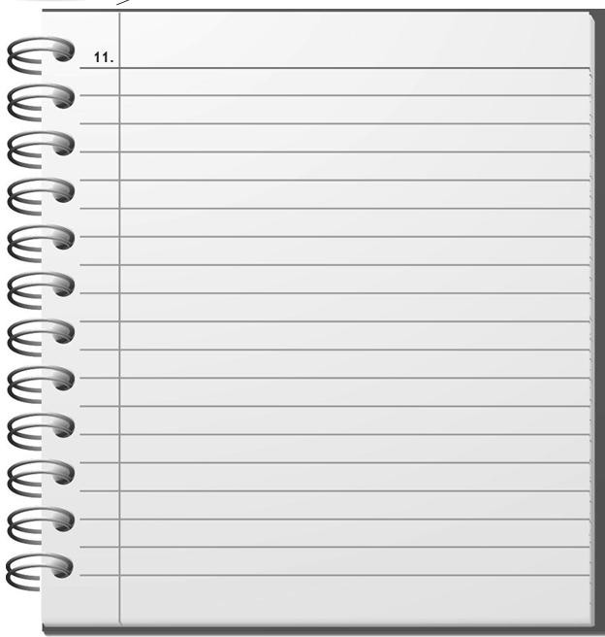

Section 3.

You will hear a telephone conversation. First, read the notes below then listen and complete the notes with information from the conversation. You will hear the recording twice.

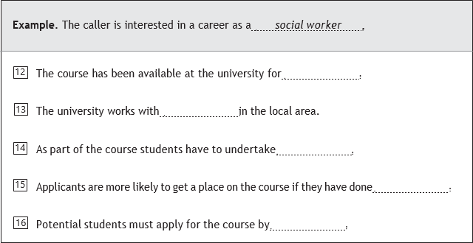

You will hear a talk. First, read the notes below then listen and complete the notes with information from the talk. You will hear the recording twice.
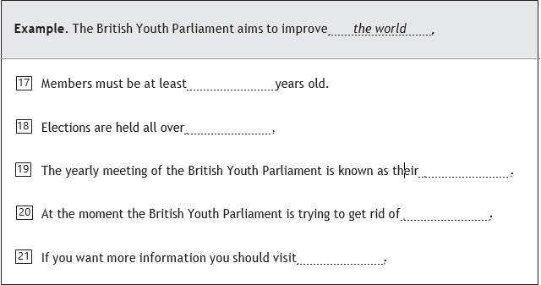

MODULE 12
PTE. READING Section.

Section 4.
Read each text and put a cross (X) by the missing word or phrase, as in the example:

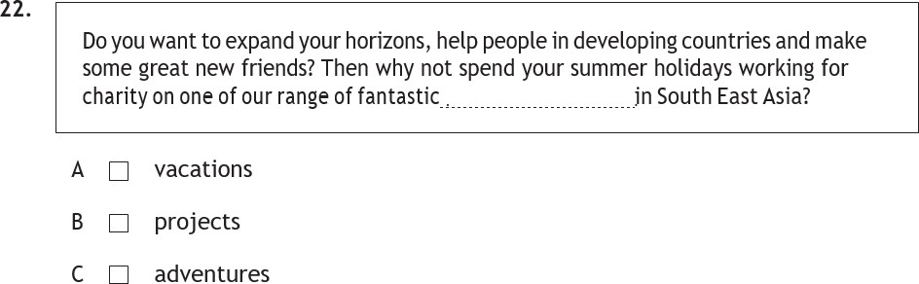
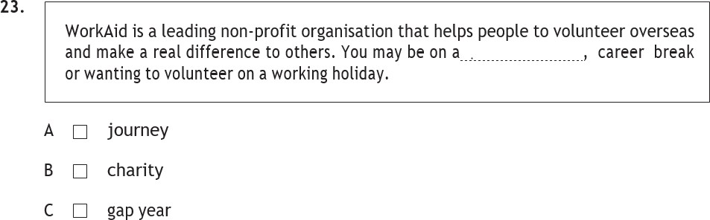
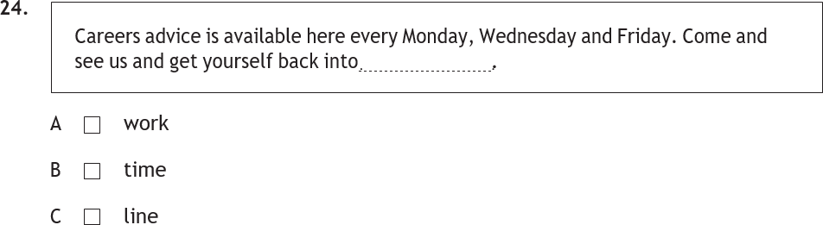

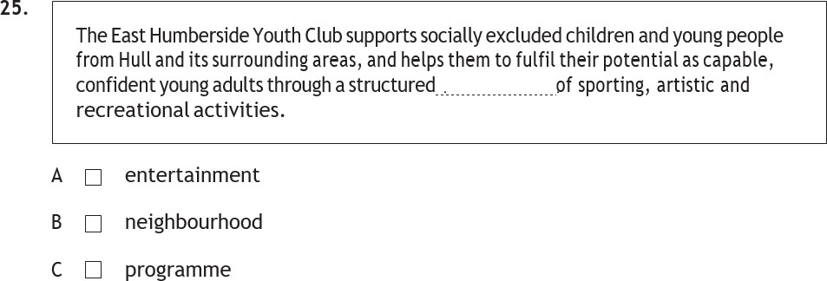

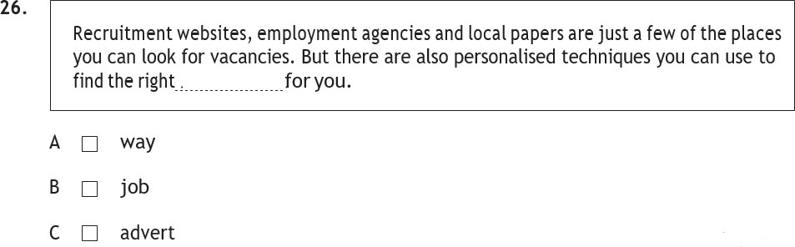

Section 5.
Read the passage and answer the questions below. Put a cross (X) in the box next to the correct answer, as in the example.
Rotherham-based Harpinder Kaur was stuck in a dead- end job, but a chance meeting with a man on a bus in Bradford changed everything, she tells James Grey.
Harpinder Kaur will never forget the first day she worked as a court interpreter. “It was a gang-related murder trial at Leeds Crown Court two years ago,” she says. “There were about 30 or 40 barristers in the room, perhaps 80 or 90 other people in the courtroom and public gallery, plus other people in the dock, so I was really nervous.”
Harpinder had been called into court to translate the testimonies of the defendants, all Punjabi speakers living in the UK. Until then, Harpinder had been working as a teacher of English as a second language in Leeds, and had been attempting, very gradually, to move into a career as a translator. Her experience in court that day lends new meaning to the phrase “thrown in at the deep end”.
“It was a difficult day, but I think I did pretty well,” she says. “At first I decided that I wouldn’t take any more bookings to work in court”. Then I thought, “This is part of my job. These people need me to help, and I can’t just say that I don’t want to do it.”
Harpinder doesn’t always enjoy what she does, her work takes place in situations like courtrooms, police stations and immigration centres. It doesn’t matter whether she sympathises with the situation her clients are in, or believes they are innocent or guilty: her role is to capture the precise meaning of their words.
So, what made her pursue a career as an interpreter? “One day, when I was still teaching, I met a man on a bus reading a Chinese dictionary. When I asked him why, he told me he was planning to move to China and needed to understand the language to understand the people. It made me realise I wasn’t using the languages that I spoke. When I got home I telephoned a careers office, and an adviser suggested I try interpreting. That’s how it all began.”

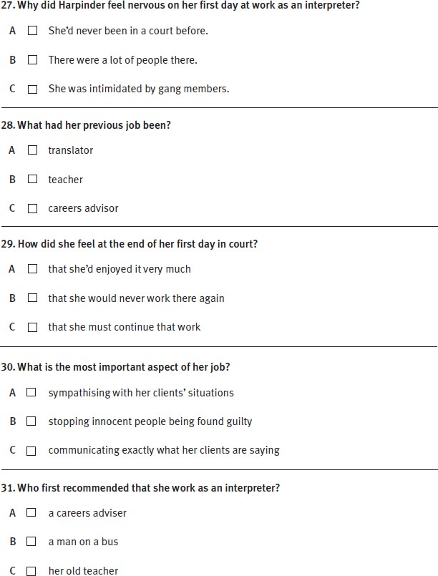

Section 6.
Read the web article below and answer the questions.

Innocent Water provides clean drinking water in developing countries across southern Asia. The company was founded by Cathy Cousins in 2002 when she returned to the UK from a year’s travelling after university. She contracted dysentery in Bangladesh after drinking dirty water.
Despite being very sick, she realised she was “one of the few lucky ones”: more than 4000 people worldwide die daily due to lack of clean drinking water. Her brainchild was to sell ethical bottled water, to concerned people who wanted it, using the profits to provide safe drinking water for remote communities.
Initially, Cathy had just a shoestring budget and a few volunteers to help her. She set up Innocent Water intending to be honest and outspoken about water supplies in developing countries.

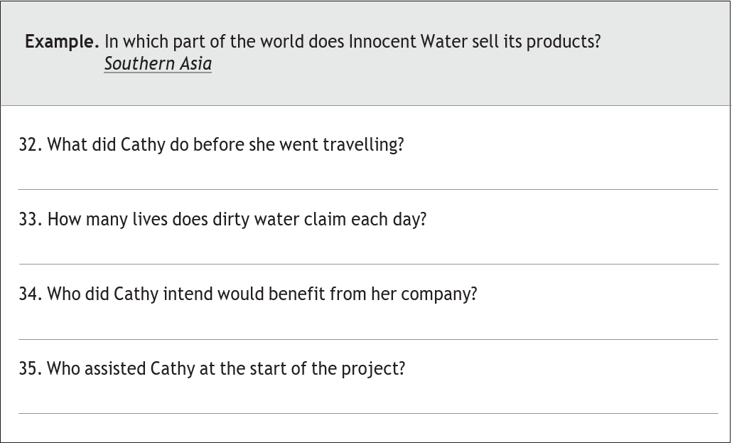

Read the newspaper article below and answer the questions.

A new survey of 16-24 year olds reveals that 82% of young people “cannot live” without the internet.
The research, generated by the youth charity TeenNet, also found that eight out of ten young people under 24 use the web to look for advice. About 25% of those surveyed added that online resources are so good that they don’t feel any need to discuss their problems personally.
Despite many recent examples of poor internet security, 69% of youth surveyed said they believed the internet to be a safe place “if you know what you’re doing”.
John Wright, a Professor of Psychology, believes that ‘the middle-aged but especially the elderly are probably most vulnerable to internet scams. Today’s youth have grown up with technology and have a deep understanding of how it works.”
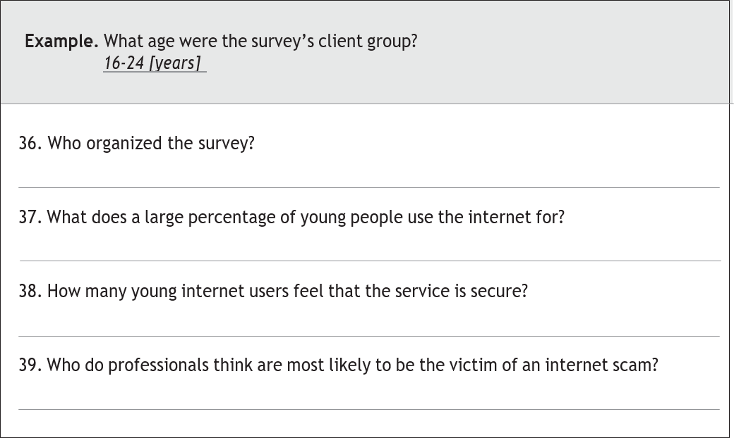

Section 7.
Read the web article and complete the notes. Write no more than three words in each gap from the article.

Portfolio Careers: Creating a Career out of Several Part-Time Jobs
If you have a portfolio career, you have several part-time jobs instead of one traditional full-time job. These might include part-time, temporary and free-lance employment with different employers: when combined, the jobs are the equivalent of a full-time position. A portfolio career offers more flexibility, freedom and variety than conventional employment, but involves some risk as well as requiring a high level of organisational skills.
If you opt for a portfolio career, it will usually be built around core skills or interests. For example, someone whose background is in education may teach part-time, write text books and examination materials, mark exams at certain times of the year, and perhaps train other teachers.
Most employment experts believe that James Hardy, an American management guru, was responsible for the sudden increase in the popularity of portfolio careers in the early 1990s. He suggested that individuals could gain more control over their working lives by having several small jobs rather than one big one.
Many people believe that another factor in the increasing status of portfolio careers is Harold Rivers’ recent book How to Succeed in a Workplace without Jobs. He suggests that the lack of job security today means that we are all temporary workers. There are many reasons to consider a portfolio career: to gain better work/life balance; to experience variety and use a range of skills; to control your own work life and to seek new challenges.
One survey of portfolio careerists shows that the majority (around 65%) were satisfied with their success in establishing a new type of career. They mainly put their success down to their ability to network. But, establishing a portfolio career isn’t easy for many. It can be difficult to balance the demands of different jobs and find employers willing to take you on a part-time basis. There’s also the possibility of isolation if you work from home, a possible drop in earnings and the risk of being out of work for periods of time.

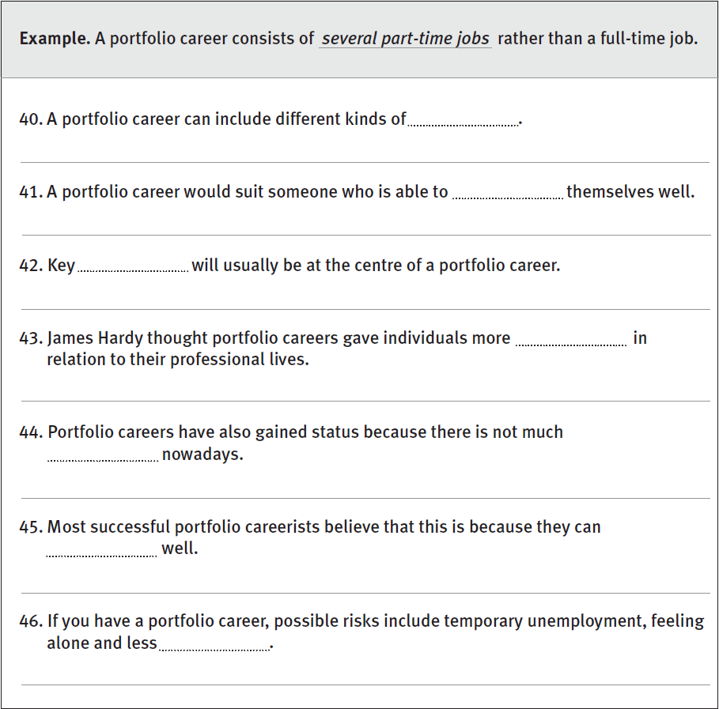

MODULE 13
PTE. WRITING Section.

Section 8.
Use the information in Section 7 to help you write your answer.

You have read the article about portfolio careers. Write an email giving advice to a friend who is considering changing to a portfolio career. Write about 90 - 120 words and include the following information:
  - the advantages of a portfolio career

the disadvantages of a portfolio career
  - how you think your friend could succeed Write your answer here. Do not write outside the box.

Section 9.

Choose one of the topics below and write your answer in 150

– 200 words.

- A) Your teacher gives you the following statement and asks you to write an essay.
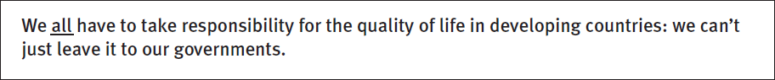

Write an essay agreeing or disagreeing with this statement giving reasons and examples.
OR

B) You see this post in an online magazine.
Write a blog entry for the online magazine. Include the following information:

a place to visit in your country
  - something young people should see while they are there

an activity they might enjoy
  - Explain why your recommendations are suitable for young people.

Write your answer here. Do not write outside the box.

MODULE 14

PTE. SPEAKING Section.

Section 10. Speak on the suggested topic for about 90 seconds
Main prompt 1: | Describe your perfect holiday.
Follow-up prompts: | ·Which type of holiday do you like best, an active or relaxing one?  ·What sort of things do you typically do when you are on holiday?  ·Do you think holidays should provide opportunities not only to relax, but also to expand your horizons?  ·Do you prefer package tours or travelling individually?
Main prompt 2: | Tell me about your favorite TV programme.
Follow-up prompts: | ·Do you agree that TV should be not only entertaining, but also educative?  ·People say, there’s too much violence on TV these days, do you agree?  ·Is there enough variety of TV programmes in your country?  ·TV finds it difficult to compete with other media, e,g, internet, don’t you think so?
Main prompt 3: | Can you describe your lifestyle as a healthy one?
Follow-up prompts: | ·Which things make up a healthy lifestyle?  ·Are your eating habits healthy?  ·Do you do enough exercise?  ·Is health inherited from parents or rather something we develop during our lives?
Main prompt 4: | How environmentally-friendly are you?
Follow-up prompts: | ·What are the typical environmental problems in your country?  ·Do you think it is the responsibility of individuals or of the governments to protect our planet?  ·What are the most common ways common people can help save the environment?  ·How important is recycling, in your opinion?

Section 11.
Keep the conversation going for around 2 minutes. Expect the examiner to ask at least 3 prompts.

You say: | Now we are going to discuss something together. The question is, should TV companies reduce the length of advertisements running on TV? What do you think?
For: | - Sometimes it’s impossible to watch your favourite programmes because of continuous interruptions by advertisements.  - Viewers want to watch the shows, not the commercials.  - Some TV advertisements are absolute rubbish.  - Viewers get irritated by long commercials and are more likely to switch the channel.
Against: | - For TV companies advertisements are the only way to provide financial support.  - Viewers may use TV advertisements break to make some coffee or tea.  - How else would the public know the details about the latest latest products and services if not from advertisements?  - Some advertisements are real masterpieces of film-making.

Section 12.
Be ready to speak on visual prompt for around 90 seconds (1,5 mins)

You say: Now, Here is a picture of some people. Please tell me what you can see in the picture.
You say: Now, can you tell me, which of these pictures would make a better illustration for a book called “The importance of sharing”?

Section 13.
Be ready to do a role play for around two minutes.

You’re at the dentist’s office. You’ve got an appointment for 4pm. It’s already 4.05, but there seems to be at least 3 other patients waiting. You need to pick up kids from school at 5pm. Talk to the receptionist, explain the problem, make sure you are taken care of as soon as possible.

Interlocutor, You say:
Ready? I’ll start.
- Excuse me sir / madam. Is there anything I can do for you?
………………….

СПИСОК ВИКОРИСТАНИХ ДЖЕРЕЛ
- Bailey S. Academic writing : A handbook for international students. London : Routledge, 2006. 293 p.
- Baxter S., Bloom B. Pearson Test of English General. Skills Booster. Level 3. Student’s Book. Pearson Education Limited, 2010. 145 p.
- Carr J. C., Eales F., Williams D. Cutting Edge. Upper-Intermediate. Third Edition. Workbook With Key: Pearson Education, 2013. 112 p.
- Cunningham S., Moor P., Bygrave J. Cutting Edge. Upper-Intermediate. Third Edition. Students’ Book: Pearson Education, 2013. 176 p.
- Eales F., Oakes S. Speak Out : Upper Intermediate Student’s Book. 2nd edition. Pearson. 2018. 176 p.
- Eales F., Oakes S. Speak Out : Upper Intermediate Workbook. 2nd edition. Pearson. 2018. 96 p.
- Evans V. CPE. Use of English : Examination Practice. Swansea : Express Publishing, 2000. 296 p.
- Evans V., Dooley J. Grammarway 4. Express Publishers, 2008. 276 p.
- Evans V., Dooley J. New Round-Up 5. Express Publishers, 2011. 210 p.
- Evans V., Dooley J. Upstream : level B1+. Students' Book. EU : Express Publishing, 2007. 166 p.
- Evans V., Dooley J. Upstream : Intermediate B2. Students’ Book. EU : Express Publishing, 2008. 175 p.
- Evans V. Successful Writing. Upper-Intermediate. Berkshire : Express Publishing, 2011. 138 p.
- Fuchs M., Bonner M. Grammar Express : For Self-Study and Classroom Use. Pearson Education, 2002. 415 p.
- Hewings M. Cambridge Academic English : An integrated skills course for EAP : Student's Book. Upper intermediate. Cambridge University Press, 2012. 176 p.
- Misztal M. Tests in English : Thematic vocabulary : Intermediate and advanced level. Kyiv : Знання, 2016. 352 p.
- Murphy R. English Grammar in Use. Fourth Edition. Cambridge University Press, 2012. 380 p.
- Prodromou L. Grammar and Vocabulary for First Certificate (with key). Longman, 2005. 320 p.
- Redston C., Сunningham G. Face 2 Face. Upper Intermediate : Student’s Book with CD-Rom/Audio CD. Сambridge : Сambridge University Press, 2007. 160 p.
- Soars J., Soars L. New Headway. English Course : Upper-Intermediate. Student’s Book. Oxford : Oxford University Press, 2008. 168 p.
- Soars J., Soars L., McCaul J. New Headway. English Course : Upper-Intermediate. Workbook with key. Oxford : Oxford University Press, 2008. 104 p.
- Swan M., Walter C. How English Works : A Grammar Practice Book, Oxford, 1997. 358 p.
- Tims N., Bell J., Redston C., Сunningham G. Face 2 Face. Upper Intermediate : Workbook. Сambridge : Сambridge University Press, 2007. 88 p.
- Wallwork A. English for Academic Research : Vocabulary Exercises. Springer, 2013. 193 p.
- Wallwork A. English for Research : Usage, Style, and Grammar. Springer, 2013. 252 p.
- Weale H. Oxford Exam Trainer B2. Oxford University Press, 2020. 185 p.

Навчально-методичне видання
(українською мовою)

Андрєєва Ірина Олександрівна Залужна Марина Володимирівна Запольських Світлана Петрівна

ПРАКТИЧНИЙ КУРС ІНОЗЕМНОЇ МОВИ (АНГЛІЙСЬКОЇ) ДЛЯ ВИКЛАДАЧА-ДОСЛІДНИКА

Навчально-методичний посібник
для здобувачів вищої освіти освітньо-наукової програми третього рівня (підготовка докторів філософії) усіх спеціальностей
2 рік

Рецензент К. М. Василина
Відповідальний за випуск О. А. Каніболоцька
Коректор Погонець В. В.

